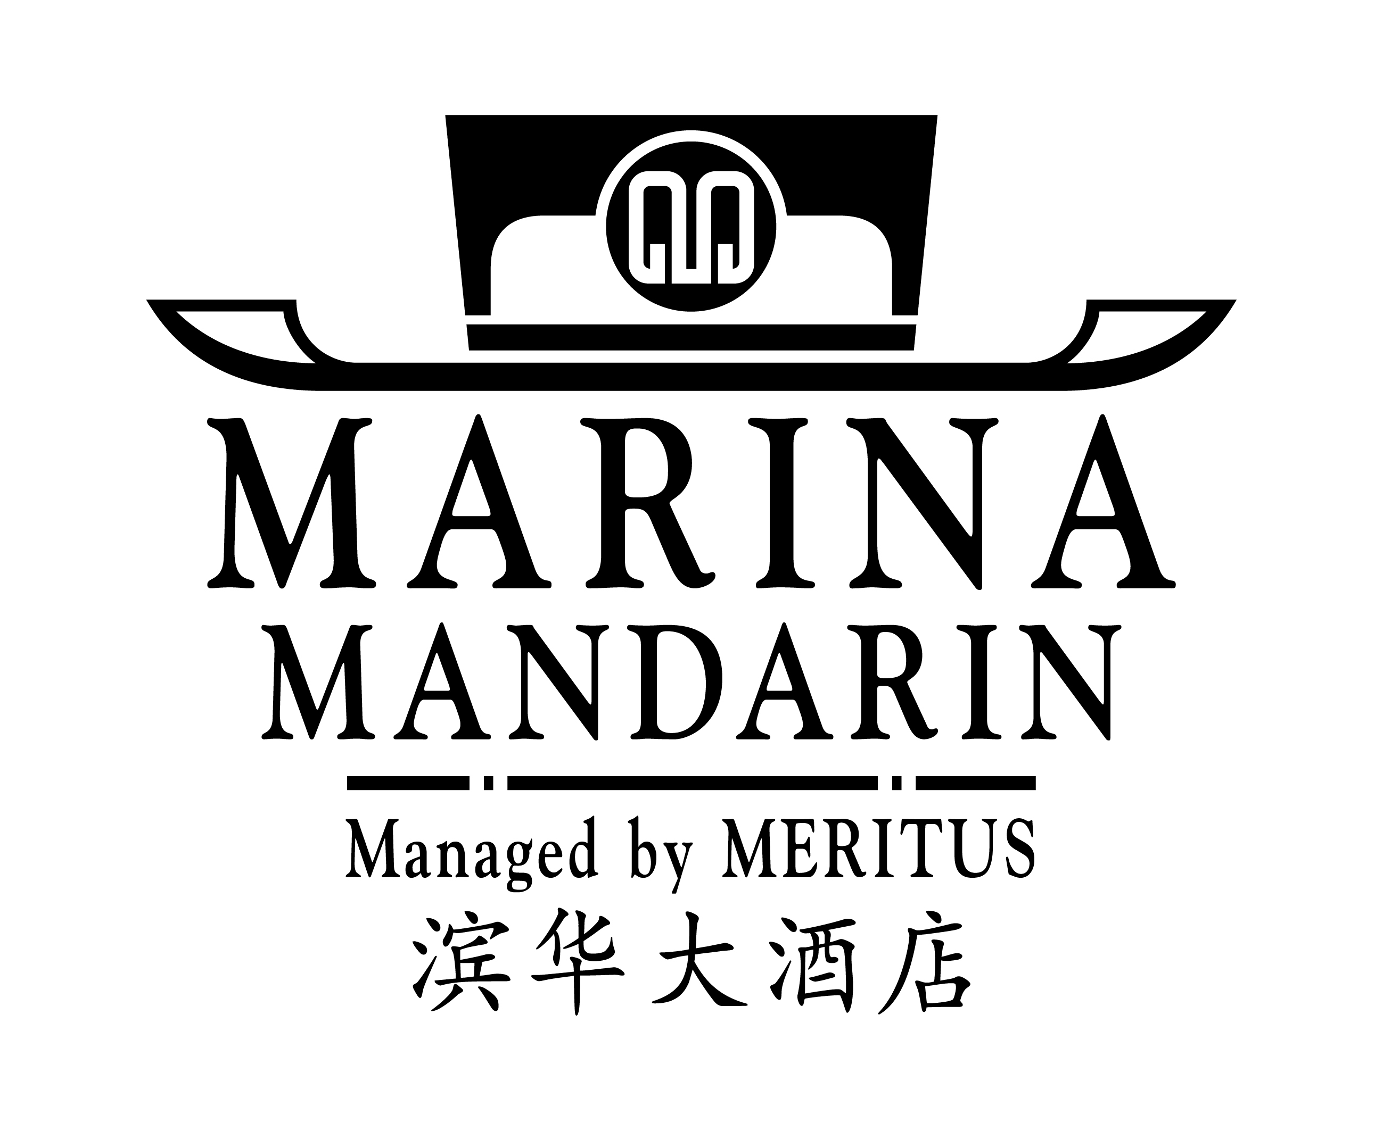

6 Raffles Boulevard, Marina Square, Singapore 039594
Telephone : (65) 6845 1224 Facsimile : (65) 6845 1020 Email : racheltee.mms@meritus-hotels.com
Attention : Rachel Tee

ROOM RESERVATION FORM

CONFERENCE ON ALGORITHMIC LEARNING THEORY & DISCOVERY SCIENCE

(8 – 11 OCTOBER 2005)
Rates quoted are for Marina Mandarin Singapore and applicable for this event only. To secure a confirmed reservation, please fax your request directly to the Hotel by 7 September 2005. An acknowledgement will be sent to you upon confirmation of your room reservation.
Prof. Dr. Mr Mrs Ms
X

Family/Last Name : First Name :
Name of Sharer : First Name :
Organization : Mailing address :
City : State: Postal/Zip Code : Country :
Phone : Fax: E-mail :
Date of Arrival : Date of Departure: Number of Nights:
Flight Number/Time : Flight Number/Departure Time:
* Please note that check-in time is 2.00 pm and check-out time is at 12.00 noon
* If you are arriving in the early hours of the morning, we suggest that you reserve your room for the night before to
ensure that your room will be available upon check-in.
X
Room Category

Deluxe at SGD$160.00 +++ (Room only)
Deluxe at SGD$180.00 +++ (Inclusive of 1 American Buffet Breakfast)
Premier at SGD$190.00 +++ (Inclusive of 1 American Buffet Breakfast)
Above rates quoted are subject to 10% service charge, prevailing 1% government tax and 5% goods and services tax (GST) per room per night, and room category is subject to availability at time of reservation.

One night non-refundable deposit is required for a guaranteed reservation confirmation.
X
Please guarantee to my credit card: American Express Visa Mastercard Diners

Card Number: Expiry Date: month year
Cardholder's name: Signature of Cardholder:
Any cancellation should be faxed to the Hotel at least 14 working days before arrival.
One night room rate will be levied for no show up or if reservations are cancelled less than 14 working days prior to arrival.
Request for early check-in and late check-out are subject to room availability.
Room reservations without arrival flight details or non guaranteed reservation by credit card will be released at 6pm.

For Hotel Use : YOUR RESERVATION IS CONFIRMED/WAITLISTED
Confirmation Number :
Remarks:

