
Copyright © 2003 by The NUS Students’ Computing Club. All rights reserved.
All information in this guide is correct at the time of publishing. Please refer to the respective websites for the most updated information.

Prologue – Welcome to Ohana
Dear freshmen,
Welcome to a new life with a fresh start. As you enter into the School of Computing (SoC), you will be stepping into another phase of your life. Let me assure you that it is going to be an exciting one filled with surprises and fun.
As I was once a freshman, I can understand the fear that you may have when coming to deal with university life. A word of advice is to know more friends when you have the chance. To be on a lonely island for the next three to fours years in the university is almost guaranteed to be unbearable.
No longer will you be grouped in fixed classes where you can get to know the people better with time. No more will your timetables be fixed or planned for you in advance by someone else. And most of all, no one is going to come after you should you decide to skip lectures.
Welcome to the freedom of university life. You will be choosing the modules that you are going to study. You will be fixing your own timetables and choosing which lectures you wish to attend. And most of all, should you not do well in your studies, no teacher or lecturer is going to run after you.
Although all these may seem overwhelming, there is still hope. There is no need to fear about this unknown future that lies ahead of you now. Many paths await your foot to thread upon and you will have many choices.
To aid you in preparing for the paths of life in SoC, this setup.exe guide has been prepared to help you through those basic necessities so that you can stand on your own feet as soon as you enter into SoC.
One final advice as you flip through the pages of this guide: You live what you believe. The way you view your life in SoC will determine how you are going to go through. So, let it not be fear but hope in the exciting life you are going to lead in SoC.

With blessings,

___________________________
Tan Teck Wee
President
5th Management Committee
NUS Students’ Computing Club

CONTENTS
Prologue – Welcome to Ohana 3
CONTENTS 4
Academic Matters 6
SoC at a Glance… 6
Module Recommendations 7
CAPs, MCs & Grades 10
The Deanery Boards, Head of Departments and Administration Staff 13
Computing Club 16
Links to Important Academic NUS Websites 19
NUS Notebook Ownership Scheme 21
Webpage, Intranet and Internet 22
Connecting to SoC Server 22
Setting Up Your Personal Homepage 23
NUS Dial-up Account / Email Setup Details 24
SoC Dial-up Account / Email Setup Details 26
Integrated Virtual Learning Environment (IVLE) 28
Getting Around 30
Map of SoC 30
Mass Rapid Transit (MRT) 31
SBS Transit Bus Services 32
Internal Shuttle Bus Services 34
Supplementary Bus Service During Peak Hours (Term Time Only) 38
Campus Parking 39
Tips to Get Around NUS 40
Study Woes 40
Money Business 41
Food Paradise 42
NUS Libraries 43
Science Library 44
Central Library 45
Hon Sui Sen Memorial Library 45
NUS Multi-Purpose Co-operative Society Limited 46
International Students Matters 47
Student Pass Information 47
Extension Of Stay 48
Frequently Asked Questions 49
Sponsors 53
Acknowledgements 54
Important Dates 56

Academic Matters

SoC at a Glance…

The School of Computing (SoC) was established in 1998, with the aim of becoming an international centre of excellence for multi-disciplinary learning and research in information technology.
To date, the school offers a total of 7 degree programmes and its academic structure revolves around the two pillars: the Department of Computer Science and the Department of Information Systems.
All newly matriculated students in the academic year 2003/2004 will have to fulfill 120 Modular Credits (MCs) to graduate with the three-year Bachelor degree. Students who wish to pursue an Honours degree will have to satisfy 160 MCs in four years.
SoC students who are not enrolled in the Computer Engineering course (CEC) will be streamed into the various degrees at the end of the first year, based on their interest, career-orientation and first year results. Therefore, do work hard to get into the stream of your choice!

Adapted from http://www.comp.nus.edu.sg/undergradprog/

Module Recommendations

One major difference between a junior college and a university is this: You get to choose your own modules (get familiar with this word – it has similar connotations to the more common word “subjects”). Before you gloat over your new-found freedom, we advise you to choose your modules carefully. Not all modules can be taken when you are in Semester One, as some of them have pre-requisites, i.e.: if module X is a pre-requisite of module Y, then module X has to be taken before you are eligible for module Y. Similarly, you will be advised to take level 1000 modules (covering the basic foundations) before proceeding upwards to 2000 and 3000 (with a higher degree of depth and difficulty).
Below are the modules that we highly recommend you to take in your first semester. For those who want to be different or intend to challenge yourself by choosing a perilous academic journey, you can kindly ignore this page. *grins*

CS1101 / CS1101S Computing Methodology (5 MCs)
CS1101 provides the fundamentals for many other modules you are going to take in the later semesters and is taught using JAVA! For Java lovers, have fun! For those who know nuts about programming and think that Java is a country or some kind of coffee, fret not because you will start from the basics and pick it up in no time!
The course basically covers algorithm design, and some simple data structures. There is extensive lab-work and is definitely not going to be a breeze for most students. Unfortunately, this is an essential module – so get used to it!
For more adventurous students, or students with high inclination towards mathematics, the S option provides a very interesting and vibrant approach to learning programming. The module is modelled after the infamous introductory programming course at the Massachusetts Institute of Technology (MIT). The programming language used is not Java, but a very tiny language called Scheme. Through this simple but effective language, the module provides students with a taste of the various aspects of computer science through programming.
For students who have been exempted from taking CS1101, you can still consider taking CS1101S (with or without taking CS1101S, you will still be given the free 5 MCs from the exemption), and experience programming from a refreshing angle. This will broaden your understanding of computing and programming from a computer science perspective.

CS2301 Business and Technical Communication (4 MCs)
It teaches you how to write reports, letters and do oral presentations with a touch of professionalism. Though it is project-intensive, all the tutors for this module are very fun and entertaining. You will get to have another “orientation” from this module as the group projects will give you more opportunities to know your friends better. Rest assured, this module will definitely be fulfilling and memorable.

CS1231 Discrete Structures (4 MCs)
This module introduces mathematical tools required in the study of computer science. Some of the topics include logic, equivalence relations and functions. It is also the prerequisite for a number of modules. Heard of the pigeon-hole principle? Take this module to find out that your choices are limited by pigeon holes!

CS1104 Computer Organization (4 MCs)
As of AY2003/04, the pre-requisite for this module is CS1101, so only students with formal computing education background will be eligible for this module in their first semester. If you do not have the necessary background, you will need to pass CS1101 or CS1101S before you may take this module. Some of you may find parts of the syllabus familiar such as binary numbers, logic gates etc. Unfortunately, this is another workload-extensive module which provides a better understanding on how computers work. There are a total of 6 labs which are scheduled fortnightly. You will be given short assignments which have to be submitted for grading. If you attend lectures and tutorials religiously, you should have no problem in coping with this module.
You may want to know that CS1104 is a pre-requisite for many Level 2000 modules, so try to clear this module as soon as possible.

General Education Modules (GEMs) / Singapore Studies (SS) (4 MCs)
For the ambitious and talented people out there who want to take 6 modules in the first semester, we recommend light-hearted modules from the GEM/SS categories. These modules not only allow you to receive a broad-based education, but also provide you with the chance to interact with people from other faculties.

University Scholars Programme (USP) Modules
One of the essential modules in the USP is the Writing Module. This writing module has been modeled after Harvard and is conducted in a very small class of 8 to 10. There is a lot of interaction between students and the facilitator, with a catch. There are a lot of writing assignments to be done!
USP students will find yourself only taking one USP module in the first semester as you have to clear a few essential modules. But don’t worry, as you can clear all the 8 first-tier modules throughout your four years in NUS. For more information on the USP modules to take, you can refer to http://www.scholars.nus.edu.sg/.

Note:
Students taking Computer Engineering (CEC) should take up MA1505 (Mathematics I) or EG 1108 (Electrical Engineering) instead, as a 5th or 6th module.

CAPs, MCs & Grades

CAP
The Cumulative Average Point (CAP) is the weighted average grade point of all modules taken by the student, excluding modules read through Student Exchange Programs or modules credited under Advanced Placement.
The CAP is rounded up to 2 decimal places, and a minimum CAP score of 2.00 is required for graduation.

MCs
Each module is assigned a number of modular credits (MCs) usually within the range of 4 to 8, according to its workload.

Grades
Grades are assigned as follows:
Grade | Grade Point | Description
A+/A | 5.00 | Excellent
A- | 4.50 | Excellent
B+ | 4.00 | Very Good
B | 3.50 | Very Good
B- | 3.00 | Very Good
C+ | 2.50 | Good
C | 2.00 | Satisfactory
D+ | 1.50 | Probationary Grade *
D | 1.00 | Probationary Grade *
F | 0.00 | Fail
Table 1 Table of Grades, their corresponding CAP points and description
* Acceptable for graduation on condition that CAP ≥ 2.00

Under certain circumstances, the following grades may also be awarded:
IC (Incomplete): | Given when a student sat for and failed exam due to valid medical reason or external circumstances.
EXE (Exempted): | Given when student is exempted from taking the module and awarded the credits.
W (Withdrawn): | Student drops the module in the time period given.

Calculation of CAP score
CAP =
Suppose you took 4 modules in a certain semester. Assume the grade obtained and MCs are as follows:

Module | MC | Grade | Grade Point
Module 1: | 4 MCs | A+ | 5
Module 2: | 3 MCs | B | 3.5
Module 3: | 5 MCs | B+ | 4
Module 4: | 3 MCs | C+ | 2.5

Therefore your CAP for that semester will be:
= 3.87 (rounded up to 2 decimal places)

Be warned that CAP scores are accumulative! Therefore, if you do badly for a certain semester, you will have to do extremely well the following semester to pull up your CAP score to a respectable level.

How is my degree determined by my CAP?
- 4-year course with Honours
Class of Honours | CAP Cut-offs
1st Class | 4.50 & above, with at least an "A-" in Honours Project
2nd Upper Class | 4.00 - 4.49
2nd Lower Class | 3.50 - 3.99
3rd Class | 3.20 - 3.49

- 3-year course
Class of Bachelor’s degree | CAP Cut-offs
Pass with Merit | Above 3.20
Pass | 2.00 to 3.19

Degrees offered by SoC
3-year Bachelor of Computing with technology focus
3-year Bachelor of Computing with business focus
4-year Bachelor of Computing (Computer Science) with Honours
4-year Bachelor of Computing (Electronic Commerce) with Honours
4-year Bachelor of Computing (Computer Engineering) with Honours
4-year Bachelor of Computing (Communications and Media) with Honours
4-year Bachelor of Computing (Information Systems) with Honours

* More information can be obtained from http://www.comp.nus.edu.sg/undergradprog/

The Deanery Boards, Head of Departments and Administration Staff

Deanery
 | Name | Office | Tel
Dean | Prof Joxan Jaffar | S16 #05-11 | 6874 4782
Vice Dean | Prof Ooi Beng Chin | S15 #05-26A | 6874 4860
Vice Dean | Assoc Prof Rudy Setiono | S15 #05-25 | 6874 3578
Vice Dean | Assoc Prof Mohan Kankanhalli | S15 #05-09 | 6874 6552
Asst Dean | Mr. Tan Tuck Choy, Aaron | S16 #06-16 | 6874 2906
Asst Dean | Assoc Prof Teh Hung Chuan | SoC1 #04-10 | 6874 2912
Asst Dean | Dr Ang Chuan Heng | S15 #05-14 | 6874 2729
Asst Dean | Assoc Prof Danny Poo | SoC1 #05-15 | 6874 2783

* Information can be found in the “Deanery” link in http://www.comp.nus.edu.sg/undergradprog/content03_04.htm

Heads of Departments

Department of Computer Science
Prof Sanjay Jain
S16 #05-12 6874 2726 dcshead@nus.edu.sg

Department of Information Systems

Assoc Prof Tan Cheng Yian, Bernard
S16 #05-10 6874 4368 dishead@nus.edu.sg

* Information can be found in the “Department Heads” link in http://www.comp.nus.edu.sg/undergradprog/content03_04.htm

Academic Advisors

Undergraduate Advisors
Assoc Prof Chionh Eng Wee
S16 #04-10 6874 6227 chionhew@comp.nus.edu.sg
Assoc Prof Sung Sam Yuan
S16 #06-20 6874 6148 ssung@comp.nus.edu.sg
Dr Teo Hock Hai
SoC1 #05-23 6874 2979 teohh@comp.nus.edu.sg
Mr. Voicu Razvan
S15 #04-10 6874 2732 razvan@comp.nus.edu.sg
Assoc Prof Yeo Gee Kin
S15 #05-12 6874 2908 yeogk@comp.nus.edu.sg
Mr. Yuan Bo
S16 #04-03 6874 2904 yuanb@comp.nus.edu.sg

International student advisors
Dr. Heng Aik Koan For students from Mauritius
S15 #05-13 6874 2731 hengak@comp.nus.edu.sg
Dr. Bimlesh Wadhwa For students from Indian sub-continent
S16 #4-09 6874 2973 bimlesh@comp.nus.edu.sg
Dr. Tan Sun Teck For students from Indonesia
S16 #08-14 6874 2778 tanst@comp.nus.edu.sg
Assoc Prof Loe Kia Fock For students from China
S16 #08-21 6874 2786 loekf@comp.nus.edu.sg
Students from countries not listed here may consult any of the international student advisors above.

* Information can be found in http://www.comp.nus.edu.sg/undergradprog/advisor.html

Program specific email enquiries can be sent to the departments offering the programmes:
Department of Computer Science: csit@comp.nus.edu.sg
Department of Information Systems: isec@comp.nus.edu.sg

Administrative Officer (For all academic matters)
Ms Lim Li Sze, Jane
S16 #05-06 6874 4371 jlimls@comp.nus.edu.sg

Office of Student Affairs (OSA)
Level 3, Yusof Ishak House (YIH) 6874 2370
Sports and Recreation Centre (SRC) 6874 2384
University Health and Wellness Centre (UHWC) 6874 2880
Personal Guidance and Counselling Service (PGCS) 6874 2376

Computing Club

Established in 1998 together with the School of Computing (SoC), the NUS Students’ Computing Club was formed to serve the interests of SoC students. To cater to the needs of SoC students, the Computing Club organizes the Freshmen Orientation Week (FOW) for incoming freshmen as well as other activities like panel discussions with professionals from the industry for graduating seniors.
The Computing Club is a training ground for aspiring young people who are willing to undertake challenges in organizing events, liaising with external companies for sponsorships and taking on leadership roles. A successful person is not one who never fails, but one who never quits.
Currently the Computing Club constitutes two categories of Committees: Events and Support. The Events Committees concentrate on the planning and execution of events while the Support Committees focus on the supportive roles to ensure the success of the events. The Computing Club's office is located on the ground floor of S15, facing the Science Canteen.

Computing Club Executive Committee (2002/2003)

President Mr. Tan Teck Wee
Internal Vice President Mr. Qiu Jiang
External Vice President Ms. Lee Shu Xia
Honorary General Secretary Ms. Guo Xiao Jia
Finance Director Mr. Tuan Shunde Noel
Communications Director Mr. Abhesh Kumar
Welfare Director Mr. Zhu Tao
Assistant Secretary Ms. Yeo Lu Yee
Assistant Finance Director Ms. Lee Qiuju Avril

Computing Club Advisors

Dr. Tan Sun Teck tanst@comp.nus.edu.sg
Dr. Tan Soon Huat, Gary gtan@comp.nus,edu.sg
Mr. Tan Tuck Choy, Aaron tantc@comp.nus.edu.sg

Events Committees

Academic Liaison Committee (ALC)
The ALC looks after the academic needs of students and bridges the gap between the students and the teaching community. The committee is also involved in any other academic issues that may help the student community at large. In the process, the ALC regularly organizes industrial visits, facilitates academic talks, help sessions and the like.

Freshmen Orientation Co-ordinating Committee (FOCC)
The FOCC organizes the annual orientation for the SoC freshmen. Activities such as the SoC Summer Camp, the Freshmen Orientation Week (FOW) as well as Rag and Flag are organized to help freshmen familiarize themselves with the faculty. FOCC thus plays a pivotal role in welcoming the freshmen into the SoC family.

Social and Liaison Committee (SLC)
The SLC caters to the social needs of the members of the Computing Club. It organizes gatherings, outings and celebrates various festivals that aim to integrate the international community at the School of Computing.

Sports Liaison Committee
The Sports Liaison Committee aims to promote a healthy lifestyle among members of the Computing Club by organizing sporting events. It will liaise with the Sports and Recreational Centre (SRC) to facilitate the Inter-Faculty Games (IFG) throughout the year.

Welfare Committee
The Welfare Committee looks after the day-to-day needs of the members and is your feedback tool to voice out your views about SoC. Apart from addressing the concerns of all the students of SoC, the Welfare Committee also handles the locker concerns of the school’s population.

Special Projects Committee (SPC)
The SPC organizes special events that do not fall into any of the above categories. Examples of Special Projects include seminars on academic and non-academic subjects, LAN gaming, stamp collections... you name it!

Computer Engineering (Computing) Committee
The CEC Committee takes care of the interests of CEC students pertaining to their academic matters and social welfare. As CEC students have to take Engineering modules together, the CEC committee helps to organize activities to bond CEC students together and aids them in any problems faced during module planning.

Support Committees

Marketing Committee
The Marketing Committee handles the important role of projecting the school’s image within the university, to the corporate world. They are the ones who source for funds for Computing Club events and act as ambassadors for the School.

Multimedia Committee
The Multimedia Committee is formed on its two pillars: The Web team and the Video Team. The overall objective of the multimedia team is to exploit the multimedia infrastructure available to maximize the spectrum of communication. As part of the Multimedia Committee, the Web Team is responsible for delivering web-based solutions to a range of requirements from online registrations to web based inventory management. The video team utilizes its expertise in filming by capturing memorable events throughout the year.

Publications Committee
The role of the Publications Committee is to provide a channel of communication for the SoC students, and to keep them updated on the changes and improvements being made to the faculty. They are responsible for the contents of Computing Club-related materials in print and other forms of published media.

Publicity Committee
Publicity Committee is the chief mouthpiece of Computing Club. Made up of people skilled in diverse talents from poster designing to manpower managements, the Publicity Committee solely bears the responsibility of off-line publicity for various events. Coupled with the online publicity base provided by the Multimedia Committee, the committee provides a comprehensive package to provide for Computing Club publicity requirements.

Links to Important Academic NUS Websites

Remember to add the following links to your bookmarks… you can be sure to access them quite frequently during your varsity days.

SoC Website http://www.comp.nus.edu.sg
This is the official homepage of SoC, where you can get links on module descriptions, timetables, and other relevant information pertaining to the faculty.

IVLE (Integrated Virtual Learning Environment) http://ivle.nus.edu.sg
This online portal is where you can download your lecture notes and extract all sorts of information. Remember to check it at least once every two days! More information about it is given in the later part of this guide.

Tutorial/Lecture Links http://www.comp.nus.edu.sg/~tutorial/
This page allows you to check the available lecture and tutorial time slots you might be bidding for.

Course Schedule http://www.comp.nus.edu.sg/~online/course_list/courses.html
This page provides a list of all the courses that are offered in the semester.

Online Registration http://www.comp.nus.edu.sg/~online/
You will need to access this link after matriculation in order to bid for the modules you want to take for the semester.

Module Description http://www.comp.nus.edu.sg/~cmcurric/ModDes.html
Over here, you can read more about the various modules and their scope.

University Level Requirements https://online.nus.edu.sg/services/ulreg/
Information about GEM/SS/UE modules can be found here.

Undergraduate Programmes http://www.comp.nus.edu.sg/undergradprog/
Confused with the various degrees offered by SoC? You can learn more about them from this link!

Centre for Development of Teaching & Learning (CDTL) http://www.cdtl.nus.edu.sg
The Center was set up to enhance the quality of teaching and learning at NUS, and to establish itself as a leading centre for teaching and learning in higher education.
Its publications, found at http://www.cdtl.nus.edu.sg/cdtlhome/pubs.htm offers valuable information to all students.

NetStart https://noc.comp.nus.edu.sg
Your express guide to getting started with SoC network and related computing facilities.

NUS Notebook Ownership Scheme
The NUS Notebook Ownership Scheme is part of the Global Campus Project by NUS to prepare students for the ever-changing world outside campus and move towards an e-Learning Environment.
Annually, the NUS Computer Centre conducts an open tender exercise to seek for computer vendors. The NUS Multi-purpose Co-operative Society Limited (NUS Co-op for short) provides services which include the processing of the notebook sales, students’ loan and the handling of repair and maintenance of the notebooks.
All NUS students are entitled to one notebook purchase during their study at NUS through this scheme. Latest details on the various models available under the scheme can be found at the following websites:
http://www.nus.edu.sg/global/2002/nbos/price-1.htm
All models sold under this scheme come pre-configured to connect to the NUSNET. PCMCIA network card will be loaned to students carrying notebooks without built-in network cards.
Interest-free loans up to the full cost of the laptop computer⁺⁺ are available to freshmen matriculated in July 2003. The latest updates on the interest-free loans can be found at the following website:
http://www.nus.edu.sg/global/2002/faq.htm
⁺⁺Changes could be made without prior notice and changes can be found at the above website.
Enquiry, viewing, purchase and collection of models covered by this scheme can be done at the following locations in NUS:
NUS Co-op Notebook Service Centre  Multi-Purpose Sports Hall Level 4 | Tel: 6775 5162
NUS Co-op Computer Center (Branch)  LT26 (Near Science Canteen, the “Frontier”) | Tel: 6873 6267
In addition, with a notebook by your side, it is also your responsibility to take care of your notebook in school. There have been cases of lost notebooks reported in the past few years.

Webpage, Intranet and Internet
As an SoC student, you will be given free web space (100MB) to host your own webpage.

Connecting to SoC Server

To connect to any SoC server, you will need to download SSH (Secure Shell Client) from ftp://ftp.comp.nus.edu.sg/pc/win95/ssh2/.

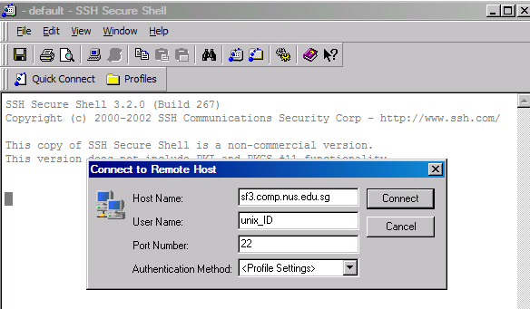

Figure 1 Secure Shell Client login screen

Fill in your user name as shown above. Upon supplying your password in the next screen that follows, you will be logged in to the SoC server. You will need to activate NUS-VPN (downloadable from http://www.nus.edu.sg/vpn/download.html) if you are connecting outside NUS.

Setting Up Your Personal Homepage

The SoC WWW server allows you to host your own personal web page. You can access your homepage using the following URL: http://www.comp.nus.edu.sg/~userID
- Connect to a SoC server using SSH (Secure Shell Client).
- Create a directory called public_html.
mkdir ~/public_html
- Create a homepage and name it index.html. This file will be automatically loaded when the above URL is accessed.
- Transfer all the required files using a FTP (File Transfer Protocol) program for the webpage to the public_html directory.
- Set the permission level for your directories and files.
To make public_html a read-only directory:
chmod 711 ~/public_html
To make any file, e.g. readme.doc a read-only file
chmod 644 ~/public_html/readme.doc
Please refer to https://www.comp.nus.edu.sg/cf/www/setup-homepage.html for further details.

WARNING!!!
Any leasing out of allocated server space or hosting of illegal materials is prohibited. NUS will take strict disciplinary action against such practices.

NUS Dial-up Account / Email Setup Details

The connection will be automatically disconnected after 2 hours. There are no subscription fees, but normal SingTel toll charges apply.

Configuration Information
Access Numbers | 6557 1070 (480 lines)  6557 1078 (60 lines, NUS Intranet)
Incoming Mail Server (IMAP) | imap.nus.edu.sg
Outgoing Mail Server (SMPT) | mail.nus.edu.sg
News Server | news.ex.nus.edu.sg
Mailbox Size | 10 MB
Table 2 Table of configuration information for NUS Dialup
* You may also use the Automatic Proxy Configuration (APC):
http://www.nus.edu.sg/proxy/config.pac

Every NUS staff and student is given a NUSNET-IV MS Exchange email account by the Computer Centre. You can access your NUSNET-IV MS Exchange mails through http://exchange.nus.edu.sg or via IMAP using MS Outlook.
The login ID and the password for the NUSNET email account is the same for both IVLE and NUSNET login.
Login ID: NUSNET User ID E.g. U03XXXXX
Password: NUSNET Password
More instructions can be found at https://www.comp.nus.edu.sg/cf/mail/index.html

NUS Dial Up settings

1. Create a new dial-up networking connection.
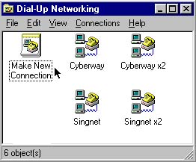
Figure 2 Dialup Networking
2. Right-click on the dial-up icon and choose Properties from the drop-down menu.
3. Make the following selections:
Area code (uncheck)
Type of dialup server PPP: Internet, Windows NT Server, Windows 98
Advanced options (uncheck all)
Allowed network protocols TCP/IP only

A more detailed step-by-step guide is available at:: http://www.nus.edu.sg/dialup/config2.html

SoC Dial-up Account / Email Setup Details

This connection will not be disconnected automatically. The usage hours for the connection are unlimited. There are no subscription fees, but normal SingTel toll charges apply.
Configuration Information
Access Numbers | 6874 5356 (30 lines, V.90 56K modems)  6874 5357 (30 lines, V.90 56K modems)  6873 7906 (30 lines, V.90 56K modems)  6873 6377 (60 lines, V.90 56K modems)
Incoming IMAP Mail Server (SSL) | stuimaphost.comp.nus.edu.sg
Outgoing Mail Server (SSL) | mailauth.comp.nus.edu.sg
News Server | news.comp.nus.edu.sg
Proxy Server* | proxy.nus.edu.sg Port: 8080
Mailbox Size | Part of your Unix HOME directory space, ie. 100 MB currently.
Table 3 Table of configuration information for SoC Dialup

* You may also use the Automatic Proxy Configuration(APC): http://www.nus.edu.sg/proxy/config.pac
SoC provides its own mail services on Unix for staff and students. In order to access SoC emails, you must have an SoC Unix account first. Our Internet domain is "comp.nus.edu.sg". Therefore, our Internet mail address is of this format "userid@comp.nus.edu.sg".
You can read your SoC Unix emails using:
- command line (eg pine(1), mutt(1), elm(1))
- email readers (eg Outlook, Outlook Express, Netscape Mail)
- web browsers (eg MS Internet Explorer, Netscape Navigator, Opera) via SoC Webmail (http://mysoc.nus.edu.sg/~webmail ).
Please refer to https://www.comp.nus.edu.sg/cf/mail for more details.

SoC Dial-Up Configuration
1. Click on the "Start" button, go to "Control Panel", followed by "Network and Internet Connections."
2. Click on "Create a connection to the network at your workplace". This will launch the New Connection Wizard.
3. Check the first radio button "Dial-up connection", click Next.
4. Type in a name for the connection, it can be any name. In this example, we use "SOC 68745356". Click Next.
5. Key in the dialup number in the space provided. Click Next.
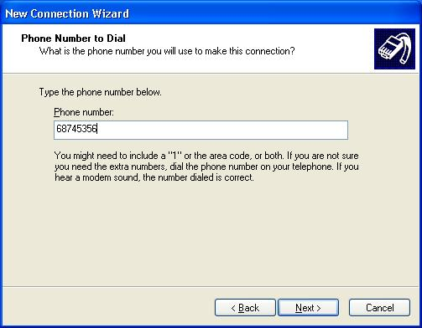
Figure 3 Connection Details
6. Select the appropriate option on whether you want this connection to be available to all users who login to your computer. Click Next.
7. If you have created a shortcut to the connection, double click on the dialup icon just created on your desktop. You can also bring up Network Connections window by following this navigation order: Start > Control Panel > Network and Internet Connections > Network Connections, double click on the desired dialup icon. Key in your SOC UNIX userid and password, click "Dial" to initiate the connection.

For more information, please refer to: https://noc.comp.nus.edu.sg/docs/dialup.html

Integrated Virtual Learning Environment (IVLE)

Where: http://ivle.nus.edu.sg/
What: Your personal portal to your online modules and resources. This is where you can download and access module resources such as lecture notes and tutorial sheets. Information regarding modules, for example, reading lists, and course syllabus, can also be viewed here. Some quizzes are conducted online via the IVLE. The forums pose as a great meeting place for online discussions of course-work and intellectual exchange of ideas.
IVLE requires logging in. It is important that you log out of the system when you are done.
Other functions:
- My Organizer
- Active Messaging (An instant messaging program)
- NUS Events
- My Modules
This feature is extensively used by SoC
- My Bookmarks
- SELF (holds information about yourself, such as modules taken, CCA records etc)
- Library (Exam Papers)

Here is a glimpse of the IVLE workspace:
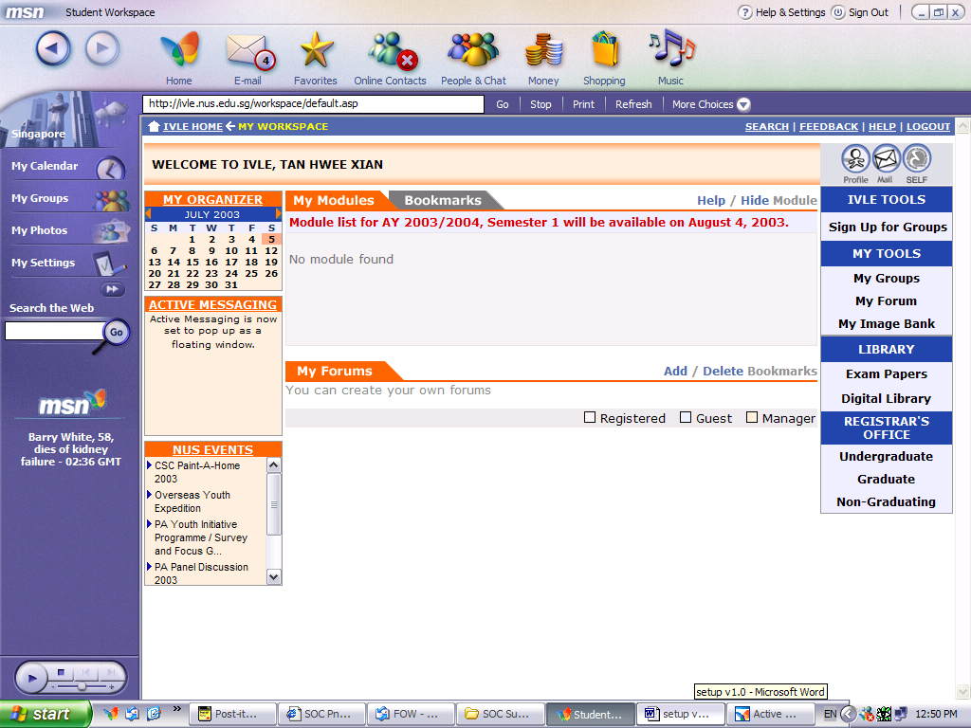
My Organizer provides you with a daily, weekly, monthly event summary. You can also create your own personal to-do list.
The modules you are currently taking will be reflected under My Modules. You can click on the respective module(s) to view the module outline.
Read email.
You can create your own Forum here.
You can bookmark any course in NUS.
You can go to Profile to change personal particulars such as email and handphone number.

Figure 4 IVLE workspace

Getting Around

Map of SoC

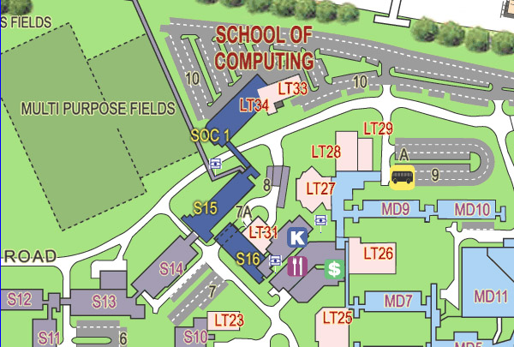
Figure 5 SoC Map

Mass Rapid Transit (MRT)

The nearest MRT stations serving NUS are Buona Vista and Clementi. Take 96 from Clementi bus interchange or take 95 from the bus stop opposite Buona Vista MRT station.
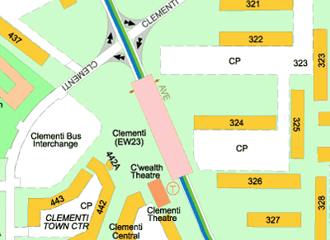
Figure 6 Clementi MRT station and bus interchange
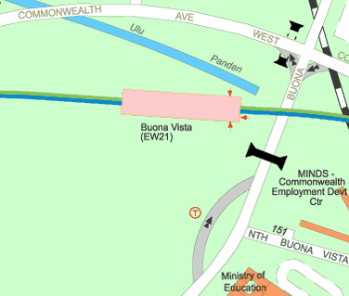
Figure 7 Buona Vista MRT
Bus stop

SBS Transit Bus Services

The SBS buses which ply through NUS are 95, 96 and 151.
Bus Service Number | Operational Route
SBS 96 | From Clementi Interchange via Clementi Avenue 3, Commonwealth Avenue West, Clementi Road and Kent Ridge Crescent (loop).
SBS 95 | From Buona Vista Terminal via Holland Drive, Commonwealth Avenue, North Buona Vista Road, Buona Vista Flyover, Lower Kent Ridge Road , Kent Ridge Crescent, Kent Ridge Terminal (loop).
SBS 151 | From Hougang South Interchange via Hougang St 21, Tampines Road, Hougang Avenue 3, Airport Road, MacPherson Road, Serangoon Road, Jalan Toa Payoh, PIE, Whitley Road, Bukit Timah Road, Clementi Road, Kent Ridge Crescent and Kent Ridge Terminal.
Table 4 Detailed route of bus services plying through NUS

Their operating hours are:
 | From | Mon – Sat | Sun & Public Holidays
SBS 96 | Clementi | 7.00 am - 11.30 pm | 7.00 am - 11.00 pm
SBS 95 | Buona Vista | 6.45 am - 11.30 pm (Mon – Fri) | 7.00 am - 11.00 pm
 |  | 7.00 am - 11.30pm (Sat)
SBS 151 | Hougang South | 6.00 am - 11.00 pm | 6.00 am - 11.00 pm
 | Kent Ridge | 6.15 am - 11.00 pm (Mon-Fri) | 6.30 am - 11.00 pm
 |  | 6.30 am – 11.00 pm (Sat)
Table 5 Operating Hours of Bus Services plying through NUS

Other public buses which service the roads near campus are mentioned below.
Bus Service | Operational Route
33 | Bedok Interchange to Kent Ridge Terminal
95 (loop) | Buona Vista Terminal to NUS/NUH
96 (Loop) | Clementi Interchange to NUS
96A | Clementi Interchange express to NUS
151 | Hougang South Interchange to Kent Ridge Terminal
200 (Loop) | Kent Ridge Terminal to Holland Drive
10 | Tampines Interchange to Kent Ridge Terminal
97, 197, 198, 507, 521 | Along Ayer Rajah Expressway
97, 197, 507, 521 | Along Buona Vista Flyover (NUH)
33, 96, 188 | Along Clementi Road
10, 30, 51, 143, 188, 200 | Along Pasir Panjang Road (near Heng Mui Keng Terrace)
Table 6 Bus Services plying by NUS

All maps and tables are taken from the NUS website at http://www.nus.edu.sg/corporate/visitors/

Internal Shuttle Bus Services

NUS is served by 3 shuttle bus services and 1 supplementary bus service (during term-time peak hours only), provided free-of-charge for all NUS students. ISB A, ISB C and the supplementary bus service serve the School of Computing.

ISB A | Weekdays |  | Saturdays |  | Sundays/  Public Holidays
ISB A | 1st bus | Last bus | 1st bus | Last bus | 1st bus | Last bus
ISB A | 0730 | 2300 | 0730 | 2230 | 0900 | 2230
Time of the Day | Frequency Range (min) during Semester 1 and 2
0730-0900 | 4 ~ 7 |  | 4 ~ 7 |  | 30
0900-1400 | 4 ~ 7 |  | 4 ~ 7 |  | 30
1400-1900 | 4 ~ 7 |  | 15 ~ 18 |  | 30
After 1900 | 15 ~ 18 |  | 30 |  | 30
Time of the Day | Frequency Range (min) during University Vacations
0730-0900 | 7 ~ 9 |  | 7 ~ 9 |  | 30
0900-1400 | 7 ~ 9 |  | 7 ~ 9 |  | 30
1400-1900 | 7 ~ 9 |  | 15 ~ 18 |  | 30
After 1900 | 30 |  | 30 |  | 30
Table 7 Time and Frequency of ISB A

Direction A1 | Direction A2
Prince George's Park Road  PGP terminal  South Buona Vista Road  After Science Park  Drive  Lower Kent Ridge Road  NUH  LT 29  Opp. Football Field  Opp. Faculty Club  Kent Ridge Crescent  Yusof Ishak House  Central Library  Kent Ridge Drive  LT 13  AS 7  Law Link  Car Park 13 @ BIZ/ Law  Business Link  Hon Sui Sen Memorial Library  CBRD @ BIZ 2  Prince George's Park Road  Opp. House No.12  House No.7  PGP terminal | Prince George's Park Road  PGP terminal  Between House 14 and House 15  House 12  Business Link  NUS - BIZ 2  Opp Hon Sui Sen Memorial Library  Law Link  Car Park 13 @ BIZ/ Law  Temasek Hall  Eusoff Hall  Kent Ridge Drive  Opp. LT 13  Kent Ridge Crescent  Computer Centre  Opp. Yusof Ishak House  Office of Estate and Development  Lower Kent Ridge Road  Faculty Club  Football Field  School of Computing 1  Opp. NUH  Prince George's Park Road  PGP terminal
Table 8 Route of ISB A

ISB B | Weekdays |  | Saturdays |  | Sundays/  Public Holidays
ISB B | 1st bus | Last bus | 1st bus | Last bus | 1st bus | Last bus
ISB B | 0730 | 2300 | 0730 | 1900 | No service
Time of the Day | Frequency Range (min) during Semester 1 and 2
0730-0900 | 5 ~ 8 |  | 5 ~ 8 |  | No service
0900-1400 | 6 ~ 10 |  | 6 ~ 10
1400-1900 | 6 ~ 10 |  | 30
After 1900 | 30 |  | No service
Time of the Day | Frequency Range (min) during University Vacations
0730-0900 | 10 ~ 13 |  | 10 ~ 13 |  | No service
0900-1400 | 12 ~ 15 |  | 12 ~ 15
1400-1900 | 12 ~ 15 |  | 30
After 1900 | 30 |  | No service
Table 9 Time and Frequency of ISB B

ISB C | Weekdays |  | Saturdays |  | Sundays/  Public Holidays
ISB C | 1st bus | Last bus | 1st bus | Last bus | 1st bus | Last bus
ISB C | 0730 | 2300 | 0730 | 1900 | No Service
Time of the Day | Frequency Range (min)
0730-0900 | 10 ~ 13 |  | 10 ~ 13 |  | No service
0900-1400 | 12 ~ 15 |  | 12 ~ 15
1400-1900 | 12 ~ 15 |  | 30
After 1900 | 30 |  | No service
Table 10 Time and Frequency of ISB C

ISB B - Loop Service | ISB C - Loop Service
Kent Vale terminal  Engineering Drive 1  University Hall  Kent Ridge Crescent  Office of Estate and Development  Yusof Ishak House  Central Library  Kent Ridge Drive  LT 13  AS 7  Law Link  Car Park 13 @ BIZ/Law  Temasek Hall  Eusoff Hall  Kent Ridge Drive  Opp. LT13  Kent Ridge Crescent  Computer Centre  Opp. Yusof Ishak House  Raffles Hall  Engineering Drive 1  University Hall  Kent Vale terminal | Kent Vale terminal  Engineering Drive 1  University Hall  Kent Ridge Crescent  Office of Estate and Development  Lower Kent Ridge Road  Faculty Club  Football Field  School of Computing 1  (Loop at NUH roundabout)  LT 29  Opp. Football Field  Opp. Faculty Club  Raffles Hall  Engineering Drive 1  University Hall  Kent Vale terminal
Table 11 Routes of ISB B and ISB C

Supplementary Bus Service During Peak Hours (Term Time Only)

Supplementary Bus Service | Weekdays
Time of the Day | Frequency Range (min)
0800-1030 | 5 ~ 9
1130-1400 | 5 ~ 9
1600-1830 | 5 ~ 9
Table 12 Time and Frequency of Supplementary Bus Service
The supplementary bus service during peak hours will stop at the following major bus stops on campus:
Supplementary Bus Service
Kent Vale terminal
Opposite Hon Sui Sen Memorial Library
Opposite Lecture Theatre 13
Computer Centre (loop at NUH roundabout)
Lecture Theatre 29
Yusof Ishak House
Central Library
Lecture Theatre 13
Hon Sui Sen Memorial Library

Table 13 Routes of Supplementary Bus Service

Campus Parking

Free parking is available at Kent Vale, which is opposite NUS along Clementi Road. Students can take the free shuttle bus services from Kent Vale to various campus destinations. Alternatively, if you drive to school everyday, you can apply for a season parking pass, which is far cheaper than paying for the hourly parking rate on-campus. Season passes are pretty scarce and are allocated once a semester. An email will be circulated by NUS to ask interested students to apply for the season parking pass.
In the campus itself, parking costs 1.5 cents per minute (90 cents per hour, just like HDB parking), and the mode of payment is strictly by cash cards only. Please be careful not to park at staff carparks because it is extremely expensive to do so! It costs S$4.80 per hour!
A licence plate recognition system is employed so that drivers do not need to carry a ticket or chip around with them. The operating hours of each carpark (when parking is chargeable) are mentioned at the carpark entrance.
Refer to http://www.nus.edu.sg/corporate/visitors/car_parks.htm for complete information on parking in NUS.

Tips to Get Around NUS

To make life a bit easier in SoC, we will share some insider tips on how to get around SoC. But sometimes, it is more fun to explore and discover for yourself!

Study Woes

Exams are around the corner and you badly need a place to study. Though SoC may not be a big place as compared to the engineering blocks, but we assure you that we too have many conducive places for you to study or even work on your projects. We even help you to rate the study corners (1 as the most conducive and 3 as the “not so quiet but still can make it”)

Rating 3:

- Try out the Science canteen, also known as the “Frontier”. Fresh air with some LAN points for you to connect your laptops. Avoid it during lunch time though as it can be very noisy. However, during the evening period at around 5 to 6pm, the canteen can be a very conducive place to study and meet for project discussions.

- Tables outside S16 Lobby. Quite deserted as they are located at a corner. The only disadvantage is that it can be quite dark so you may not find it conducive to study. However, if you are looking for a place to chit chat, you may want to go there instead.

Rating 2:

- S16 Level 3 Study Area. This is where most SoC students hang out to study. There are many LAN points there so it is a good place to work on your programming as well. However, you may be easily distracted by passers-by as it is very near to the lift.

- S15 Level 3 Corridors. A fairly good place to study with air conditioning, It is quiet and bright. There are also LAN points for you.

- S15 Level 1 Corridors. Similar to Level 2 with one big advantage. The network printers are located at the first level so if you are doing any printing, you can collect them almost immediately. If you have any problems with your laptop connection, the helpdesk is also at the first level – pretty convenient!

- SoC1 Building Level 8 General Computer Laboratories. It is a blue building, fairly new with lots of computers. A lot of SoC students like to go there to study or do their programming as there are sufficient computers and tables for you to work with your laptops. If you have any problems with your programming, be sure to ask your seniors around.

Rating 1:

- For the USP students of SoC, you guys are lucky! A large room is allocated for the USP students of SoC with big tables and comfy sofas for you to nap when you are tired. Only SoC USP students are allowed to enter and you will need to use your matriculation card to enter the room.

- Classrooms, provided they are not used by any tutorials. However, you will have to leave the classrooms around 6 to 7pm as the aunties will be cleaning the room and locking the rooms as well.

Anymore secret getaways in SoC? You will have to find out yourself – have an interesting stay in SoC!

Money Business

The nearest ATM (for POSB and DBS) is at NUH (National University Hospital) which is about 5 to 10 minutes walk from SoC. There is another one at Yusof Ishak House (YIH).

There is a UOB ATM just outside LT 25.

An AXS machine is located right outside LT 27. Users can use it to pay their phone bills and also to book movie tickets!

Food Paradise

It’s 8p.m. and all the stalls in the Science canteen have closed! No worries, we will recommend you some other food centres nearby.

Within the school compound:
- The canteen @ National University Hospital. Flash your matriculation card to get a 10% discount! Prices become more affordable with this discount!
- Angie’s Place which is near the SRC (Sports Recreational Centre) by the road. You can take Bus A1 and head down towards YIH (Yusof Ishak House). You will only take you 5 minutes to reach there by bus (2 bus stops). They sell fired rice, Hor Fun etc. Prices of food ranges from $2.50 to $4 depending on what you order.
- Fong Seng Coffee Shop. It is situated at the other end of NUS, near to Eusoff Hall and you can also take Bus A1 there. You will take around 10 minutes to reach there by bus (around 4 bus stops) The food there is very famous including cheese prata, Dinosaur drink, mee goreng, nasi lemak etc. A favorite hangout place at night!

Outside of school:
- If you need to go back to school to study at night, we recommend you a coffee shop near Dover Road. It is located in a market and sells food such as chicken or duck rice, Hokkien mee, sugarcane juice etc. You will have to walk towards NUH and cross a bridge to the other side of the road. It will take you around 10 minutes by foot.

Snacks and Tidbits
So you want more food? Though the Co-op is closed at 6pm on weekdays and at 1pm on Saturdays, you can still head down to the 7-11 store (closes at 11 p.m.) at NUH to get your noodles, bread, chocolates, drinks etc.
There is also a small mama shop near the YIH and it sells pretty much everything. You can take Bus A2 and it will take 2 bus stops to reach there. If you like traveling, the mama shop will be a good place to get food.

Love is in the air – but where to get flowers??!!

Fret not, Valentine’s Day is a day not forgotten in NUS, not to mention SoC. If you want to get cute gifts for your loved one, the Science Co-op is a good place to do some shopping. But if you need to buy or order fresh flowers, take a bus down to the Central Coop @ the Forum. There is a bigger Co-op there and you can rest assured that are fresh flowers daily. Furthermore, they are inexpensive and the auntie is excellent in wrapping the flowers.

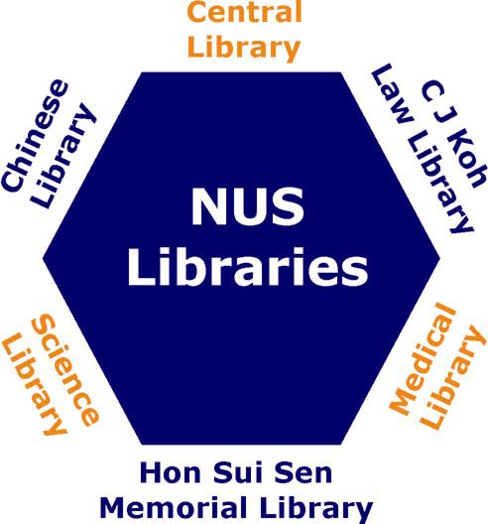
NUS Libraries
NUS Libraries is the largest academic library in Singapore and is made up of six libraries. All NUS students are members of the NUS Libraries and are entitled to use and borrow from all six libraries. The Library provides reference and information services, user education programmes and conducts library tours and tutorials.

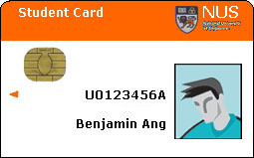
Library Opening hours during semester:
Mondays - Saturdays: 8am to 10pm
Sundays: 9:30am to 4:30pm
Public holidays: closed

Any changes of opening hours are announced on library notice boards, Web site and LINC.

Matriculation card = Library card
Use your Matriculation card’s Pin to access your Library account – myLINC

Important Library URLs:
http://www.lib.nus.edu.sg
NUS Libraries Homepage.
http://linc.nus.edu.sg
LINC stands for Library INtegrated Catalogue and is the catalogue for over 1 million books, journals, publications in NUS Libraries collection
- To find an item, search by Author, Title or Keywords.
- Note the location and call number.
- Go to the correct location to look for the item.
- Use Login to myLINC to check your loans & renew

http://www.lib.nus.edu.sg/lion
Science Library Briefing cum Tour
11 & 12 Aug (Mon & Tues) 1pm – 2pm
Held at Science Library AV Viewing Room near Loan Counter
For Computing Club
Briefing on 6 Aug 10 am - 10:30 am @ LT27
Tours on 6 Aug 11 am - 3 pm
@ Science Library AV Viewing Room
LION is Library Instruction ONline. Learn about finding information in the library, citing sources, how to search LINC, index databases and much more!

http://www.lib.nus.edu.sg/help
Frequently Asked Questions.

http://www.lib.nus.edu.sg/digital
NUS Digital Library for access to all electronic resources subscribed by the NUS Libraries:
- Dictionaries & encyclopedia  - Electronic books  - Electronic journals | - Exam Database  - Indexes & abstracts  - Online newspapers  - Statistical data
You can use the forms posted on the Digital Library to inform us for changes of your email and postal address, request for new materials to be bought by the library and other services.

Science Library

A Special Library within the NUS Library System, opened its doors on 19 May 1986. Located at S6 in the Faculty of Science, it serves primarily the Faculty of Science, Graduate School of Science, School of Computing and its Graduate Division.
Its collection covers primarily the biological sciences, chemistry, computer science, mathematics, statistics & applied probability, materials science and physics.
Science Library conducts Information Literacy Skills
Every semester, the library would liaise with all the departments in the Science Faculty and School of Computing to organize information literacy skill to share with students how to do research effectively and efficiently. Do look out for poster for these sessions in the library.
To learn more about information sources on a topic, form a group with your classmates and request the Library to conduct a session.

Central Library

Central Library is the largest of the six libraries and its collection covers architecture, building and real estate, engineering, the humanities and social sciences.
It serves primarily the Faculty of Arts and Social Sciences, the Faculty of Engineering and the School of Design & Environment and the University Scholars Programme.
Central Library houses the Singapore/Malaysia Collection which is particularly strong in source materials tracing the various aspects of the development of the Singapore, Malaysia and Borneo (excluding Indonesian Borneo) from their founding through the period of colonial government up to independence and thereafter.

Hon Sui Sen Memorial Library

Hon Sui Sen Memorial Library is located next to the School of Business. It serves primarily the School of Business and its Graduate Division.
The Library was built in memory of Mr Hon Sui Sen (1916-1983), former Minister for Finance and Member of Parliament for Havelock.
The HSSM Library collects and maintains a rich collection of management, business and finance books, journals, audiovisual materials and digital resources.

NUS Multi-Purpose Co-operative Society Limited
The NUS Multi-Purpose Co-operative Society Limited (or NUS Co-op for short) provides students and staff of NUS the convenience of in-campus shopping and services, which includes textbooks, computers and notebooks, sundries and other services such as travel agency, photograph re-print, optics, photocopying, gifts and novelties and florist shop.
The nearest store is the Science and Medicine branch located behind LT 27. The other branches are at the Forum (below the Central Library), Architecture, PC Centre and the Notebook Service Centre.
The NUS Co-op has the policy of providing textbooks at the lowest price for its members. To find out more about the NUS Co-op, visit their website at http://sunsite.nus.edu.sg/co-op/.

International Students Matters

Student Pass Information

Upon your arrival in Singapore, you will be given a Social Visit Pass for a minimum of 2 weeks at the airport or point of entry. You may be asked to show your Letter of Admission. During this period, you must apply for a Student's Pass (immigration visa) after obtaining your Matriculation/ Registration Card.

Eligibility
Any foreigner wishing to pursue full-time studies in Singapore in an institution that is: registered with the Ministry of Education (MOE); or has obtained approval from the Director of Singapore Immigration & Registration (SIR) to accept foreign students is required to apply for a Student's Pass.

Exemption from applying Student Pass:
- Dependant's Pass holders studying in Government, Government-Aided, Independent, Kindergartens or Foreign System Schools
- Immigration Exemption Order holders

Where to Apply:
1. Immigration and Checkpoints Authority (ICA)
Obtain application forms from:
ICA Building, 4th Floor
Information/Queue Ticket Counter.
Your passport will be returned within a week.
Submit applications to:
Visitor Services Centre (VSC)
4th Floor, ICA Building
10 Kallang Road
Singapore 208718
The ICA building is just next to the Lavendar MRT station.
2. Office of Students’ Affairs (OSA)
Your passport will be retained for a minimum of three weeks during peak periods.
Students wishing to cash traveller’s cheques, open bank accounts or travel during this period are advised to take note.
A local sponsor is required except for those studying in Institutes of Higher Learning (IHL).
Note: Some applications may take a longer time (up to 6 weeks) to process. Applicants are usually given a Social Visit Pass during this period and will be informed of the outcome by post.

Extension Of Stay

If you wish to stay in Singapore after the expiry of your Student’s Pass or if application for extension is made after the expiry of the Student’s Pass, you may apply for a Social Visit Pass through the Visitor Services Centre, ICA Building (4th Storey), and bring along a confirmed air ticket for your departure.

More information on all matters on international students can be found on http://www.nus.edu.sg/NUSinfo/osa/foreign_student.html.

Frequently Asked Questions

When exactly does the semester start?
The first semester for the year 2003/2004 will begin on the 4 August 2003. The first week is known as week 0.

Do lessons start from day 1?
No. Week 0 is known as the orientation week and there will be no lessons scheduled. This is the week where SoC holds its orientation week programme, covering Dean’s Welcome Tea, Unix Workshop etc.

How do I know when to go for classes?
It depends on what are the modules that you are bidding for. Every module will have its own timetable and schedule, so do take note of them when you are choosing your modules.

Bidding for modules sounds a bit difficult!
It’s actually quite a simple process. Everything is done online nowadays so just follow the on-screen instructions and you’ll be fine. The main thing you need to do is to make sure the timetables of the various modules you want do not clash. This includes the timings for the lectures, tutorials and exams. It is your responsibility to ensure that there are no clashes. Do check all the pre-requisites before registering for modules! Refer to www.nus.edu.sg/~cors

What if the timetables clash?
Usually, each module will have several timings allocated for tutorials so it should not be a problem getting a suitable tutorial class. If you choose two modules where their lectures or exams clash, the on-line registration system would not allow you to register for both the modules together.

What happens if you lose your matriculation card?
Go to www.nus.edu.sg/registrar/undergraduate/replacematriccard.html. A replacement of $15.60 is charged. So take good care of your matric card or pay up!

What are the facilities available to me?
As SoC students, you are free to use any of the available computer labs in NUS.
The labs in SoC however, are only available to SoC students. For security purposes, you have to scan your matriculation card before you can enter the computer labs.

What happens if I run out of print quota?
Each month, every undergrad in SoC would be allocated 50 free A4 pages for his/her printing needs. You can make use of this quota to print your tutorials, your lecture notes and your projects’ documentation. If you happen to run out of printing quota, you can purchase more from the School. The form for purchasing additional print quota is available online. Go to https://mysoc.nus.edu.sg/~eform/forms.
After you have duly completed the form, please quote the reference number of your application and make payment at SoC Finance(S16 #08-18) within 7 days (you shall receive a receipt) or else your application will be void.
The cost of the print quota is $10.40 for 200 sheets of A4 black laser printing or $12.50 for 20 sheets of A4 colour laser printing.
NOTE:
If you use duplex printing, you will be given a 25% discount in the number of pages being printed.

What other services does the Helpdesk provide?
In addition to enabling you to purchase additional print quota, you would need to visit Helpdesk if you lose or forget your UNIX password to ask for a new one. If you have any queries, you can also email them at helpdesk@comp.nus.edu.sg.

U03XXXXA, u03xxxxx, unix ids, pin number, passwords, etc. What are all these numbers for actually?
Your matriculation number uniquely identifies you as a student of NUS. Typically, it will look something like this: U031111A.
Your Matriculation number will also come with a pin number which you will use to access your student account on various occasions. The pin number is used with the matriculation number. Eg: To register for your examinations and to check your examination results online.
There are also the NUS student account ID and passwords to remember. These are used to access your online e-mail account, and to access the student intranet. The ID will be like u03xxxxx and a default password will be given to you.
Similarly, you have an ID and password for your Unix e-mail account. The ID will normally be the first 8 characters of your name.

WARNING!!!
It is very important to safe guard your computer accounts. You must not leave accounts unattended. Log off from the terminals when you are away, even if it is for a few minutes.
Do not disclose any of your passwords to your friends as this would undermine the security of the systems.

What is Unix?
UNIX is a portable operating system which is available in our School in a variety of implementations such as SunOS 4, SunOS 5 (Solaris 2.x), Sys V Rel 4 and Rel 4.2 (Destiny), IRIX, AIX and Ultrix. It offers multi-tasking, multi-user, client/server support, networking and graphical user interface.

Ok, now I have my Unix account, how do I get into Unix itself?
For a start, you will need to have SSH installed on your system. Go to ftp.comp.nus.edu.sg/pc/ssh/ to download the program. Refer to page 22 for more details.
In addition, you are also highly encouraged to attend the UNIX workshop in the Orientation Week to familiarize yourself with Unix.

Where do I get my lecture notes for my School of Computing Modules?
There are a few places where you can get your lecture notes. Most importantly, you must attend the first lecture where the lecturer will brief you on everything regarding the course.
The places where you are most likely to find the lecture notes are:-
- IVLE → workbin
- The course webpage
- The NUS CO-OP printing services

How do I configure my notebook for wireless access at SoC?
For most of you, your notebooks are bought from the official NUS vendors. Therefore, the CISCO Aironet Client Utility will have been already installed on your systems. All you have to do is to insert in the CISCO wireless card (given to you together with your notebook) at a location where there is wireless access. The software will automatically detect the wireless network and you will be able to access the Internet from there.
For notebooks that are bought from non-NUS vendors, you will need to access www.nus.edu.sg/winzone/drivers/drivers.htm to download the driver required for the wireless card. You will also need the CISCO Aironet Client Utility and it can be downloaded from the same URL.
Please note that the above instructions are only for CISCO wireless card bought or loaned from NUS. For other wireless cards configuration, please refer to www.nus.edu.sg/winzone/config/config.htm.

Sponsors
We would like to thank the following sponsors for their support in making the whole Freshman Orientation Project a success.






Acknowledgements

We would like to extend our heartfelt gratitude to the following who have helped to make this SETUP.exe a success:

Advisors of Computing Club
Dr. Tan Sun Teck
Dr. Tan Soon Huat, Gary
Mr. Tan Tuck Choy, Aaron

5th Management Committee, Computing Club

All who have helped, in one way or another.

Editorial Team
Tan Hwee Xian
Oh Hang Sim, Jackson
Yeo Lu Yee, Janfy
Feng An Qiang, Eric
Lin Dan Tong

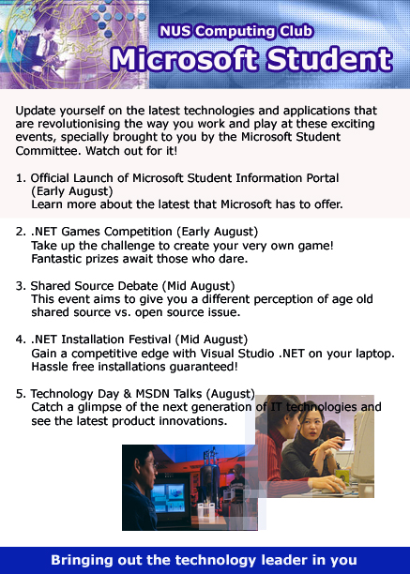

Important Dates
Date | Time | Venue | Event
Monday, 28 July | 0900-1200 | MPSH1 | Matriculation (Computing & Computer Engineering)
Tuesday, 29 July | 1000-1200 | LT33 | Course briefing (Computer Engineering) – All
 | 1400-1630 | LT27 | Course briefing (Computing) – All (exclude poly freshmen)
Wednesday, 30 July | 1000-1200 | LT33 | Course briefing (Computing) – Poly freshmen only
Monday, 4 Aug | 0830 | LT27 | Registration for Freshmen Orientation Week (FOW)
Tuesday, 5 Aug | 0800 | LT27 | Flag Day
Thursday, 7 Aug | 0900-1530 | LT27 | Unix Workshop and Q&A Session
Thursday, 7 Aug | 1600-1700 | LT27 and LT33 | Dean’s Welcome Tea
Friday, 8 Aug | 0800-2200 | LT27 | Rag Day
Module Registration
Bidding for modules is done via the Centralised Online Module Registration System (CORS) web site at http://www.nus.edu.sg/cors. More information on the registration details will be available sometime in early July.
Items |  |  | Schedule
Add/Drop modules |  |  | 1 to 17 August 2003
Drop modules with Withdrawn (W) grade |  |  | 18 to 31 August 2003
Drop modules with Fail (F) grade |  |  | After 31 August 2003
Tutorial Registration for English Proficiency modules |  |  | 11 to 16 August 2003
Tutorial Registration for Computing modules |  |  | 18 to 23 August 2003

