Contents
LIFE IN SOC ……………..…………………..2
MODULE SELECTION ………………………………………2
TIME MANAGEMENT …………………………………..…..3
STUDY IN SCHOOL OF COMPUTING …………………….4

RULES AND REGULATIONS ……………..6

The UNIX Operating System ……….14
Getting Started ……………………………………………15
Basic Unix Commands ……………………………………...16
Printing Documents ………………………………………..23
APPLICATIONS
EDITORS ...………………………………27
PICO …………………………………………………………27
EMACS ………………………………………………………29
EMAIL ...………………………………….32
PINE …………………………………………………………32
NEWS ……………………………………38
BBS ………………………………………………………….38
COMMON MISTAKES …………………………………….43
OUTLOOK EXPRESS ……………………………………...44
PINE ………………………………………………...………44
FTP ……………………….………………44
WS_FTP …………………………………………………….44
DOS FTP ……………………………………………………48

COMPILING AND EXECUTING a java program …………………………………50
SeTTING UP YOUR ACCOUNT ..………………………………50
RUNNING A JAVA PROGRAM …………………………………50
CREATING YOUR OWN JAVA PROGRAM .………………...52
JAVA DEVELOPMENT KIT ...……………………………………53
OTHER SOFTWARES FOR DEVELOPING JAVA
APPLICATIONS ……………………………………………………...55
Dialup Services ………………………56
Overview …………………………………………………...56
Some Important Information …………………………….56
Setting up PPP connection in Microsoft
Windows 95/98 ……………………………………………...57
Dialup Services for Other Systems ……………………...63
MISCELLANEOUS ………………………...64
SPNP …………………………………………………………64
SETTING UP YOUR HOME PAGE ………………………..66
WHAT TO DO WHEN YOUR PROFILE SPACE IS EXCEEDED ………………………………………………….69
Unix Commands (Quick
Reference) ………………………………72

SCHOOL OF COMPUTING

FRESHMEN SURVIVAL GUIDE
2000

LIFE in SOC

Module Selection
School of Computing offers a large number of courses, and allows students to select modules themselves. Before doing online registration to select modules for your first semester, we recommend that:
- You have a good knowledge of the courses offered in our faculty.
- Take into consideration what you would like to focus on (i.e., whether you would like to focus on CS, IS or IT modules).

Hint: You can trace your way down from the last undergraduate year to the first year, selecting the modules that you want to take in the fourth year and then see what are the prerequisites required for them and try and do all those are required first.

Cross faculty modules are offered by faculties other than SoC. These modules not only enhance your knowledge in different fields, but also let you dip into subjects that you are interested in. Some CFM modules are graded while others are on a pass/fail basis.

Things to remember:

- Read the course information of all the modules offered by SOC and see how much workload you are suggested to have in each semester, and check how much workload you would actually like to take.
- Think about in which area you would like to develop and then select your modules appropriately and accordingly.
- Do not take too many modules that would not be counted into your total modular credits at graduation.

Page 2

- As you are required to have at least 135 modular credits (if you are doing honours), you should divide your modular credits over all semesters and on average try to do 18 modular credits every semester.
- Always keep in mind that if you perform badly or even fail in one of the courses, you are likely to have a very upset schedule for the rest of your life in SOC, so best of luck, organize your courses and do well!
- If you are not sure about how to choose the modules and fulfil their prerequisites without burdening yourself, you should talk to our counsellors who will guide you along the way.
- You should also do your module registration on time (pay attention to your e-mails and notices in SOC).

Time Management

One of the major problems students usually encounter in university is managing their time properly. One typical routine of a student could be: stay up till late in the night doing nothing useful, oversleep in the morning, skip lectures and then go for tutorials with a totally blank mind. The result? Such students end up being very stressed out during examinations, not knowing their work, and end up doing poorly.

As one saying goes, “early to bed, early to rise makes a person healthy, wealthy and wise”. Now here are some points to how to make good use of your time:

- Make a schedule for your whole semester, which tells you what you are going to do and accomplish periodically.
- Make a schedule for your whole day, which tells you what you are going to do daily.
- Always attend your lectures so that you do not have to waste hours just trying to catch up what has been taught during past lectures.

Page 3
- Always study in between your classes and refresh in your mind what was just taught in the last lecture.
- Do your tutorials and homework on time, and do not wait until the last minute.
- Relax your mind regularly so that your efficiency in study will remain high, but do not be addicted to computer and video games.
- Take part in hall activities only when you think you can manage it, remembering that studies should always take priority.

Remember that you have as much time as anyone else does, so if others can make all their jobs done, why not you?

Study in School of Computing

In School of Computing, you will inevitably face tougher courses at some point – it goes with the territory. Students without any background in programming or computer skills may probably start with difficulties, yet you can still excel in your studies as long as you do work at it.

Attitude counts

If your goal is to study, you will enjoy the courses (any course actually), and will be rewarded later as you take most of the high level courses. If your goal is to pass, without the intent to learn, you may end up copying, without knowing why things are done the way they are. You may survive for the moment, but later, you will have problems, with the quizzes, with practical exams (which you will have to take in almost every programming courses), with the final exam, with later courses, or even with your future employment. Therefore, be an independent learner, and be proactive in your study, and you will soon get the payoff.

Page 4

Good way of learning helps

If you do want to study, and are still having problems, you can try to clarify them whenever you see any of the lecturers or tutors. Alternatively, you can visit during the consultation hours (usually every lecturer and tutor has his or her own consultation hours). Studying is actually much more than just attending lectures and tutorials – do ask questions and try to figure out why things are done in the way they are.

Some of the courses in School of Computing are under LoD system (Lecture on Demand), which means there is no live lecture during the semester. Instead, CD-ROMs will be distributed to everyone who takes the module. Do view the CD-ROMs according to the course schedule; otherwise you will be totally lost in the module very quickly.

Page 5

Rules and Regulations

All users must comply with the following Rules and Regulations when using computing facilities and resources of the School. These rules & regulations are part of the computing-facility user agreement, which must be signed by every legitimate user.

They are intended to serve the following purposes:

- to prevent any abuse or misuse;
- to maintain the integrity of the computing facilities; and resources (eg, multi-user computer systems);
- to protect the interests of users who use the computing facilities and resources legitimately for academic, research, administrative or authorized commercial purposes.

Disciplinary actions shall be taken against any user who breaches, neglects and/or ignores the said rules and regulations.

The School reserves the right to impose extended rules and regulations as the need arises. The most updated and current version of rules, regulations and policies are available at http://www.comp.nus.edu.sg/cf/rules.

The School and the University

Users must ensure that all computing facilities and resources are used in a manner which does NOT sully the good name of the School and the University.

Computer Accounts

An individual user account is strictly for its owner's use only. The owner of an account is fully responsible and accountable for activities and security of his/her account(s). A user must disallow and prevent anyone else from using and accessing his/her account, for whatever purpose. Eg, he/she must not let another person (eg, another student not belonging to the School) to login to

Page 6

one's account in the School for the sole purpose of remote-login to another host.

Processes submitted by students using staff-accounts will be terminated without advance notice followed by immediate account suspension. Repeated offenders will be referred to the Disciplinary Committee.

Penalty For Account Sharing

First offenders will have their SoC computer accounts suspended for two weeks. No warning will be given, and no appeal will be entertained. Repeat offenders will be referred to the Disciplinary Committee.

Passwords

A user is responsible for the security of his/her own passwords. This includes changing password first time receiving it for an account, changing password on a regular basis, keeping them confidential, making sure that no one else comes to know about the passwords and selecting easy-to-remember but difficult-to-guess passwords.

Staff users must not disclose their accounts' passwords to their students.

Mail and Public Forum

The following activities are strictly PROHIBITED in email communications or in any public forums, eg, USENET, IRC, BBS etc:

- misrepresenting your true identity and your data. Eg, trying to impersonate another user or devise ways to hide your true userid and nodename in electronic mails and articles submissions;
- engaging in SPAM or mailbombing activities of any kind;
- entering anything illegal, confidential, vulgar, distasteful, derogatory or prejudicial to other users, the School and the University.

Page 7

Offenders will have their accounts suspended and may be subjected to disciplinary action by the School.

Networking

All IP addresses assigned to machines in the School are under the control of the Network Administrator. It is an offence for any user to attempt to change or implement any addresses without the prior knowledge and approval of the Network Administrator.

All users are also to note that activities like port-scanning or probing, jamming or causing denial of services, sniffing or wire-tapping the network, eliciting security-sensitive information from computers via network connections, and illegal tampering with SMTP/NNTP and other reserved network ports, objects or services are SERIOUS offences which warrant offenders to be sent to the Disciplinary Committee right away.

Staff are required to get approval for all network addresses changes/migration from the Network Administrator.

Security

Users must safeguard the security of all computing facilities and resources including servers, networks and user workstations. For example, running background or unattended processes which allow remote access of any form is PROHIBITED.

Any user activity (eg, running processes on computer systems) which undermines or introduces possible weaknesses in the security of the computing facilities and resources in any way is ILLEGAL.

Users must not attempt to circumvent authentication and data protection schemes or exploit security loopholes. These are serious offences.

Page 8

Users are expected to report immmediately any found security loopholes or breaches to the Systems/Network Administrator of the School (security@comp.nus.edu.sg).

Users must not obtain access to computing resources fraudulently through cracking of accounts and systems, impersonation, running password-trapping programs of any kind, or other ILLEGAL means. These are serious offences.

Serious Offences

Any serious offence of a rule, especially those of networking and security breaches, warrants the offender to be sent to the Disciplinary Committee right away.

Towards Other Users and Related PROHIBITED Activities

Users are to respect the rights and privacy of all users.

Users are not permitted to read, copy, delete or modify another user's files and data without expressed consent of the owner.

Users are strictly PROHIBITED from running processes on computer systems that cause inconvenience to other users.

Users are not allowed to play practical jokes of any kind on other users on the systems.

Users are strictly PROHIBITED from harassing or intentionally denying, or degrading another person's legitimate access to computing facilities and resources.

Page 9

Games

Game playing is not allowed during the following hours:

Monday-Friday | 8:30 am - 7:00 pm
Saturday | 8:30 am - 3:00 pm

Restricted hours may be extended when necessary. Any changes will be announced to all users prior to implementation.

Penalty for game playing during office hours :

For first-time offender :
- account suspension for 2 weeks
- publication of offender's name in MOTD and BBS
For repeat offender :
- account suspension for 4 weeks
- letter of apology to the School
- publication of offender's name in MOTD and BBS

Internet Regulation

All account holders must comply with the Internet Code of Practice as spelled out in the Singapore Broadcasting Authority Act (Chapter 297). Details can be found at the SBA's web site at http://www.sba.gov.sg.

Page 10

Other Laws Of The Land

Users must not engage in or facilitate any act that contravenes any Singapore Laws.

Users are warned that any activity contravening the Computer Misuse Act http://www.lawnet.com.sg/freeaccess/CMA.htm will subject themselves to legal actions.

Users must not public, duplicate, transfer, store or exchange any software and data protected by copyright and license without permission. Any pornographic data or files are ILLEGAL and PROHIBITED by the School.

Rules and Regulations

(Equipment, Rooms and Labs)

Behaviour

Abusive behaviour towards equipment and/or accessories is considered delinquent. Users are accountable for the equipment and/or accessories they utilize. Removal of any equipment and/or accessories without permission from relevant authorities is considered as theft. Immediate disciplinary action will be taken against offenders.

Users are reminded that any computer resources and terminal or workstation rooms reserved exclusively for tutorial, lab or similar sessions are off-limits to non-participants. Any interference in such sessions is PROHIBITED.

Users must not disturb others (like watching movies or listening to music without headset) or behave rowdily, in the terminal rooms, in workstation labs, or in all other student's labs. Offenders will be subjected to warning for the first time and suspension of accounts for 1 week the second time.

Page 11

No Tampering Of Security Door

Anyone found tampering with the security door shall face the suspension of his UNIX account and NUSNET account and the denial of his access to the lab for two weeks. Your research lab coordinators will be informed and they might want to take whatever action deem appropriate. Repeated offences will be meted with doubling the previous punishment.

No Eating Or Drinking In The Labs Or Discussion Rooms

Other than plain water, users who bring food or drink into any lab or discussion room will have their accounts suspended for 1 or 2 weeks if they are caught while consuming it.

No Hogging Of Terminals

- Users who do not attend to their terminals for more than 15 minutes have to logout from the system and remove their belongings. Those who want to leave for less than 15 minutes should display clearly a note stating the name, userid, the time he/she left, and sign it.
- Any users who wants to use a terminal which is not occupied can use it immediately if
  - there is no notice on the terminal;
  - there is no time stated;
  - the time stated is more than 15 minutes earlier;
  - the time stated is later than the current time.
He/She should keep the note and write down the time of taking over. Show it to the lab technologist if there is any argument.

Page 12

How The Punishments Are Meted Out
- The period of suspension is usually 1 week for the first offence. The suspension period will be doubled over the previous one for each subsequent similar offence.
- Offenders will be asked to write a letter to the Vice Dean in-charge of facilities to apologize for their own behaviour by stating the details of the incident and promise not to do it again.
- The account will be suspended until the period is over or the letter is received, whichever is later.
- If the suspension period is more than 4 weeks, the account will be suspended for 4 weeks. Meanwhile, the case will be handed over to the Disciplinary Board.

Notes
- The accounts suspended include the NUSNET account and any other accounts.
- In the lab, we will put down the names or room numbers of the lab tech in-charge. The guidelines and rules will be posted in the labs and the discussion rooms.

For the most updated and current version of rules, regulations and policies, please refer to http://www.comp.nus.edu.sg/cf/rules

Page 13

The UNIX Operating System

Why Learn UNIX

It is the multi-user operating system that runs our school computers and the one that contains your account. This is the operating system where you access your email and read the news from the school Bulletin Board System (BBS), If you know the basics of UNIX commands you can manage your files well as well discuss any issues on the BBS. Learn UNIX – it is easy!!!

UNIX Is Easy To Learn

Unlike the Windows 3.1 and Win95 operating systems in our home PCs that use graphical user interfaces, UNIX is text-based and can appear quite intimidating to some people. However, rest assured if you spend some time reading this document, you will have no trouble navigating through UNIX.

Introduction and Convention
Before you begin reading this document, here are some conventions to follow when reading this text.

- Text printed in Courier New Font represents what you will see on your terminal screen.
- Text printed in Bold represents what you are expected to type when prompted to.
- Text printed in Italics is just things you should take note of while reading this document.
- Text in a box refers to special keys like Enter on the keyboard which you are expected to type.

Page 14
There will also be references to variables in the form <name of variable> which requires you to replace the name with an actual command or key that the name represents. For example, <printer id> expects you to replace this occurrence with an actual printer id like “dmll214” in the context where <printer id> occurs.

Getting Started

Changing Your Passwords
It is good to have your password changed often. For that type yppasswd Enter at the $-prompt. You will also be required to change your passwords when you first log in.
You will be asked to key in your old password and then your new password twice. Choose any combination of 8 characters and/or digits. UNIX is a cranky old nagger where it comes to passwords, so mix UPPERCASE characters and digits generously with the usual lowercase letters. For example PaSsw4Rd makes a decent password (think of something similar in style, DO NOT use the above password for your own!)

An Introduction to UNIX Shell
The first concept that you will be familiar with is files and folders in UNIX. In future, your programs will be stored in files as well as your data, assignments, love letters etc. Think of your files as pieces of paper on which you write something.
The next natural question is “How do I find these pieces of paper?” in other words, “how are they organised?” You can think of the UNIX system as being gigantic filing cabinet with many folders that hold the files you want. These folders are organised in a hierarchical fashion. Folders may in turn contain folders within them and so on.
UNIX has one big folder that holds everything. It is known as the root and is represented by the “ / “ symbol. Any folder directly below the root has the name /<level 1 folder name> . Folders which are below

Page 15
this folder have the name /<level 1 folder name>/<level 2 folder name> and so on . This is known as the pathname of the folder. Hence the structure of the UNIX file system is a tree as shown:
/ root

/home /bin /hello.txt it has 2 directories and 1 file

/home/stu00 /home/course
the home directory inside root (/) has 2 directories

myname myphone myloveletters
the stu00 directory incside /home has 3 files

Basic UNIX Commands
Now you can manipulate your files and data through UNIX commands. The typical structure of these commands is:

$ <command> <options> <parameters> Enter

<command> is the name of the command you want to use .
<options> are usually (not always!) a “-“ followed by some alphabet or digit. For example, “-P”.
<parameters> typically refers to a list of filenames or folder names that you want to pass to the command .

Page 16
Enter is the key you hit after typing in the command. Henceforth, this key will be taken to be hit at the end of all commands in UNIX. In addition, note that UNIX is case sensitive. So ‘pwd’, ‘Pwd’ and ‘PWD’ are different as far as UNIX is concerned.

Getting Help – the man command
Online help in UNIX is in the form of man pages which consist of an online version of the Unix documentation set. The “man” command is used to access the man pages. The basic syntax is
$ man <topic>
where “topic” is the name of the command or filename that you need help with. For example, man ls will display help for the command ls. To find out more about man, type man man at the command prompt. You are also strongly encouraged to read the following man pages:

$ man rules - rules & regulations on the school’s computer systems
$ man policies - policies on the school’s computer systems
$ man printers - help on printing with the school’s printers

Where am I? – The pwd command
Occasionally, you might want to know “ what folder am I looking at?”. UNIX always starts you off at what is known as your home directory. This will be /home/stu97/<your user id>. As you move around in the folder system, you might get lost, hence the “pwd“ command .

wongwf@decunx:~[501]$ pwd
/home/stu98/wongwf

“pwd” stands for print working directory . This command essentially tells you which folder you are in.

Page 17

What is in my directory? – the ls command
Now that you where you are, the next important thing is to be able to see what files and folders you have in the current folder.
Type ls.

wongwf@decunx:~/News[511]$ ls
ManPages1 Print eye vacation

If you prefer to have a more detailed output, type ls –l. This means you have used your first <option> . You should see something similar to the following:

wongwf@decunx:~/News[512]$ ls -l
total 6
-rw------- 1 wongwf iscs97 939 Apr 24 15:14 ManPages1
-rw------- 1 wongwf iscs97 1182 Apr 17 21:42 Print
-rw------- 1 wongwf iscs97 1372 Apr 17 21:43 eye
-rw------- 1 wongwf iscs97 980 May 13 14:24 vacation

You distinguish files and folders by looking at the very first character of each column. Should be a “d”(which stands for directory) or a “-“ which stands for a file. There are hidden files. To view them use the “-a” option for “ls”. Type ls –la. You will see something similar to the following:

Page 18

wongwf@decunx:~/News[514]$ ls -la
total 22
drwx------ 2 wongwf iscs97 8192 May 13 14:24 .
drwx--x--x 25 wongwf iscs97 8192 Jun 1 14:26 ..
-rw------- 1 wongwf iscs97 939 Apr 24 15:14 ManPages1
-rw------- 1 wongwf iscs97 1182 Apr 17 21:42 Print
-rw------- 1 wongwf iscs97 1372 Apr 17 21:43 eye
-rw------- 1 wongwf iscs97 980 May 13 14:24 vacation

Hidden files in UNIX are prefixed by a “.” Symbol. By convention, the current directory “.” and parent directory “..” are also hidden. Hey! What else have you have noticed? Yes, you have combined two options together! UNIX allows you to do that. Cool huh?

How do I read my files? – cat, more & less
To see your file called <filename>, type cat filename
It is often not useful to have a hundred page document flash right pass you when you “cat” it. This is where “more” and “less” comes in. “more” and “less” are more or less the same. They allow pages to be displayed a screen at a time. You may then press ENTER to scroll to the next line, SPACE to call up the next page, “b” to go back one page and finally ‘q” to quit from viewing the document. ”more” and “less” are friendly too , try more or less to find out!

Page 19

How do I move around? – the cd command
The change directory or “cd” command is one that you do not pass filenames as a parameter to it. Instead, you supply the names of a folder. There are three special symbols used in conjunction with this command:
”.” represents the current directory .
”..” represents the parent directory of the current directory .
“~” represents the home directory .

Hence there are several ways to use “cd” :
$ cd <pathname>
as in cd /home/stu98/user-id/love_letters will bring you to the love letters directory in your home directory.

$ cd <special symbol>/<path>
like cd ~/love_letters will bring me to exactly the same directory as above !

$ cd <directory name>
brings you to the folder stored directly in your current folder with the name given as <directory name>. If I am at my home directory, typing cd love_letters will bring me to the same location as the above two examples.

$ cd is a shortcut to your home directory .

Can I make new folders? – the mkdir command
The syntax of the “mkdir” command is mkdir <pathname>/<name of new folder>. For example, if you wish to place a new folder into the new folder /home/stu97/leecw/love_letters and call it Deep_Impact, then type

$ mkdir /home/stu97/leecw/love_letters/Deep_Impact

Page 20

Moving and Renaming files – mv
To rename a file
$ mv <sourcefile> <newfile>

To move files
$ mv <source directory><destination directory>

Removing Files and Directories
“rm” and “rmdir” are the commands to remove a file and a folder respectively .Their forms are
$ rm <filename>
$ rmdir <pathname>

Use these commands with care. There is no “unremove/undelete” or recycle-bin in UNIX. If you ever accidentally removed something from your directory, please seek help from machine room staff at S15 Level 1.

Copying Files – cp
The format is $cp <sourcefile> <destination file>
The above will create a new file with name <destination file> that has exactly the same content as the original name <source file>.

How secure is my files and directories? And how can others read my files in my directories?
When you type ls -l, you will most likely see something like this:
-rw-r----- 1 marty techsupp 18417 Jun 18 15:00 memo1

The set of 10 characters on the left of the line of output indicates

Page 21
first the type of file, and then the access rights for the file. Each file (and directory) has three sets of access privileges, one set for the owner of the file, one set for the group owner of the file, and one set for those users who are neither of the 2 groups.
If an access rights for a particular category of user has been granted, a dash (-) will appear. The layout of the privileges is as follows, starting from the left most character:

- The first character can be ignored.
- The next 3 characters are for the read, write and execute permission for the user himself.
- The next 3 characters are for the read, write and execute permission for the group members.
- The next 3 characters are for the read, write and execute permission for the other users.

So, in the above example, -rw-r----- would mean the file can be read and written by the user himself and can also be read by users from the same group. You can use the “chmod” command to change the permission setting of your file.
As an example, chmod a+r /usr/marty/letter will add permission to read the file for the 'a' categories of users (that is, all types of users).
We can view the 'a+r' as 3 parts. The first part is to indicate which user group is to be affected. The second part is to indicate to enable or disable the permission type, which is the third part.

The following is a table for the symbols to use for the 3 parts:

User Groups:
u owner himself
g group members
o other users
a combination of the above 3 groups

Page 22

Action to Take:
+ enable
- disable

Permission Type:
r read
w write
x execute

Printing Documents

There are 2 different ways to print your documents/files. One method is via the Print Manager utility, and the other is via the Unix Prompt.

PM – Print Manager

How to Invoke Print Manager
- Type ‘pm’ at the Unix prompt.
- The Print Manager Menu Screen will be displayed with 3 frames.
- The 2 frames on the left are a list of directories and their respective files (the Directory List on the top, and the Files List at the bottom), and the Printing List on the right shows a list of files selected for printing (initially empty).

How to Select Files to Print
- Using the Arrow Keys, select the directory from which the file(s) reside in the Directory List, and press Enter.
- Press ‘tab’ to proceed to the Files List.
- Using the Arrow Keys, select the file(s) which you wish to print and press Enter.

Page 23
- Selected files to print will appear in the Printing List on the right.
- To select files from other directories, press ‘tab’ to move back to the Directory List and repeat Steps 1-3.
- To deselect files for printing, press tab to move to the Printing List. Using the Arrow Keys, deselect the files by pressing Enter.

How to Select the Output Format
- Currently, there are 2 formats available. One-Column-One-Page or Two-Columns-One-Page
- Press ‘f’ to toggle (change) the format. A pop-up screen will inform you of the format chosen.

How to Select the Printer
Different printers reside in different locations. To select a printer to use, press ‘L’ and a list of printers and their locations will be presented. Use the Arrow Keys and press Enter to make your selection.

How to Select the Font Size of the Printouts
This option is available only for the One-Column-One-Page Format.
- Press ‘x’
- You can make a selection from a list of 3 font sizes using the Arrow Keys and press Enter to confirm.

How to Print Selected Files
- Press ‘s’
- You may be prompted to select a printer
- Print Manager will confirm your print request. Press ‘q’ to abort the operation, or any other key to proceed.
- Collect your printouts (a penalty will be imposed on your limited print quota if you fail to collect them)

Page 24

How to Be Informed When Printouts are Successful/Ready for Collection

You can configure Print Manager to inform you of successful/failed printouts.

- Press ‘n’ to toggle whether you want to be informed or not. (A pop-out box will inform you of the status)
- If you wish to be informed, a mail will be sent to you each time a print job is completed. This mail comes from Mr. Background.

How to Refresh the Screen
Sometimes the Print Manager screen may be filled with “gibberish”. Press CTRL-L to refresh the screen.

Page 25

Printing from Unix Prompt
- Syntax: lpr –P<printer id> <filename>
- For a list of printers, type ‘man printers’ at the Unix prompt. Alternatively, each printer has a “number tag” fixed on top of it. So make a quick check to ensure the print jobs are sent to the correct printer.
- For example, lpr –Pdmll214 x-files will send the file ‘x-files’ to the line printer at Programming Lab 2.
- To check the print queue (to see if your print jobs are in the queue, or just to see if the printer is really busy), type in the following command at the Unix Prompt
$ lpq –P<printer id> (note: no space after “–P”)
- To delete your print job from the print queue,
- Check for the print job number (via the lpq command as stated above)
- Type in the following command
$ lprm –P<printer id> <job number>

- To play it safe, you can check the print queue again to ensure your print job is taken off the queue.

P.S. You can only delete your own print jobs from the same host you printed.

Page 26

Applications

Editors

PICO -- A Text Editor

How to Invoke pico?
- Syntax: pico [options] [file]
- Some options:
+[n] Causes pico to start an the nth line of the file
-w Disable word wrap (for editing of long lines)
-z Enables ^Z (Ctrl-Z) suspension of Pico
- If file is not specified or does not exist, then a new file is created. If file exists, then pico allows you to edit the contents.
- Start typing!

How to Navigate in pico?

- Arrow keys allow for simple navigation.
- CTRL-Y Page Up
- CTRL-V Page Down

How to Save File

CTRL-O You will be prompted for a file name. Press Enter to save it in current file, or key in a new file name. You will also be prompted to make a save upon exiting Pico

Page 27

How to Add in contents of Another File?
CTRL-R You will be prompted for the name of the other file. Simply type the filename relative to your home directory. Alternatively, CTRL-T will display a list of files/directories for you to choose your desired file.

How to Do a Cut & Paste?
CTRL-K To cut the entire line that the cursor is currently on.
- To mark out a block of text to cut, use CTRL-^ and "shade" the desired block of text using the up/down arrow keys.
- You can also use CTRL-V and CTRL-Y for marking out pages of text.

CTRL-U To paste whatever text that was cut by CTRL-K.

How Do I Check The Line Number You Are Currently On?
CTRL-C Show the line number and the percentage of the file you are at.

How To Perform A Spell-Check?
CTRL-T If any misspelled words are found, you will be prompted for a replacement. Enter the correct word and press the Enter Key to make a replacement.

How Do I Get Out of pico?
CTRL-X If you have modified the content of the file, you will be prompted to save the file before exit.

How to Change the Default Editor
There are quite a few document editors in Unix, such as pico, emacs, vi, vim, etc. Following is how you can choose your preferred editor to use.

Page 28

- In your home directory, use command “pico .profile” to go to your profile. Add the following line:

export EDITOR=<your preferred editor>

into it.

- In pine, after you enter it, go to its SETUP, then go to CONFIG, find the line with heading

editor

Then set the value of it to your preferred editor.

Emacs -- A Powerful Program Editor

How to Invoke Emacs?
- Syntax: emacs [options] [file]
- If file is not specified or does not exist, then a new file is created. If file exists, then Emacs allows you to edit the contents.
- Start typing!

Notes:
- C- means “holding Ctrl”.
- M- means “holding Alt” (on X-terminal) or “press ESC once” (on PC).

E.g. C-x C-f means that “holding Ctrl then press x and f”.
C-x 2 means that “press Ctrl and x at the same time, then press 2.
M-g means that “press Alt and g at the same time” (on X-terminal) or “press ESC once then press g” (on PC).

Page 29

How to Open Files?
C-x C-f You will be prompted for a file name.

How to Navigate in Emacs?
- Arrow keys allow for simple navigation.
- C-v Page Up
- M-v Page Down

Entity to move over | Backward | Forward
Character | C-b | C-f
Word | M-b | M-f
Line | C-p | C-n
Beginning/End of a line | C-a | C-e
Sentence | M-a | M-e
Paragraph | M-{ | M-}
Page | C-x [ | C-x ]

How to Save Files?
C-x C-s You will be prompted for a file name. Press Enter to save it in current file, or key in a new file name. You will also be prompted to make a save upon exiting Emacs.

How to Search a particular string in a file?
- C-s Search forward
- C-r Search backward
- C-g Abort current search
You will be prompted for a search string.

How to go to a particular line?
C-g n Cursor goes to the n^{th} line.

Page 30

How to Work with Multiple Windows?
- C-x 2 Split window in two vertically
- C-x 3 Split window in two horizontally
- C-x 1 Delete all the other windows
- C-x 0 Delete this window
- C-x o Switch cursor to another window

How to Delete?
Entity to Delete | Backward | Forward
Character | DEL | C-d
Word | M-DEL | M-d
Line | M-0 C-k | C-k
Sentence | C-x DEL | M-k

C-y Yank back last thing deleted

How to Get Out of Emacs?
C-x C-c If you have modified the content of the file, you will be prompted to save the file before exit.

If I am a professional programmer ☺, is there any program editor better than Emacs?
Yes!!! There are other editors, such as Xemacs and VIM, available. You may find out how to use these editors by consulting your seniors.

Page 31

Email

PINE - Program for Internet News and Email

How Do I Invoke pine?
Type pine at the UNIX prompt, and the Main Menu will be displayed.

How To Navigate In Pine
You can use the arrow keys to scroll line by line, or use the spacebar and the '-' key to scroll by page. The key CTRL-C is used to cancel any wrong request/command entered.

How To View Mails
- From the Main Menu, select Folder List and press Enter
- A List of Folders will be shown. Select one of the folders and press Enter. Usually, New Mails reside in your INBOX.
- A List of Mails in the selected folder will be presented. Select one and press Enter
- The Content of the Mail will be displayed

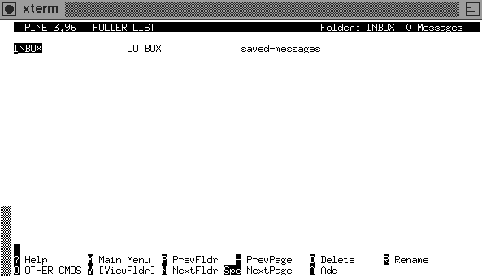
- To view the next or previous mail in the folder, press 'n' or 'p' respectively.
- To return back to the List of Folders, press 'l'.
- To return back to the Main Menu, press 'm'.

How To View File Attachments In Mails
Press 'V' to view, and 'E' to exit the attachment viewer.

Page 32

How To Save Mails
After viewing your mail, here's how to save them:
- Press 's' to save
- You will be asked to save it in a (separate) folder. Type in the name of the destination folder
- If it does not exist, you will be asked if you want to create it. Press 'y' to agree, 'n' otherwise

How To Save Mails Into Files (Export)
To save a mail as a file in a directory (instead of a folder in Pine),
- Press 'e' to Export
- You will be asked for a filename. Key in a filename relative to your home directory.

Page 33

How To Mail Someone
- Select 'Compose Message' from the Main Menu
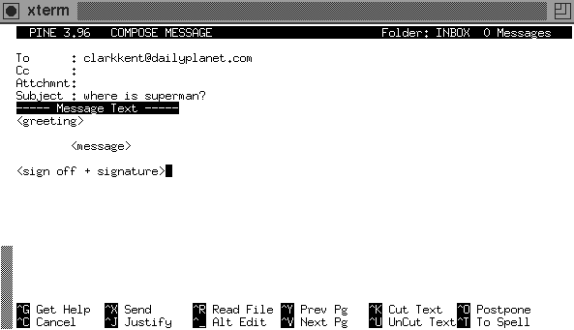
- You will see 4 fields:
- 'To:' field: key in the email address of the recipient(s) here
- 'Cc:' field: key in the email address of secondary recipients (optional)
- 'Attchmnt' field: to attach a file (see later)
- 'Subject' field: A brief description of your mail
- Type in your message in the pico-like text editor
- To send, press CTRL-X

How To Reply A Mail
After reading a mail and you want to reply to it,
- press 'r' to Reply,
- If there are more than one recipient in the mail, you will be asked if you wish to reply to everybody. Press 'y' if you wish to do so, 'n' otherwise

Page 34

- You will be asked if you wish to include the original message. Press 'y' if you wish to do so, 'n' otherwise
- Type in your reply, and press CTRL-X to send.

How To Forward A Mail
- After reading a mail and you wish to send a copy to somebody else,
- Press 'f' to Forward
- Type in the email address of the recipient(s)
- Type in a message if you wish
- Press CTRL-X to send

How To Add In Contents From A File
- When you are typing your mail,
- Press CTRL-R and you will be asked for a filename
- Type in the filename relative to your home directory, or
- Press CTRL-T for a list of directories/files.

How To Attach A File Separated From The Mail
- In the 'Attachment' Field,
- Enter the filename relative to your home directory, or
- Press CTRL-T for a list of directories/files

How To Delete/Undelete A Mail
- You can:
- Press 'd' when you are viewing the mail, or
- Press 'd' when you are viewing a listing of mails in the folder
- To undelete a mail, press 'u' instead.

Page 35

- When exiting Pine, you will be asked if you wish to 'Expunge' deleted mails in a particular folder. By Expunging, you will not be able to undelete the mails marked for deletion. Press 'y' if you wish to do so, or press 'n' otherwise.

How To Use The Address Book
- You may wish to store the addresses of people you mail often, and so the next time you mail them, you can type in a nickname that represents that group of people.
- Press 'T' while reading your mail. A list of addresses that appears in the mail will be displayed
- Mark those that you wish to add in your address book. One way is to press 'l', then press 'x' to mark the boxes besides the address.
- Press 'T' when finished marking
- You will be asked to enter a nickname for this group of addresses. Add in any additional information. Press CTRL-X to save and exit
- The next time you want to email this group of people, you can just type in the nickname instead of the individual addresses.
- You can also store addresses manually by selecting 'Address Book' from the Main Menu. You can add a list of addresses to an existing nickname by pressing 'A'.

How To Add A Signature Line(s) To Outgoing Mail
Usually, you will like to sign off your mail with 'Best Regards' and the likes, together with any additonal information you will like the recipient(s) to know (like homepage URL etc).

Do the following with any text editor:

- Create a file called .signature (note the dot)
- The contents of the above file should contain your signature line(s) - please limit your signature to 8 lines.

Page 36
- Thus whenever you compose or reply to a mail, your signature line(s) will automatically appear.

How Do I Get Out of pico?
- Press “Q” to exit to UNIX prompt.

Others
There are some other soft wares available for checking mail as well. “Mutt” is one that works on UNIX platform. “Outlook Express” can also be used to retrieve mails from the SoC account. Please refer to the section on Dialup Services for the settings of mail servers.

Page 37

NEWS

BBS

General

“BBS can eat or not?”
BBS stands for Bulletin Board System, which is like a notice board where anyone can post questions on relevant topics and anyone can answer them. However, there are rules and regulations to adhere to and "newbies" are advised to read one of the folders, soc.rules (formerly iscs.rules), first to familiarize themselves with some basic netiquette. The scope of topics in the BBS ranges from academic to entertainment.

How To Invoke BBS
Type 'bbs' at the prompt
That's it!

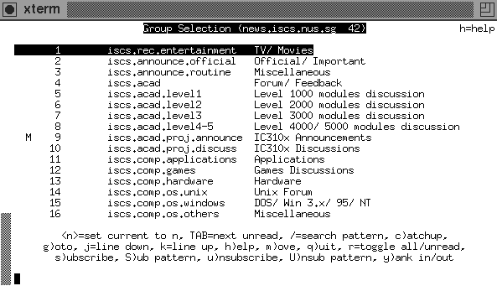
(Ed. Note: The actual BBS screen may look a little different, as the folder names have been changed on 1 July 2000.)

Page 38

- There should be 4 fields on your screen.
- Folder Number
- Number of Articles (including follow-ups) posted in the folder
- Name of the Folder
- A Description of the Subject Covered by the Folder

- Help is available by pressing 'h'.

How To View Articles
There are many ways to navigate in the BBS; the most common is using the arrow keys.
- UP/DOWN - to select a folder
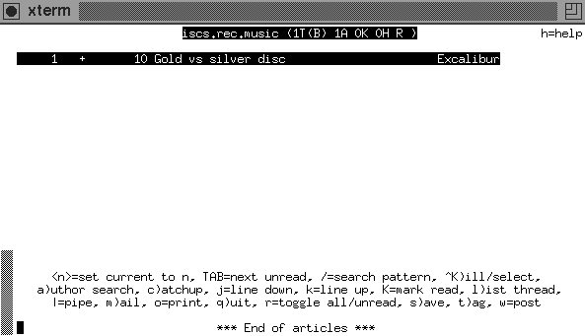
- RIGHT/LEFT - to go into/out of a folder

Page 39

When a folder is selected, you will see a list of threads with 6 fields:
- Thread Number
- If there is a '+' sign, this means that there are articles in the thread that are not yet read
- The Number of Articles in the thread
- Length (in lines) in the Article which is not read
- Name of Thread
- Name of Person who posted the article
Again, you can use the arrow keys to navigate through the threads, and to select the article which you wish to view.

Summary : Select Folder → Select Thread → Select Article

How To Post (A New Thread) In BBS
- Select the *relevant* folder which you want to post. (so your intended readers get to read your articles, and not someone else who isn't interested in what you have to say) Newbies are strongly encouraged to experiment in the folder soc.test
- Press 'w' to Post,
- Type in the Subject of your posting
- Type in your article in the text editor which is automatically invoked.
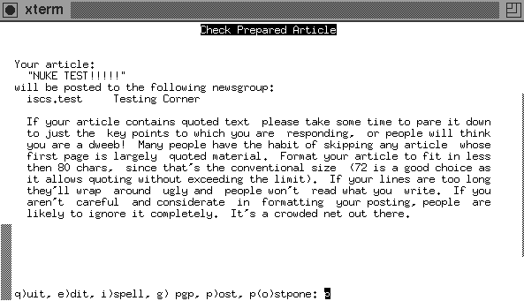
Page 40

- When you have finished, exit the text editor. You will be asked to q)uit, e)dit, i)spell, g)pgp, p)ost, or p(o)stpone. To post, press P or the Enter Key.
- To view the article you just posted, you have to exit the folder first.

How To Follow Up As A Response To An Article
- Select the article which you wish to follow up
- There are 2 ways to follow up:
- to include contents from the followed up article: Press 'f'
- to exclude contents from the followed up article: Press 'F'
- Perform Steps 4-5 as above

How To Reply To The Author
- You may wish to make a reply to the author of an article only, instead of "making a statement" in the bbs.
- Select the article which you wish to reply to the author
- There are 2 kinds of replies:
- to include the article contents in your letter: Press 'r'
- to exclude the article contents in your letter: Press 'R'
- Type in your letter in the text editor
- When you are finished, exit the text editor.
- You will be prompted to q)uit, e)dit, i)spell, g)pgp, s)end.
- To send your letter, Press 's' or the Enter Key.

How To Delete an Article
- If you accidentally posted an article when you don't intend to, you can delete the posting as follows:
- Select the article which you wish to delete
- Press the 'D' key. The article will be deleted from the BBS
- Note that you can only delete your own posting.

Page 41

How To Change Your Name, Organization & Editor For BBS
- In your home directory, there is a .profile file. You will need to add the following in that file:
export EDITOR=XXXXX
export NAME="<whatever name>"
export ORGANIZATION="<whatever place>"
where XXXXX is your choice of a text editor (vi, vim, pico, joe, emacs etc).
Do note, in particular, that if you change your name or organization, be very careful as to your new name choice. Do lurk around the BBS to find out which names have already been taken, and avoid names that look too similar to any of these. You’ll feel terrible if you found out someone used your name. So, do see what names your seniors have already taken, and don’t use them!

Page 42

Common Mistakes

Check the soc.rules folder to familiarize with the common rules. In addition to those in soc.rules, here are some common mistakes made by BBS posters:

- Post in a wrong folder.
Mistakenly post a message to an inappropriate folder. For example, you have some queries on the ECA system. You have posted this message to soc.acad (It should actually have been soc.clubs-n-societies), use “shift + d” to delete the message as soon as possible.

- Post an empty message.
If you mistakenly post an empty message on a folder, before receiving any warnings from the system administrator, use “shift + d” to delete it.

- Etiquette.
When you post a new message into a folder (not to follow up others’ messages), the first line should be some simple greetings, such as “Hello,” and “Hi,”, then write your message on the next blank line.

- Follow up useless messages
When following up messages, in the new posting, keep those previously posted message lines that are convenient for your need and delete the rest away, for the sake of easy reading.

Page 43

Outlook Express

Outlook Express can be configured to retrieve the news from the SoC server to the desktop. Please refer to the section on the dialup services for further details.

PINE
Pine can also be used to read news. From the Main Menu, choose L (for list of folders) and then select “News from SoC newsgroups”.

FTP

FTP or file transfer protocol allows transferring of files from one system to another through a network. FTP works as a client/server process. The ftp command running on your system is the client to an FTP process that acts as server on a remote address.

File transfer can be done through the windows based WS_FTP software, or by running the ftp command at the DOS prompt. Several other software packages that facilitate FTP are also available.

WS_FTP
WS_FTP is a file transferring software that is easy to use and adds convenience to the use of the SoC UNIX accounts on the SUN machines. It can be window-shopped from the NUSNET III or downloaded from the NUS Intranet I-drive.

Page 44

Logging on
On double clicking the WS_FTP icon, a Session Properties window appears on which the username and password that are recognized by the remote server have to be entered. This is to authenticate the file transfer process. This window disappears once you are logged on, but can be accessed at any time by clicking on the Connect button at the bottom of the FTP window.

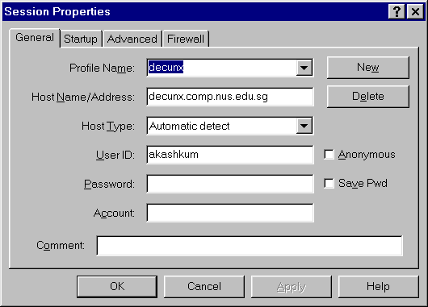

Page 45

For transferring files to or from the SoC servers, on the Session Properties/General window:
- Type in any reference name for the remote host or profile in the Profile Name field.
- In the Host Name/Address field, type in the remote server address:
- E.g. decunx.comp.nus.edu.sg
- Select Host Type to be Automatic Detect.
- Type in your SoC user id in the User Id field and click OK or press Enter.
- A new window for entering the password appears. Type in your password and click OK.

The logging on process is now complete and you will see the WS_FTP screen, with the contents of the local directory on the left and the remote home directory on the right. All the instructions executed through the FTP software are shown on a log window below the directory listings on the FTP screen. The contents of the log window can be viewed by scrolling or by clicking the LogWnd button at the bottom of the FTP screen.

Changing directory for file transfer
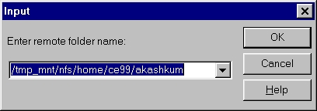
The working directory can be changed by clicking on the Change Directory tab on whichever side the directory needs to be changed, i.e., either on the left for changing the local directory, or on the right for the remote directory.
Page 46

A window for changing directory appears as shown on the following page. Type in the desired directory path and click OK or press Enter.

There are links to the other main drives of the system below the contents listing of the working directory. These can be directly accessed by double clicking them.
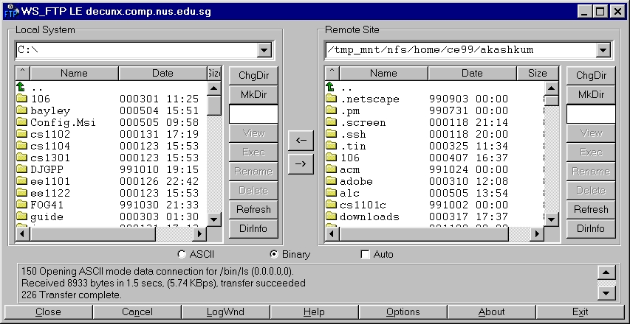

Transferring files
Before transferring files, set the transfer mode to either Binary or ASCII mode. This is done by checking the appropriate circle at the bottom of the FTP window. Binary mode is suitable when the file contains non-text data, such as images and movies. (Word and Excel documents are also considered non-text data). ASCII mode is recommended when the file is text based.

Page 47

To transfer a file from the local directory to the remote directory or vice versa, do either of the following:
- Double-click the filename on the FTP screen, (OR)

- Click on the desired filename and then press the appropriate arrow key between the local and remote directory listings. (Refer figure 2)

The file transfer process will be displayed as it takes place and the time taken, transfer speed and size of the file transferred will be displayed on completion.

Other utilities on WS_FTP
Other than transferring files, FTP can also be used to make new directories, rename or delete files on the remote server or on the local workstation. For instance, to delete a file on the remote system just log on, click on the required file and click on the Delete button next to the directory listing on the FTP screen.
Thus WS_FTP allows complete access and control over files on a remote host.

To exit the FTP session, just click on the Exit button at the bottom of the FTP screen. This will log you off from the remote server and close the FTP window.

DOS FTP
The ftp command can also be run on DOS to facilitate file transfer. This command on DOS is similar in use and syntax to the same command in UNIX.

Just type ftp at the DOS prompt followed by the address of the remote host.
E.g. C:\> ftp decunx.comp.nus.edu.sg

Page 48

Once connection to the remote host is established and you are logged on to the host, you are ready to start transferring files.

There are many commands under ftp that facilitate file transfer and file access at the remote host. The commands are typed in at the ftp prompt. Some of the basic commands are as follows:
- ls – This command is used to view the directory listing on the remote host.
2. cd – This command is used to change directory at the remote host.
3. lcd – This command is used to change the working directory on the local system.
4. get – This command is used to get the required file from the remote to the local system.
E.g. get abc.xyz will get the file abc.xyz from the remote working directory and store it into the local directory.
5. put – This command is used to transfer a file from the local system directory to the remote host working directory.

Commands like delete, dir, open, type, rename, rmdir etc. work on the remote host files. The corresponding commands for delete and dir on the local system are mdelete and mdir. Help on ftp can be obtained using the command help for the local system and remotehelp for the remote host. Commands binary and ascii are used to choose the respective mode of transfer of data.

The user (for user id) and pwd (for password) commands are used to log on to the remote server. To exit the DOS ftp session, just type bye or quit at the prompt.

When in doubt, type help or help <command> for more details on the various FTP commands.

Page 49

Java Programming Language
+---------+  +---+-->| EDIT |  | ^ +---------+  | | |  | | |  | | v  | | +---------+  | +---| COMPILE |  | +---------+  | |  | |  | v  | +---------+  +-------| RUN |  +---------+ | - Use an editor of your choice, type in the source code (filename must have extension .java, eg: inventory.java)
 | - Compile your program to obtain the object file (with extension .class) by using the javac Java compiler. If there are compilation errors, identify them and re-edit the source code before you proceed.
- Run your Java object file (default file extension .class) using the java command).
decunx:~/java0[xxx]$ java inventory

Compiling and Executing a Java Program

Setting up your Account
Enter the command pwd to print the current working directory. What is shown following the command is your home directory.
Enter mkdir java_program to create the directory java_program to store files used or created during the laboratory session.
Enter cd java_program to change the current diretory to java_program.
Create one subdirectory of each laboratory session by entering mkdir labnn for nn = 01, 02, to 16.

Running a Java Program
The process of creating a working Java program involves the following steps:
If there are run-time errors, you must identify them and re-edit the source code, and compile again.

A sample Java program
A sample Java program has been copied into your "java0" subdirectory. Use "cat" to view the program.

tanhappy@decunx:~[xxx]$ cd java0
tanhappy@decunx:~/java0[xxx]$ cat square.java

import java.io.*;
class square {

public static void main(String arg[])
throws IOException {
int n;

BufferedReader stdin = new BufferedReader
(new InputStreamReader (System.in));

Page 50

System.out.print ("Enter the number to be squared: ");
n = Integer.parseInt (stdin.readLine());
System.out.print("You typed in ");
System.out.println(n);
System.out.println();
System.out.println("The square of " + n + " is " + Math.pow(n,2));
}
}

Compile and run the program as follows:

tanhappy@decunx:~/java0[xxx]$ javac square.java

(this will compile square.java and produce the byte code file square.class)

tanhappy@decunx:~/java0[xxx]$ java square
(this will execute the byte code file square.class)

Page 51

Creating your own Java Program

Create your first Java program "first.java"
There are a number of editors available in decunx: vim, vi, emacs, joe, pico, etc. Some are more powerful than others, but take a longer time to learn. For this lab, you will use the simplest editor of all -- pico. It is YOUR responsibility to pick an editor and master it, and in future labs we will assume that you are familiar with your editor and its various functions.
Get into your java0 subdirectory if you are not there. Enter "pico first.java" and type in the following program:

class MyProgram {
public static void main (String [] args) {
System.out.println(“It is my first Java Program.”);
System.out.println(“Amazing, isn’t it?”);
}//end main
}//end class

When you are done, enter ctrl-x to exit from the pico editor. You will be asked to save the buffer. Type Y for yes and hit the [RETURN] key when the filename first.java appears (if you forgot to type in the filename first.java when you invoked pico earlier on, you must type it now).

Compile and run your program
tanhappy@decunx:~/java0[xxx]$ javac MyProgram.java

There will be error messages if your program has errors. Go to Step 7.1 to make the necessary corrections and re-compile. If there are no compilation errors, proceed with program execution as follows:

tanhappy@decunx:~/java0[xxx]$ java MyProgram

Page 52

Another program
Use the instructions above to create, compile and run the following program Age.java. What is the output of the program?

import java.io.*;
class Age {

public static void main(String arg[]) throws IOException {
int year;
BufferedReader stdin = new BufferedReader
(new InputStreamReader (System.in));

System.out.println ("Enter the year when you were born: ");
year = Integer.parseInt (stdin.readLine());
int age=2000-year;

System.out.println ("You are now "+age+" years old. " );
}
}

The above program uses Integer.parseInt to convert a String to int so that we can do calculation on the input.

Java Development Kit

JDK, the java development kit, is a set of programs and packages designed to support the development of java programs. It can be installed on UNIX platform or MS-DOS.

For most of our lab assignments in CS1101 (Programming Methodology), we would be using the MS-DOS environment. This means that we'll be using a compiler called Java Development Kit (JDK) to compile and run our programs.

Most of the machines in our Programming Labs on S15 Level 2, have already been pre-installed with JDK.

Page 53

1. Open a new notepad from your computer by going
Start menu -> Programs -> Accessories -> Notepad

2. For illustration purposes, type the following program :

class first {
public static void main(String arg[]) {
System.out.print ("Hello World");
System.out.println ("My first program works !");
}
}

3. Go to File -> Save As... -> (select an appropriate directory) ->
File Name: first.java -> Save as type: All file (*.*)
4. From the Start menu, open up the program MS-DOS Prompt.
5. Depending on which directory your JDK has been previously saved and what version of JDK your computer is using, type:
set path=%path%;C:\jdk1.2\bin
6. Go to the directory you've saved your first.java.
7. To compile your program, first.java, type javac first.java.
8. To run your program, first.java, type java first.

That's all! Have fun!!

Page 54

Other Softwares for Developing Java Applications:

KAWA: simple yet powerful
KAWA is an IDE (Integrated Development Environment) to build Java applications and applets on Win32 machines. KAWA supports Windows 95, Windows 98 and NT 4.0 platforms. We are serving the Java community since 1996 with some powerful tools and are committed to releasing stable and intuitive products.

KAWA is the most preferred Java development tool for individuals and companies committed to doing 100% pure Java development.

KAWA provides a powerful, easy to use and intuitive environment for Java development. KAWA is a wrapper on Sun's JDK and therefore 100% compatible with any JDK version. (1.0.X - 1.3 beta)

For more information about KAWA, please visit our Web site at: http:\\www.tek-tools.com\kawa

JAVA WORKSHOP

Java WorkShopTM software is a powerful, visual development tool for professional programmers using JavaTM technology. It offers a complete, easy-to-use toolset for building Java technology-based applets and applications and components based on the JavaBeansTM architecture quickly and easily.

Java WorkShop 3.0.6 Community Edition binary code is currently available for free for use by developers.

You can download any of the following: http://www.sun.com/workshop/java/

Page 55

Dialup Services

Overview
There are altogether 216 dialup lines available for staff and students of SoC. Some of the dialup lines connect to terminal servers. This section of the guide deals with what to do when you are at the terminal screen.
Upon dialing in, you will be presented with a user-friendly menu via which you can:
- Choose to telnet to our various workstations
- Activate SLIP or PPP mode.
- Read information and tips on dialup usage
Phone Numbers  8745356  8745357  8721547  8721548  8736377  8737906 | Domain  comp.nus.edu.sg  Domain Nameservers  137.132.94.2  137.132.87.2  News Server  news.ex.nus.edu.sg  (authentication using NT account and password) | POP Mail Server  stupophost.comp.nus.edu.sg  SMTP Server  stumailhost.comp.nus.edu.sg  SoC BBS  news.comp.nus.edu.sg  Proxy Server  http://proxy.nus.edu.sg:8080

Some Important Information
# These dialup lines connect to terminal servers.

Page 56

Setting up PPP connection in Microsoft Windows 95/98

Configuration
- Go to the control panel folder in your PC
- Click the Network icon
- Make sure that the proper network components are installed (TCP/IP)
- If not click the add button to install them. *

* for details on installing network components please refer to the following hyperlink:
http://www.comp.nus.edu.sg/cf/nw/win95ppp.html

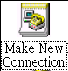
Making a New Connection
- Go to the Dialup Networking Directory
- Double click on the Make New Connection icon
- Go through the series of 3 screens
- Enter the appropriate info and click next on each of the screen

Page 57

- Enter any name you like, choose your modem and click next.
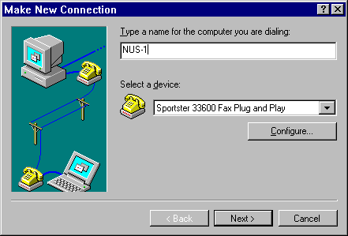
- Enter the phone number and click next.
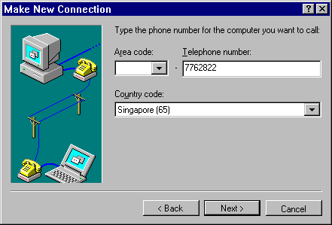
- Click Finished

Page 58

Page 59

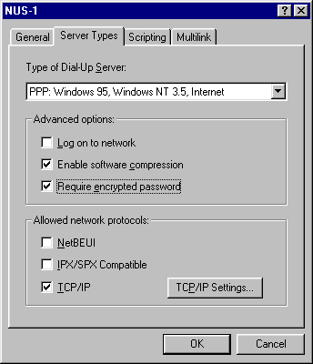
Configuring the Connection
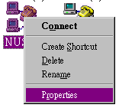
- Right-click the new icon created and select 'Properties'

- Select 'Configure' and followed by
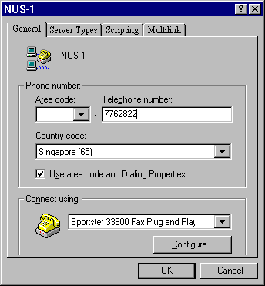

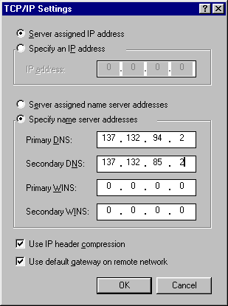

- Uncheck ‘Use area code and Dialing Properties’

- Click on the "Server Types" tab and fill in the server name and addresses, make sure the appropriate boxes are checked / unchecked.

Page 60

Page 61

I'm Ready to Dial!
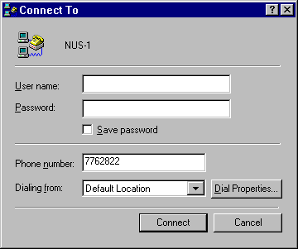
- Double click on the new icon you've just created and fill in your userid and password.

- Check Save Password and click the "connect" button.

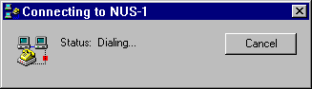

Page 62

Dialup Services for Other Systems
- Use any communication program, eg Telix, Qmodem, Hyperterminal…etc (usually comes with your modem), dial to one of the numbers in "Important Information"
- Hit "Enter" and key in your user-id and password.
- 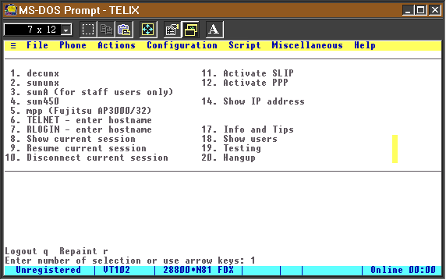At the main menu, choose the corresponding system.

Page 63

MISCELLANEOUS

SPNP

What is SPnP?

SPnP is the acronym for Secure Plug and Play. SPnP connection is a live network point that allows NUS staff and students with their notebook computers to gain access to the NUSNET & Intranet services on campus.
For more details on Secure Plug and Play, please refer to the following hyperlink:
http://www.nus.edu.sg/global/1999/fpnp.htm

Windows 2000 Network Configuration for SPNP

If you are using Windows 2000 Professional, here are some instructions for you to setup the network access via SPNP in campus.

- In case you only want to use the network instead of your H: and I: drive, as well as Windows Shopping and NUSNET III Printer Selection, every time you can logon as the Administrator. After you enter Windows, open your browser, IE or Netscape, go to
http://pnp.nus.edu.sg/ or
http://spnp.nus.edu.sg/

Use your userid and password to logon to the network.

Page 64

However, there are some limitations. For example, every time you want to open a computer in My Network Place, you have to provide your NUSNET userid and password. i.e.
Connect As: nusstu\(your userid)
Password: (your password)

- If you want to fully utilize your NUSNET account, such as the H: and I: drive, as well as nuscast TV programs, you have to logon as a member in the domain NUSSTU.
This is how you can do:
- Send an email to Computer Center, tell them your computer’s name.
- After they reply your email, confirming your computer has been registered, then right mouse click on My Computer icon, Properties, choose Network Identification tag, click on Properties, choose Domain, change it to NUSSTU. Click on OK, and reboot your computer.
- After the window prompting you enter the password to logon appears, click on button Options, change the Domain to NUSSTU, then you can connect use your userid and password.

Page 65

Setting up your Home Page

You can set up your own WWW (World-wide Web) pages through your SoC UNIX account and serve them through the SOC server at:

http://www.comp.nus.edu.sg/~userid

Know the basics of HTML

You can get the basic information on HTML from the following URL. Use a WWW browser (e.g. lynx, Mosaic, Netscape, IE) to access the website.
http://www.ncsa.uiuc.edu/General/Internet/WWW/HTMLPrimer.html
Read the following documents (in PostScript), either via ghostview/ghostscript or by printing to a postscript printer:

/usr/local/doc/www/html-primer.ps
html+.ps
url-primer.ps

A tutorial on HTML can be found on the lynx help files. Just run lynx and press h for help.

Set up your WWW directory and files.
- Create a subdirectory ~/public_html
$ mkdir ~/public_html

- Create a file named index.html under your ~/public_html subdirectory, using any editor or html authoring tool.
This is the first file that is automatically served when someone connects to your home page. Build up the necessary links in your home page to point to your other pages.

Page 66

Set up the correct permission for your directories/files.

- Make the path to your home page world executable, so that it is accessible from anywhere on the net.
From the root of your home directory downwards through your ~/public_html and any subdirectories, give x access on all these directories:
(drwx--x--x)

$ chmod a+x ~/

e.g. chmod 711 ~/
chmod 711 ~/public_html
chmod 711 ~/public_html/subdir

- Make your web pages readable.
This includes readable access to index.html and all other html files, image files etc. that you want to serve. Give r access for all those files:
(-rw-r--r--)
$ chmod a+r ~/

e.g. chmod 644 ~/public_html/index.html
chmod 644 ~/public_html/other-files

If you have a link to an image called "myself.jpg" in index.html, change directory to public.html or its relevant subdirectory, and then type:
$ chmod a+r myself.jpg

NOTE: Setting the correct file permissions is VERY IMPORTANT. Incorrect setting will allow others to hack into your files or prevent them from accessing them altogether.

Page 67

To verify permission settings

Verify your permission settings using the following UNIX commands:
$ cd ~/public_html
$ ls –la
You should see something like:
drwx--x--x 10 akashkum ce99 8192 Jun 16 14:50 .
drwx--x--x 41 akashkum ce99 8192 Aug 3 13:20 ..
-rw-r--r-- 1 akashkum ce99 1021 Feb 8 13:46 index.html
Note that it is --x--x for directories; "." and "..", and r--r-- for normal files like index.html.
Now you have a global web presence! Your home page is accessible at:
http://www.comp.nus.edu.sg/~userid

Test things out

Use a WWW browser to access your home page using the URL format mentioned above. If you encounter "Permission denied" errors, check the permission of your WWW directories and files.

Setting Up A Page Counter
- Include the line below in the html file you want the page counter to be in:
<!--#exec cgi="/cgi-bin/pagecount"-->
- Login to sununx (not other hosts). This is extremely important as no other hosts will work.

Page 68

- At the prompt, type:
/usr/local/etc/httpd/cgi-bin/pagecount -h www.comp.nus.edu.sg <target-file>
Here <target-file> is the file you want to log on to, e.g. index.html
NOTE: ‘man pagecount’ (on sununx) for more details and options.

What to do when your profile storage space is exceeded?

Checking to see if you have exceeded your profile storage space

- Please logon to your NUSSTU account.
- Then click on the Start Menu -> Programs -> Windows NT Explorer.
- Now, go to this directory C:\ Winnt \ Profiles.
- Look for the folder of your userid (eg. isc12345)
- Highlight this folder by left-clicking it with your mouse button once.
- Right-click your mouse button once and a little pop-up menu will appear. Select the option “Properties”.

If the “Size” of the folder is below 2 MB, you may choose to do nothing.
Otherwise, if this “Size” of the folder is above 2 MB, it means that you have exceeded your profile storage space, and deletion of some of your files is required.

Page 69

Here is how to go about removing some of the unnecessary files inside your profile storage space.

- Go back to your userid (eg. isc12345) folder by following the instructions as stated above.
- Double-click this folder with your left mouse button, to see an expansion of the contents inside your userid folder.
- Look for the following sub-folders and delete all the file contents inside.
- Temporary Internet Files
- History
- Check your profile storage space again to see if your profile storage space still exceeds 2 MB. Proceed to step 5 if more deletion of files is required.
- In the midst of removing the unwanted contents of your userid folder, you may like to transfer some of the files to H:\isc12345 (replace 12345 with your 5-digit userid numbers) instead.

Here is how you can also go about preventing your profile storage space from being exceeded

For Microsoft Internet Explorer (Version 4.0 and above)
- Double click the icon on the desktop of the Internet Explorer to open the program.
- Go to Tools -> Internet Options…
- Under the “General” tab, select Settings -> Move Folder…
- Change the directory to C:\ temp
- Press OK and save the changes.

Page 70

For Netscape Communicator (Version 4.5 and above)
- Double click the icon on the desktop of the Netscape Communicator to open the
Program.
- Go to Edit -> Preferences…
- On the left column of the page, click once on the ‘+’ sign beside the Advanced option.
- Click once on the option “Cache”.
- On the right side of the page, change the Disk Cache Folder to C:\ temp.
- Press OK and save the changes.

Upon realizing that your profile storage space has been exceeded, you may also choose to:
Send an email to the NUS Computer Centre at ccehelp@nus.edu.sg, and request them to reset your profile for you.

*Note: Remember to backup an additional copy of your important documents, before you send this request.

Page 71

UNIX Commands

QUICK REFERENCE

COMMAND | DESCRIPTION
alias [alias-term=["command-string"]] | Allows the entering of shorter or easy-to-remember names to execute longer or hard-to-remember commands.
at [-m] time [date] | Schedules a command to run at a particular time.
bc | A program to evaluate mathematical equations.
bg [job] | Continues a stopped job in the background.
cal [month] [year] | Displays calendar
cat [filename] | Displays the contents of the file named by filename.
cd [directory] | Change to another directory. Entering cd without the directory argument will move you to your home directory.
chmod permissions path | Changes the access permission associated with a file or directory
chown username path | Changes the ownership of the file or directory, path, to user username.
cp file1 file2 | Creates an identical copy of the file1, and names the copy file2. Note that the ownership of file2 will be set to whoever does the cp command.
date | Displays the current date and time.
diff file1 file2 | Compares the contents of two text files and displays the differences. The lines preceded with < are from file1. The lines preceded by > are from file2. Each section of differences is separated by ---.
du options | The du command summarizes disk usage. du entered on the command line with no options will return the size of all the directories beneath the current working directory
exit | Terminates the current UNIX shell.
fg | Continues a stopped job by running it in the foreground
finger -m user | Displays information about user accounts.
ftp | Connects to another computer to either get a file(s) from the remote machine or to put a file(s) onto a remote machine.
grep pattern file | Searches one or more files, specified by file, for the text string specified by pattern.
head file | Displays the first few lines of a file
jobs | Lists the jobs that are running in either the foreground or the background, and the jobs that are stopped.
kill [-9] pid | Terminates the process with the id-number pid.
less file | Displays the contents of the text file file a screenful at a time.
logout | Terminates the current UNIX session and log out of the system.
ls pattern | Lists the files and directories in a directory.
man command | Displays the standard UNIX manual page for the command you specify.
mkdir dir | creates a new directory named dir.
more file | Displays the contents of the text file file a screenful at a time
mv name1 name2 | Moves and/or renames the file or directory, name1 to name2.
passwd | Changes your UNIX login password
ps | Displays a list of the processes currently running on the machine that you are logged into.
pwd | Displays the full path of your current working directory.
rm file | Removes the file file permanently from the filesystem. Note that deletion cannot be undone.
rmdir dir | Deletes the empty subdirectory dir.
talk user | Allows you to communicate with another user using your terminal.
tail file | Lists the last few lines of file.
telnet address | Logs into another machine specified by address.
wc file | Counts the number of words or characters and lines in file.
who | Displays a list of who is logged on to the system and where they are logged on from

Interesting Unix Commands

Here are many other commands you may find more interesting.

COMMAND | DESCRIPTION
spy | Spy allows you to spy on the intended persons that you want to spy on. (Rather than the “who” command which will display all the logged on users) The userids & names of these people are stored in the file “name.dat” and the program will read and display from the file. This program will identify the userids, names, locations that the specified users are logged on to, in the same server.
spy2 | Spy2 is another version of spy, just that it displays only the task that the intended people who are logged on instead of displaying the location as in spy.
chat [userid] | Chat allows two persons who are logged on, to chat on the same server. It will bring out a chat interface for user to key in the dialogue. The recipient will receive a pop out message with name and userid from the user. It will require the user to know if the other party is logged on too, using spy or who. Then the user can initiate the chat and the other party must respond accordingly, otherwise, the chat will be one way.  Chat is in essence a user-to-user communication program. It allows you to send messages to another user a line at a time. Normally, establishing a talk connection might take quite a while and if you just need to say a few words to your friend, it will be quite meaningless to wait for such a talk connection.
write [userid] | The write command allows you to converse with another user who is logged in.  When using write, there is a possibility of the other party typing on the same line as you are. You have to wait for the other party to finish typing before you can start typing.
ytalk [userid userid] | YTalk is in essence a multi-user chat program. It works almost exactly like the UNIX talk program and even communicates with the same talk daemon(s), but YTalk allows for multiple connections.
mesg n/y | “mesg” is to reject messages. “mesg y” is to grant messages.
screen | Screen is a full-screen window manager that multiplexes a physical terminal between several processes (typically interactive shells). Each virtual terminal provides the functions of a DEC VT100 terminal and, in addition, several control functions from the ANSI X3.64 (ISO 6429) and ISO 2022 standards (e.g. insert/delete line and support for multiple character sets). There is a scroll back history buffer for each virtual terminal and a copy-and-paste mechanism that allows moving text regions between windows.  When screen is called, it creates a single window with a shell in it (or the specified command) and then gets out of your way so that you can use the program as you normally would. Then, at any time, you can create new (full-screen) windows with other programs in them (including more shells), kill existing windows, view a list of windows, turn output logging on and off, copy-and-paste text between windows, view the scrollback history, switch between windows in whatever manner you wish, etc. When a program terminates, screen (per default) kills the window that contained it. If this window was in the foreground, the display switches to the previous window; if none are left, screen exits.
photofinger [userid] | Displays the photo of a user with finger information. (photofinger is a program that displays the photo of a user(s) in addition to the usual finger information.) Photos can only be displayed on X window.
staff [staffid] | Allows you to search for another staff's email address, office number, telephone number and other particulars.
w [userid] | Display information about currently logged-in users. What each user is doing, The fields displayed are: the user's login name, the name of the tty the user is on, the time of day the user logged on (in hours minutes), the idle time-that is, the number of minutes since the user last typed anything (in hours & minutes), the CPU time used by all processes and their children on that terminal (in minutes:seconds), the CPU time used by the currently active processes (in minutes:seconds), and the name and arguments of the current process.
pilot | Unix browser that allows you to browse the files in your directories like in the window explorer/ Norton nc.
banner [any string] | A command helps you to get the enlarged view of the string you entered after it.
micq | A more convenient and useful communication tool in Unix than chat and talk. Enter this command, then your PIN and password. Then you can exchange messages with your friends.

