CHAPTER
4

COMMUNICATION

In this chapter you will learn about

- How to use pine, an e-mail program, to send e-mails to other users, and read e-mails from them.
- How to use the BBS, an electronic bulletin board, to participate in forum discussion.
- How to browse web pages.

4.1 Introduction
No man is an island, some wise guy once said. Indeed, we spend most of our waking hours communicating with other people. Academically, we communicate to disseminate information, compare notes, and exchange ideas. Socially, we communicate to build rapport, enhance relation, and to satisfy our psychological needs.
With the advent of technology in the arena of communication, we have witnessed walls crumbled, distance crushed, and cost cut. Telecommunication gadgets like facsimile machines, modems and mobile phones have assimilated into our working and social life. On the information technology front, electronic mails, bulletin board, and the World Wide Web, which has now attained the status of ubiquity, serve our communication needs at various level of intimacy, from personal to communal to inter-continental.
And these will be our subjects of study in this chapter. To all in the School, these are important knowledge for survival, pardon the justified exaggeration. How could it not be so, with the University’s endorsement and push for the ‘global campus’ concept that attempts to exploit information technology to its fullest? How could it not be so, when your lecturers and tutors are sending electronic mails to you, posting important announcements on the bulletin board, and updating their course material on their web pages, all at regular or frequent intervals?
So, here we go.

4.2 An E-mail Program: pine
A computing student or staff member easily receives over 50 e-mails (electronic mails) a day during peak seasons, and for those who subscribe to newsgroups, certainly a lot more. Even on a typical day, it is rare to get less than 10 e-mails a day for most people. Lecturers and tutors use e-mails to pass information to their students. Even administration sometimes relies on e-mails to contact students. Because of the importance and heavy reliance of this form of communication, members of this community are expected, as an unwritten rule, to check their mailbox regularly at a reasonable frequency, preferably once a day. Around here, when a person sends an e-mail and expects a reply, but receives none within two days, anxiety will start to set in.. This is why it is customary, and in good gesture, for a person who cannot reach his mailbox for an extended period, to use the vacation program to notify others of his absence. Likewise, a person who has not been able to access his mailbox for a while may get nervous about the likelihood of missing out some important messages.
A check of mailbox a day keeps the worries away.
So much for story telling. We will now look at an e-mail system called pine. Another system is the elm, but it is not covered here. As usual, this is just a brief introduction. You must practise using it yourself.

The syntax is as follows:
pine [options] [address]
For example:
$ pine
$ pine –i opens the inbox
$ pine tantc compose a new e-mail to tantc

How to navigate?
You can use the arrow keys to scroll line by line, or the spacebar and the ‘–’ key to scroll by page. The key ^c is used to cancel any wrong request or command issued.

How to read mails?
- From the Main Menu, select Folder List and press Enter.
- A list of folders will be displayed. Select one of the folders and press Enter. Usually, new mails reside in your INBOX.
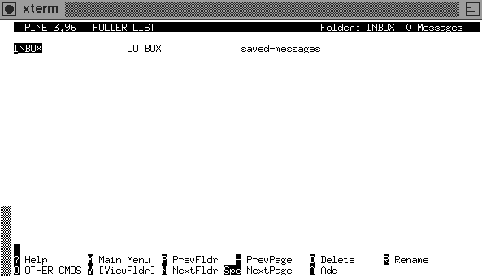
- A list of mails in the selected folder will be displayed. Select one in the list and press Enter.
- The content of the selected mail will be displayed.
- To view the next or previous mail in the folder, press ‘n’ or ‘p’ respectively.
- To return to the List of Folders, press ‘l’.
- To return to the Main Menu, press ‘m’.

How to view file attachments in a mail?
Press ‘v’ to view, and ‘e’ to exit the attachment viewer.

How to save mails?
After reading your mail, this is how to save it:
- Press ‘s’ to save.
- You will be asked to save it in a (separate) folder. Type in the name of the destination folder.
- If the folder does not exist, you will be asked if you want to create it. Press ‘y’ or ‘n’.

How to save mails into files (export)?
To save a mail as a file in a directory, instead of a folder in pine, do the following:
- Press ‘e’ to export.
- You will be asked for a filename. Key in a filename relative to your home directory.

How to send a mail?
- In the Main Menu, select Compose Message.
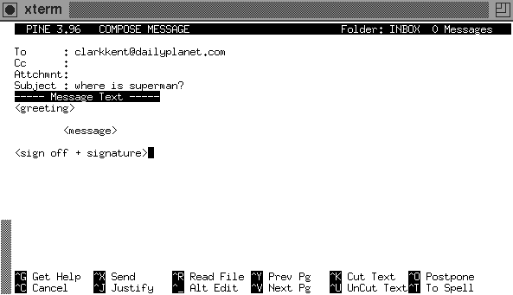
- You will see 4 fields:
- ‘To:’ field: type in the e-mail address(es) of the recipient(s) here
- ‘Cc:’ field: type in the e-mail address(es) of carbon copy recipient(s) (optional)
- ‘Attchmnt:’ field: type in name(s) of attached file(s) (optional) (see later)
- ‘Subject:’ field: type in a brief description of your mail
- Type in your message in the pico-like text editor.
- To send, press ^X.

How to reply a mail?
After reading a mail, you may want to respond to the sender.
- Press ‘r’ to reply.
- If there are more than one recipient in the original mail, you will be asked if you wish to reply to everybody. Press ‘y’ or ‘n’.
- You will be asked if you wish to include the original message. Press ‘y’ or ‘n’.
- Type in your reply.
- Press ^X to send.

How to forward a mail?
After reading a mail, you may want to send a copy of the message to somebody else.
- Press ‘f’ to forward.
- Type in the e-mail address(es) of the recipient(s).
- Type in a message if you wish.
- Press ^X to send.

How to insert content of another file?
While typing your message in the pico-like editor, you do the following:
- Press ^R to read in a file. You will be asked for a filename.
- Type in the filename relative to your home directory.
- Or press ^T for a list of directories and files.

How to attach a file in your mail?
In the ‘Attchmnt’ field:
- Enter the filename relative to your home directory.
- Or press ^T for a list of directories and files.
- Or press ^J and enter the filename.

How to delete/undelete a mail?
You can:
- Press ‘d’ when you are viewing the mail.
- Or press ‘d’ when you are viewing a listing of mails in the folder.
To undelete a mail, press ‘u’ instead.
When exiting pine, you will be asked if you wish to ‘expunge’ deleted mails in a particular folder. Press ‘y’ or ‘n’. Once a mail is expunged, you will not be able to undelete it.

How to use the address book?
You may wish to store the addresses of people you mail often, so that any time you want to send a mail to them, you can type in a nickname that represents that group of people.
- Press ‘t’ while reading your mail. A list of addresses that appear in the mail will be displayed.
- Mark those that you wish to add to your address book. One way is to press ‘l’, then press ‘x’ to mark the boxes beside the addresses.
- Press ‘t’ when done marking.
- You will be asked to enter a nickname for this group of addresses. Add in any additional information.
- Press ^X to save and exit.
The next time you want to e-mail this group of people, you can just type in the nickname.
You can also store addresses manually by selecting Address Book from the Main Menu. You can add a list of addresses to an existing nickname by pressing ‘a’.

How to add a signature to outgoing mails?
Usually, you would like to sign off your mail with ‘Best regards’ and the likes, together with any additional information you would like the recipients to know, such as your web site’s URL.
Do the following in any text editor:
- Create a file called .signature (note the dot) in your home directory.
- Enter your signature lines into this file.
Limit your signature to 8 lines, as the netiquette rule requires.
With this .signature file, when you compose or reply a mail, your signature will automatically be appended to your message.

How to get out of pine?
Press ‘q’ to exit pine and return to the UNIX prompt.

Mailing Groups
There are pre-defined mailing groups in our system. Some examples of mailing groups for staff are as follows: academic (academic staff), lecturer (lecturing staff), and ta (teaching assistants and senior tutors). man mailgroups for a complete list.
There are also course mailing lists for different groups of students and the various modules, to facilitate the lecturers’ job of sending e-mails to their class. Some examples are: comp1-l (first-year SoC students), ce98-l (CPE students matriculated in 1998), and cs1102-l (students taking CS1102 module). Students can subscribe to the course mailing lists. Again, man mailinglists for more information.
These mailing lists are accessible only to staff members, and authorised student representatives.

4.3 The Bulletin Board: bbs
The electronic BBS (bulletin board system) is a favourite talk-shop for our students. Whether you are a serious worker or a fun-loving person, you will find topics of your liking in the BBS. The range of topics swings from academic, food and entertainment, hobbies and sports, relationship and religions, social issues, to plain coffee-shop gossips. Basically, everything under the sun is discussed in there. The camaraderie of BBS life makes up part of the fond memories deeply missed by many of our graduates.
The draw of the BBS is its openness and high level of participation. It provides a public forum within the school community to get people together to share their points of view. A personal e-mail seeking help reaches only one or a few recipients, but a BBS posting invites everybody to pitch in to help. The responses are usually prompt and valuable. It is group dynamic in work.
For the “newbies”, before you jump onto the bandwagon and make your very first posting, you must first do these:
1. Read the iscs.rules folder to learn about rules and netiquettes on using the BBS. Just to quote a few, you are not to use all capital letters in your posting, for this is considered rude as it is like shouting. You signature must be limited to at most 8 lines and you are not to quote or cross-post excessively (to save bandwidth and reading time). You are not to slander, insult or harass other users. And many more.
2. Do some test posting in the iscs.test folder to familiarise yourself with how the BBS works. Only after that should you then start your real posting.
You may also want to take note of these points:
1. After you have posted your message, you may not see your new posting immediately. The BBS needs some time to update the new entries. If you are impatient, get out of the folder or out of the BBS, then get in again, and you should find your message there.
2. Once you have read a message (regardless of whether it is yours or other’s), the next time you go into the folder, the read message will not show up. This is because the default setting is ‘show only unread articles’. You can check this out: type ‘M’ and look at ‘option 9: show only unread articles’. The value has been set to ON. To see all read messages, enter ‘r’ and they will appear.
3. If you make a mistake in your posting, you should not post another message that says, “Sorry, please ignore my previous posting.” You should delete the first posting.

How to invoke the BBS?
Type bbs at the $-prompt. You will see this screen:
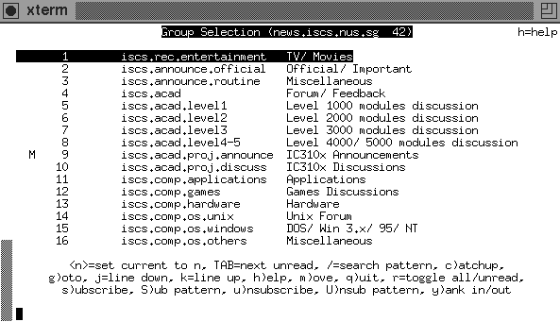
There are 4 fields on your screen:
- Folder number.
- Number of articles (including follow-ups) posted in that folder.
- Folder name.
- A description of the subject covered by that folder.
If you do not have a full list of folders, that means you have not subscribed to those missing folders. In this case, type ‘y’ to yank in all the folders. A folder marked with ‘u’ means that it is ‘unsubscribed’. Go down the list and subscribe the folders you want by typing ‘s’ for each folder.
Help is available by pressing ‘h’.

How to view articles?
There are many ways to navigate in the BBS. The most common way is to use the arrow keys.
- UP/DOWN – to select a folder
- RIGHT/LEFT – to go into/out of a folder
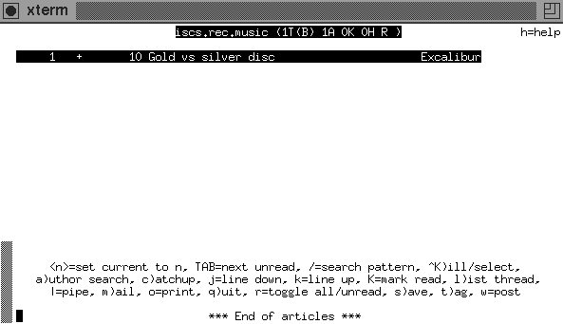
When a folder is selected, you will see a list of threads with 6 fields:

1. Thread number.
2. If there is a ‘+’ sign, this means that there are unread articles in the thread.
3. The number of articles in the thread.
4. Length (in lines) of the unread articles.
5. Thread name.
6. Name of person who posted the article.
As before, you can use the arrow keys to navigate through the thread, and to select the article that you wish to view.
Summary: Select folder → Select thread → Select article.

How to post (a new thread)?
- Select the relevant folder which you want to post, so that your intended readers get to read your article, and not those who aren’t interested in what you have to say. A gentle reminder: if you are new, you should experiment posting in the iscs.test folder first.
- Press ‘w’ to post.
- Type in the subject of your posting.
- Type in your article in the text editor that is automatically invoked. The default editor is vi, a dreadful editor for beginners. You may want to change the default editor to your favourite editor. To do this, refer to ‘How to change your name, organisation and editor for BBS’ in the next page.

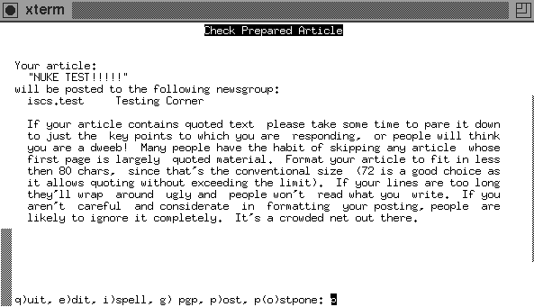
5. When you are done, exit the editor. You will be asked to
q)uit, e)dit, i)spell, g)pgp, p)ost, or p(o)stpone.
To post, press ‘p’ or the Enter key.
6. To view the article you just posted, you have to exit the folder first.

How to follow up as a response to an article?
Select the article which you wish to follow up.
There are 2 ways to follow up:
1. To include contents from the followed up article: press ‘f’.
2. To exclude contents from the followed up article: press ‘F’.
Perform steps 4 and 5 of ‘How to post (a new thread)’ given above.

How to reply to the author of an article?
You may wish to make a private reply to the author of an article, instead of posting your response in the BBS.
1. Select the article.
2. There are 2 kinds of replies:
- To include the article contents in your message: press ‘r’.
- To exclude the article contents in your message: press ‘R’.
3. Type in your message in the text editor.
4. When you are done, exit the editor. You will be prompted with
q)uit, e)dit, i)spell, g)pgp, s)end.
To send your message, press ‘s’ or the Enter key.

How to delete your article?
If you have accidentally posted an article when you didn’t intend to, you can delete the posting as follows:
1. Select the article.
2. Press the ‘D’ key (note: it is the capital-d; ‘d’ means something else!). You will be prompted with
cancel (delete) or supersede (overwrite) article? [...] (d/s/q): d
Press ‘d’ or the Enter key. You will be prompted again with
e)dit cancel message, q)uit, d)elete [...] article?: d
Press ‘d’ or the Enter key again.
Note that you may only delete your own postings.

How to change your name, organisation and editor for BBS?
Add the appropriate statements below into your .profile file:
export EDITOR=xxxxx
export NAME="<whatever name>"
export ORGANIZATION="<whatever place>"
where xxxxx is your choice of editor (vi, vim, pico, joe, emacs, etc.). Do lurk around the BBS to see what names have been used by others, to avoid conflict.

Happy exploring! Your lecturers and tutors might be posting course information on the BBS, so keep a look out on the academic folders, in your case, particularly iscs.acad and iscs.acad.level1. There are other academically oriented folders for discussion and queries on programming, operating systems, hardware, and so on.
However, beware of BBS addiction. If you find yourself getting restless barely half an hour since your last visit to the BBS, and you can’t wait to get in there immediately to check for new postings, you are manifesting BBS withdrawal symptom.

4.4 Browsing The Web
The popularity of Internet is the catalyst for the emergence of a virtual world without borders. Never before have such high degree of connectivity and power of penetration been achieved, spurring an ‘Internet culture’, and bringing the world ever so closely together, within just a few strokes of the fingers. Once the exclusive domain of researchers and academics, the Internet is now second only to the global telephone network in its scale, economic importance, and daily use.
The Internet is a network of networks, linking more than a hundred thousands networks all over the world, and serving hundreds of millions of users world-wide. The World Wide Web is a subdivision of the Internet, and it consists of servers all over the world that store information in textual as well as multimedia format. The creators of the web specified three sets of rules for creating, publishing and finding documents:

HTML (Hypertext Markup Language)
Web documents are ordinary text files that can be created with any text editor or word processor, although now there are a proliferation of software that provide features and facilities specially tailored to the creation of such documents. A web document is called a HTML file, which includes content of the web pages, and tags that control the appearance of the content. Graphics and clips of digitised video or audio can also be imbedded into HTML files. You need a web browser, like Netscape or Internet Explorer, to view web pages.

HTTP (Hypertext Transfer Protocol)
Users of the web retrieve documents from servers, or web sites. HTTP allows a networked computer to listen for and respond to incoming requests for files.

URL (Uniform Resource Locator)
A URL is the Internet address for a web document or other file. A typical URL looks like this:
http://www.cnn.com/WEATHER (CNN’s weather site)
Web users can retrieve documents either by manually entering URLs or by selecting links that contain a URL.

The web is an example of client/server computing, in which networked computers share the work of a task. You are using a client program, say Netscape, to retrieve information from a server computer. The server is responsible for transmitting the document, while the client is responsible for displaying it.

Most lecturers have their course web sites mounted. It is therefore necessary for you to learn how to access the web sites. Actually, it is very simple. All you need is a web browser, and you provide the URL. That’s all!
Shown below is the Netscape browser showing the School of Computing’s web site. Note the URL of the web site in the ‘Location’ field. Most course web sites are mounted on their respective course accounts, with the same URL format. For example, the web sites for CS1101 and CS1101C are respectively,
http://www.comp.nus.edu.sg/~cs1101 and
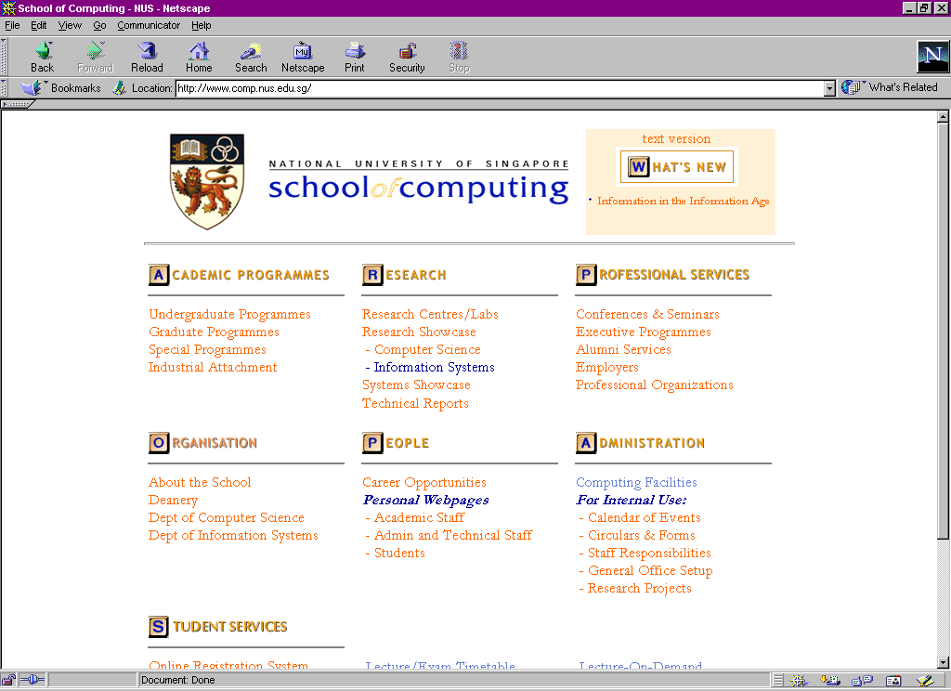
http://www.comp.nus.edu.sg/~cs1101c

If you are keen on creating your own web site, surf the web (click on the ‘Search’ icon and enter keywords such as ‘web design’, ‘html’, etc.) or go to the ‘Students’ link under ‘People’ in the School’s web site to get some free tips, or pick up a book. It is fun and it is not difficult. But perhaps you should read about good web design first, to avoid falling into the many tempting pitfalls (which I did, and still do) and end up creating a web site of poor taste without even realising it. Or worse, your site gets an unwanted and obnoxious mention from authors of sites such as ‘Web Pages That Suck’ (the URL is at http://www.webpagesthatsuck.com)!

4.5 Summary
This chapter covers three essential means of communication a student will need in his course of work: the e-mail system where private messages are exchanged, the public forum BBS where discussions are held, and the World Wide Web where surfing for information is made simple.
Students are urged to use these forms of communication devices effectively, and check their mailbox, the BBS, and the course web pages diligently for important news and updates.

Exercises

- Use the pine e-mail program to compose a message and send it to yourself. Try out the various features in pine.

- Go to BBS and try out the various commands. Enter a test posting in the iscs.test folder of the BBS.

- Visit the NUS web site at http://www.nus.edu.sg/ and the School of Computing web site at http://www.comp.nus.edu.sg/ and follow the links to gather information of your interest.

- Use the ‘Search’ facility of your web browser to surf the web.

Reference:

[1] SoC Survival Guide, Computing Club, 1998. (Updates in progress.)

The folder names in the School’s BBS begin with ‘iscs’. This is carried over by the name of the department, the Department of Information Systems and Computer Science (DISCS), predecessor of the School of Computing.

