SOLUTIONS TO HW 3

Question 1
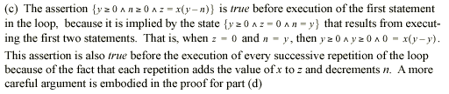

- That the assertion given above holds for every iteration of the loop can be shown by induction. The base case corresponds to the entry point of the loop where z= 0 and y = n. Thus z = x(y-n) is true since 0 = x(y-y).
For the inductive step, assume that the invariant is true up to iteration k (at the end of which we have n = y-k and z = k*x. Then, we need to show that it holds at the end of (k+1)th iteration as well. After executing the first assignment statement we will have z = k*x + x. After the second assignment statement we get n = y-k-1. Therefore at the end of the (k+1)th iteration, x(y-n) = x (y – (y-k-1)) = x(k+1) = k*x + x = z. Thus, the invariant holds at the end of the (k+1)th iteration as well. A very similar argument could be constructed using the notation of Hoare triples as well.

Question 2

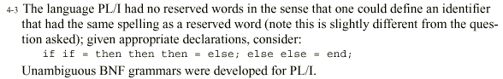

Question 3
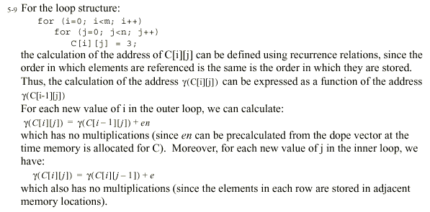

Question 4
