Solutions to HW 6
Question 1
They are name inequivalent, but structurally equivalent. Note that we will need the rule of type constructors (rule 2) to infer that they are structurally equivalent

Question 2

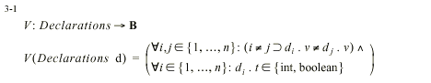

Question 3

Consider the expr. A + B + C where A, B, C are integers. Let the values of A, B, C be
21000, 21000 and –21000. Also, suppose that the machine has a maximum integer value of 32767. Computing (A + B) +C leads to a problem since
the addition A+B leads to an overflow.
If we compute A + (B + C) then we will get 21000

If A, B, C are real numbers, then again we may not have (A + B) + C = A + (B + C) due to round-off errors. When A + B is computed, the result will be approximated or “rounded off” based on the precision of floating point number representation in the underlying machine. Similarly, the other additions (such as B+C) also introduces round off errors. But, the effect of the round-off errors may not be the same for both sides of the equation.

Question 4

Left-to-right
SUM1 = 5 + (42-1) = 46
SUM2 = 41 + 7 = 48

Right-to-left
SUM1 = 7 + 41 = 48
SUM2 = 41 + 5 = 46

