Atomic Bomberman



User Guide
v1.0
Table of content

1. Introduction 3
2. Game play 3
a. Game controls 3
b. Game modes 3
Single player 3
Multiplayer 4
3. Support 5
- Introduction

“Atomic Bomberman” is the mobile version of the classic bomberman game. If you have played bomberman and enjoyed it, you are guaranteed to have fun with this mobile game. This short user guide provides instructions on how to play “Atomic Bomberman” in order to maximize the fun of playing the game.

- Game play

As the traditional bomber man game, your character will move around and place bombs to destroy all obstacles. The only difference is that your bomberman now will have health, which is displayed on top of the screen (figure 1). Game ends when the bomberman loses all his health.

  - Game controls

Only 5 keys are required to play “Atomic Bomberman” as depicted below.
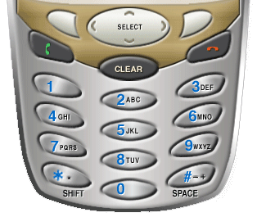
Up
Down
Left
Right
Bomb
Figure 1: Game controls

  - Game modes

There are two modes in this game: single player and multiplayer.

Single player

To enter single player mode, select “Single player” at the main menu screen (figure 2).
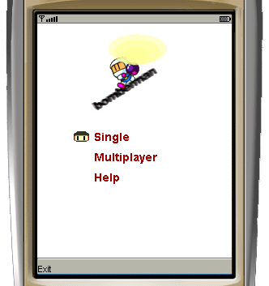
Figure 2: Single player
In this mode, your main task is to rescue the imprisoned bomberman guarded by a traitor and several dragons. Destroy them all and rescue your friend to win the game.

Multiplayer

To enter single player mode, select “Multiplayer” at the main menu screen (figure 3).
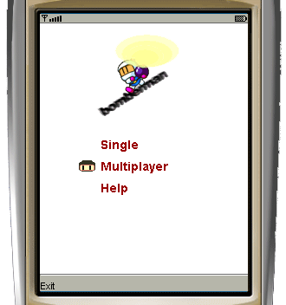

Figure 3: Multiplayer

Your phone will connect to the game server. After connected to the server, the waiting screen will be displayed (figure 4).

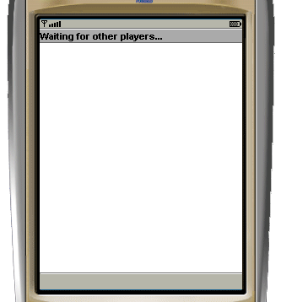

Figure 4: Wait for other players to connect.

Game will start after all your friends are connected to the server (figure 5).

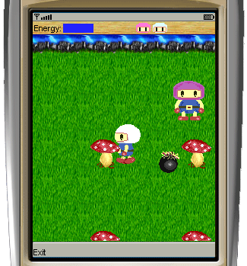
Figure 5: One game session with two players
Your main task in multiplayer mode is simple: kill all the opponents!

- Support

If you have any queries about the game, please contact
giahuy@comp.nus.edu.sg
luongchi@comp.nus.edu.sg

ENJOY THE GAME! ☺

