**Worksheet for Lab #1 Ex3: Packing**

<http://www.comp.nus.edu.sg/~cs1010/labs/2016s1/lab1/threeSimpleExercises.html>

**Task Statement**

You are given a rectangle tray and an unlimited supply of slabs. An example of a 12×20 tray and an 8×3 slab are shown in Figure 1a below.

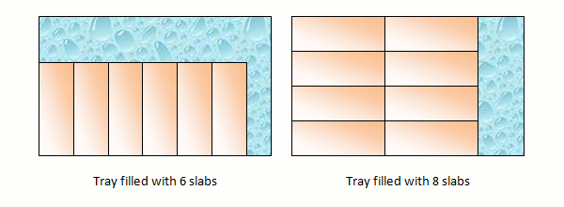

Figure 1b

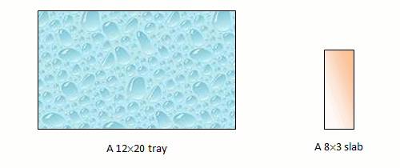

Figure 1a

You are to find the **maximum number of slabs** that can be packed into the tray. The slabs may be packed in either one of the two orientations, as shown in Figure 1b above, but not in a mix of orientations.

The figures above show that the tray may be filled with 6 slabs arranged in one orientation, or 8 slabs arranged in the other orientation. Hence, the answer is 8.

**Step 1**

What are the inputs and outputs? Are there intermediate results? Fill the table below with their variable names.

|  |  |  |
| --- | --- | --- |
| ***Inputs*** | ***Intermediate results*** | ***Outputs*** |
|  |  |  |

**Step 2**

There are two orientations to consider. The logic for both should be quite similar. Let’s focus on one orientation first. Write down your algorithm (pseudo-code) below for finding the number of slabs in one orientation. You may use additional variables if necessary.

**Step 3**

Walk through your algorithm in step 2 with the following 3 sets of test data and write down the result:

|  |  |  |
| --- | --- | --- |
| ***Test data*** | ***Values of variables*** | ***Result*** |
| 12 20 8 3 |  |  |
| 60 35 6 8 |  |  |
| 100 100 20 20 |  |  |

**Step 4**

Modify the algorithm in step 2 to find the number of slabs in the other orientation.

**Step 5**

Walk through your algorithm in step 4 with the following 3 sets of test data and write down the result:

|  |  |  |
| --- | --- | --- |
| ***Test data*** | ***Values of variables*** | ***Result*** |
| 12 20 8 3 |  |  |
| 60 35 6 8 |  |  |
| 100 100 20 20 |  |  |

**Step 6**

Combine your results in steps 3 and 5. Determine the final result.

|  |  |  |  |
| --- | --- | --- | --- |
| ***Test data*** | ***Result of step 3*** | ***Result of step 5*** | ***Final result*** |
| 12 20 8 3 |  |  |  |
| 60 35 6 8 |  |  |  |
| 100 100 20 20 |  |  |  |