A Definition of Trust for Computing with Social Networks

Content Areas: Philosophical Foundations

Abstract
Trust is emerging as an important facet of relationships in social networks. Whether it is for use in security, determining data access, or recommender systems, the definition of trust will guide the development of algorithms to make computations over the trust relationships. In this paper, we present a definition of trust based on sociological foundations. We then describe several properties of trust, including transitivity and composability, that follow from the definition and research in the social sciences, to help guide the methods used for computing with trust. Finally, we discuss the range of values used for expressing trust. Our goal is that this formalized definition will guide the research into trust and computation by providing a simple and well justified foundation.
1 Introduction
Putting a computationally usable notion of trust into social networks requires a clear, more narrow definition of the term that still preserves the properties of trust with which we are familiar in our social lives. There are two purposes for which this definition of trust must be clarified: individuals need a definition so they know how to describe their trust for others, and additional features must be understood if trust relationships are to be used in computation that will benefit the user.
In human society, trust depends on a host of factors which cannot be easily modeled in a computational system. Past experience with a person and with their friends, opinions of the actions a person has taken, psychological factors impacted by a lifetime of history and events (most completely unrelated to the person we are deciding to trust or not trust), rumor, influence by others' opinions, and motives to gain something extra by extending trust are just a few of these factors. For trust to be used as a rating between people in social networks, the definition must be focused and simplified. In this paper, we focus specifically on web-based social networks because they are large, easily accessible social networks with the relationships clearly expressed. Because they are accessible online, they also can be more easily integrated into software applications than social networks that must be inferred from other sources.
2 A Definition of Trust
Trust plays a role across many disciplines, including sociology, psychology, economics, political science, history, philosophy, and computer science. As such, work in each discipline has attempted to define the concept. The problem with defining trust is that there are many different types of trust and it means something different to each person, and potentially in each context where it is applied [Deutsch, 1973; Shapiro 1987].
Because the goal of this work is to find a definition that facilitates making computations with trust in social networks, it is natural to turn to the computer science literature. One of the most widely cited works is Marsh's unpublished PhD dissertation from the University of Stirling, "Formalising Trust as a Computational Concept" [1994]. In this work, Marsh gives careful attention to many facets of trust, from the biological to the sociological, in order to develop a model for trust among agents interacting in a distributed way. His model is complex and highly theoretical. Aside from the difficulties with implementation, it is particularly inappropriate for use in social networks because his focus was on interacting agents that could maintain information about history and observed behaviors. In social networks, users assign a trust as a single rating describing their connection to others, without explicit context or history. Thus much of the information necessary for a system like Marsh's is missing.
Web-based social networks are tools for the average web user. The definition of trust must be uncomplicated and straightforward enough than average web users understand what they are expressing, so they can express it accurately. For a simple, clear definition of trust, the sociological and psychological literature has more to offer.
Deutsch [1962] contains a frequently referenced definition of trust. He states that trusting behavior occurs when a person (say Alice) encounters a situation where she perceives an ambiguous path. The result of following the path can be good or bad, and the occurrence of the good or bad result is contingent on the action of another person (say Bob). Furthermore, the negative impact of the bad result is greater than the positive impact of the good result. This further motivates Alice to make the correct choice. If Alice chooses to go down the path, she has made a trusting choice. She trusts that Bob will take the steps necessary to ensure the good outcome. The requirement that the bad outcome must have greater negative implications than the good outcome has positive implications has been countered in other work [Golombiewski and McConkie, 1975], which does not always require disparity.
Sztompka [1999] presents and justifies a simple, general definition of trust similar to that of Deutsch: "Trust is a bet about the future contingent actions of others." There are two main components of this definition: belief and commitment. First, a person believes that the trusted person will act in a certain way. The belief alone, however, is not enough to say there is trust. Trust occurs when that belief is used as the foundation for making a commitment to a particular action. These two components are also present in the core of Deutsch's definition: we commit to take the ambiguous path if we believe that the trusted person will take the action that will produce the good outcome.
Taking the main social aspects of the definitions above, we propose the following definition: trust in a person is a commitment to an action based on a belief that the future actions of that person will lead to a good outcome.
The action of the trusted person and commitment by the truster do not have to be significant. We could say Alice trusts Bob regarding email if she chooses to read a message (commits to an action) that Bob sends her (based on her belief that Bob will not waste her time). The justification for the belief component of the definition is left undefined. People may base their belief on pervious experiences in their own lives, a history of interacting with the person, or information gathered from an outside source.
This definition forms the foundation for explaining the properties of trust, identifying where trust exists in social networks, and how it can be used in computation.
3 Properties of Trust
From this definition, several properties of trust follow. These will affect how algorithms to compose and use trust are created. In this section, we present several properties that are closely related to computation.
3.1 Transitivity
One of the primary properties of trust that is necessary for computation is transitivity. Trust is not perfectly transitive in the mathematical sense; that is, if Alice highly trusts Bob, and Bob highly trusts Chuck, it does not always and exactly follow that Alice will highly trust Chuck. There is, however, a notion that trust can be passed between people. When we ask a trusted friend for an opinion about a plumber, we are taking the friend's opinion and incorporating that to help form a preliminary opinion of the plumber. Generally, when encountering an unknown person, it is common for people to ask trusted friends for opinions about how much to trust this new person.
There are actually two types of trust one must express: trust in a person, and trust in the person's recommendations of other people. Alice may trust Bob to recommend a plumber, but not trust him at all to recommend other people whose opinion about plumbers is worth considering. Despite this dichotomy, in social networks it is preferable to let a single value represent both of these ideas.. A single rating system is also more compatible with the traditional way users participate in social networks. Users are rarely, if ever, asked to express opinions of others with such subtle differences. As the following examples will show, the definition of trust supports a single value for both concepts.
The definition of trust supports the idea of transitivity. Recall that trust involves a believe that the trusted person will take an action that will produce a good outcome. To add context to the discussion, consider the aforementioned case of finding a plumber. If Alice asks Bob whether or not Chuck is a good plumber, she is going to use Bob's answer to support her action to use Chuck as a plumber or not because she believes Bob will give her information that will lead to a good plumbing outcome. Thus, if Bob says Alice should trust Chuck, Alice relies on her trust in Bob to develop some trust for Chuck. Bob's recommendation becomes a foundation for the belief component of Alice's new trust for Chuck. She will have some trust in him because, based on Bob's information, she believes he will take the steps necessary to produce a good outcome.
This same argument can be extended to longer chains of trust. In the situation above, perhaps Bob does not know about Chuck. Bob may ask a trusted friend (say Denise) about Chuck, and report back to Alice what the trusted friend has said. This adds a step in the chain: Alice->Bob->Denise->Chuck. Alice trusts Bob to give her information that will lead to a good outcome. Bob may decide the best way to give Alice that good information is to talk to his trusted friends, namely Denise. By the definition of trust, Bob trusts Denise because he expects her to give him good information about Chuck so he can obtain a good result (in this case, giving Alice reliable information). Since Alice trusts Bob to give her the good information, she can expect that the steps he goes through to obtain that information are also trustworthy. Thus, trust can be passed along a chain of trusting people. This logic also supports the use of a single value to represent trust in a person and trust in their recommendations about other people.
Because trust is not perfectly transitive, we could expect that it degrades along a chain of acquaintances. Alice is likely to have more trust in Chuck if Bob knows him directly and says he is trustworthy, than if a chain of people pass the information back to her. The best way to compose those trust relationships down a chain to accurately how much the person asking for trust information (in this case, Alice) should trust the person at the end of the chain (Chuck) is an open question but not a neglected one. Computationally, this idea of propagating trust along chains of connections (thus exploiting some form of transitivity) has been widely studied and implemented [Golbeck, et al., 2004; Gray, et al., 2003; Guha, Kumar, 2004; Jøsang, 1996; Jøsang et al., 2003; Richardson, et al., 2003; Ziegler, Lausen, 2004].
3.2 Composability
Transitivity describes how a trust rating can be passed back through a chain of people. This is depicted in part (a) of figure 1. Recommendations about the trustworthiness of an unknown person are used to support a belief about the actions of the unknown person, and thus lead to some amount of trust. What about the case in part (b) of figure 1, where many people are making recommendations about how much to trust Chuck? In that situation, Alice must compose the information to decide whether or not to trust Chuck. This composability of trust is another important feature for making trust computations.
Composability makes sense if we look at trust recommendations as evidence used to support the belief component of trust. With information from many people, there is simply more reasoning and justification for the belief. Exactly how Alice should compose the trust values from many sources is another question. The trust values of each neighbor, and their recommendations about Chuck, all flow into a composition function that can vary from situation to situation and person to person. Richardson et al. [2003] used the concept of an openly defined composition function in their work. Other work [Golbeck et al., 2004] has defined composition functions and discussed their accuracy.

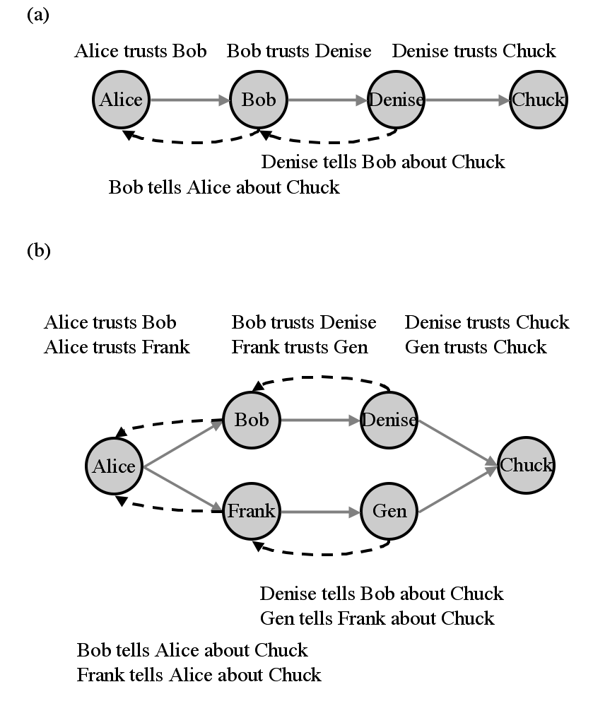
Figure 1: Part (a) shows a simple chain of people where the transitive features of trust allow Alice to form an opinion of Chuck based on the information Denise gives to Bob and Bob, in turn, gives to Alice. Part (b) shows a more complex structure where Alice receives information from two people and she must come up with an opinion of Chuck by composing the information she has.

3.3 Personalization and Asymmetry
One property of trust that is important in social networks, and which has been frequently overlooked in the past, is the personalization of trust. Trust is inherently a personal opinion. Two people often have very different opinions about the trustworthiness of the same person. For an example, we need only look to politics. In the United States, when asked "do you trust the current President to effectively lead the country?" the population will be split – some will trust him very highly, and the others will have very little trust in his abilities.
The definition of trust includes a belief that the actions of the trusted person will lead to a good outcome. What qualifies as a good outcome varies from one person to another. What is a good outcome when the Red Sox are playing the Yankees? The answer depends strongly on where a person is from. For a more immediate example, consider two sales people bidding on the same contract. What is the "good" action for the contract manager to take? Again, depending on which sales person is asked, and "good" action will be different. Since we all have interests, priorities, and opinions that can conflict with the interests, priorities, and opinions of others, when and how much we trust people will vary. Since there is rarely an absolute truth, a universal measure of the trustworthiness of a person is also rare. Calculations about trust must be made from the perspective of the individual to be of use to them and reflect their interests.
Similarly, the asymmetry of trust is important, and it reflects a specific type of personalization. For two people involved in a relationship, trust is not necessarily identical in both directions. Because individuals have different experiences, psychological backgrounds, and histories, it is understandable why two people may trust each other different amounts. For example, parents and children clearly trust one another at different levels, since the children are just not capable of many tasks. This strong asymmetry can occur in other relationships where the people involved are on close social levels. This can be carried out fully to "one-way trust" where circumstances force one person to trust the other, but there is no reciprocal trust [Hardin, 2002; Cook, 2001]. However, most asymmetry is not as extreme as any of those circumstances. Most trust is mutual [Hardin, 2002] in that each party has some trust for the other, but there are still often differences in how much they trust one another. For example, employees typically say they trust their supervisors more than the supervisors trust the employees. This is seen in a variety of hierarchies [Yaniv, Kleinberger, 2000]. Asymmetric trust can arise in any relationship, and representations of trust relationships in models of social networks must allow for these differences.
4 The Values of Trust

Trust is information about a social relationship and, as such, in a web-based social network is must be represented as a label on that relationship. There is still much freedom as to what form that label takes, and this section addresses some of the possible options for the values representing trust.
We have conducted an exhaustive survey of web-based social networks, with over 125 networks that fit within a set of criteria. Results of the are available at http://trust.mindswap.org/. Within that survey, six social networks allow users to express trust in one way or another. One of them – eCademy – uses the simplest possible representation of trust. Users have two options: do not make any statement about trust, or state that a friend is "trusted". This does not allow for any range of trustworthiness or an expression of untrustworthiness. It simply lets users indicate which people they trust.
There are some types of relationships that easily fit in this paradigm of simply existing or not existing. For example, whether or not we are related to a person, if we have met a person, or if we are co-workers, is a relationship that exists or does not exist.. Trust, however, is not this simple. It is established trust is not merely a binary concept; it falls within a range of values [Gambetta, 1990; Marsh, 1992; Marsh 1994]. Instead of being a binary value, trust falls within a range. There is some upper threshold above which a person can say another is trusted. Below that threshold, there is a range of values of trust. Gambetta argues that the threshold changes not only between people, but for each person depending on their circumstances. When using this to motivate a range of values for trust in social networks, it seems best to avoid trying to pin down the point at which a person is called "trusted" and, instead, allow people to express a value of trust they have for others. The users themselves can determine when that value qualifies as above the threshold for "absolute trust" and when it does not.
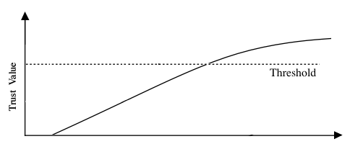
Figure 2. A range of trust values with a threshold, above which a person is considered to be firmly "trusted".
Five web-based social networks have some notion of trust that is expressed over a multiple of values. These are shown in Table I. Note that Overstock.com auctions has been included in this list, although the their "Business Rating and "Personal Rating" are not explicitly ratings of trust. Ratings in the context of business are similar to trust in that they provide information about how much one can trust a person to produce a good outcome with respect to a business transaction.
There are other schemes for representing levels of trust, including scales with more values (such as Richardson et al., [2003] that used a continuous 0-1 range) or with labels rather than numbers (e.g. "very low trust," "low trust," "moderate trust," "high trust," and "very high trust"). The numeric scales are easier to work with computationally because they can be mathematically manipulated. It is possible to convert the label-based scales to numeric schemes, but this requires attention so unintentional error is not introduced into the system.

Table 1. The range of values available for rating trust in web-based social networks.
Website | URL | Relationship | Trust Values
Overstock Auctions | http://auctions.overstock.com | Business Rating | -2 - +2
 |  | Personal Rating | 0-5
Orkut | http://orkut.com | Trust | 0-3
RepCheck | http://repcheck.com | Business Trust | 0-5
 |  | Personal Trust | 0-5
The Trust Project and FilmTrust | http://trust.mindswap.org http://trust.mindswap.org/FilmTrust | Trust | 0-10

5 Conclusions and Future Work
In this paper, we presented a definition of trust for use in social networks. We then defined a set of properties, justified by the definition, and examined possible values for expressing trust relationships. There is much work taking place in this area, and it often lacks a well expressed definition of trust. The goal of this paper is to provide a definition that can tie this work together.
Future work will expand on the undefined spaces of trust, including algorithms for calculating how to treat trust recommendations made through a chain of relationships and how to compose trust values. We are currently using this definition and set of properties as the foundation of a project that uses trust and social networks for calculating recommendations. The project's website, called FilmTrust at http://trust.mindswap.org/FilmTrust/, combines trust networks with movie ratings and reviews. We compose trust values to create personal trust recommendations that, in turn, produce personalized ratings of movies and reviews ordered by the trustworthiness of their author. This sort of application, that uses trust to filter information and personalize the data that users access, holds great promise for creating software that is intelligent with respect to a user's social perspective.
Acknowledgements
This work, conducted at the Maryland Information and Network Dynamics Laboratory Semantic Web Agents Project, was funded by Fujitsu Laboratories of America -- College Park, Lockheed Martin Advanced Technology Laboratory, NTT Corp., Kevric Corp., SAIC, the National Science Foundation, the National Geospatial-Intelligence Agency, DARPA, US Army Research Laboratory, NIST, and other DoD sources.
References
[Deutsch, 1973] Deutsch, Morton (1973). The Resolution
of Conflict. New Haven and London: Yale
University Press.

[Gambetta, 1990] Gambetta, Diego. (1990). "Can We
Trust?" Chapter 13 in Trust, Gambetta, Diego (ed).
Blackwell.

[Gray, et al., 2003] Gray, Elizabeth, Jean-Marc Seigneur,
Yong Chen, and Christian Jensen. (2003). "Trust
Propagation in Small Worlds." Proceedings of the
First International Conference on Trust
Management. LNCS 2692, Springer-Verlag.

[Golbeck, et al., 2004] Golbeck, Jennifer, James
Hendler, "Reputation Network Analysis for Email
Filtering". Proceedings of the First Conference
on Email and Anti-Spam, July 2004, Mountain
View, California.

[Guha, Kumar, 2004] Guha, R, and Ravi Kumar
(2004). "Propagation of Trust and Distrust"
Proceedings of the 13th Annual World Wide Web
Conference.

[Jøsang , 1996] Jøsang, A. The Right Type of Trust for
Distributed Systems. In C. Meadows, editor, Proc. of
the 1996 New Security Paradigms Workshop. ACM,
1996.

[Jøsang , et al., 2003] Jøsang, Audun, Elisabeth Gray,
Michael Kinateder. (2003) " Analysing Topologies
of Transitive Trust," Proceedings of the First
International Workshop on Formal Aspects in
Security & Trust (FAST2003).

[Marsh, 1992] Marsh, Stephen. (1992) "Trust and
Reliance in Multi-Agent Systems: A Preliminary
Report" 4th European Workshop on Modeling
Autonomous Agents in a Multi-Agent World. LNCS
830, Springer-Verlag.

[Marsh, 1994] Marsh, S. (1994)“Formalising Trust as a
Computational Concept.” PhD thesis, Department of
Mathematics and Computer Science, University of
Stirling.

[Richardson, et al., 2003]Richardson, Matthew, Rakesh
Agrawal, Pedro Domingos. (2003) “Trust
Management for the Semantic Web,” Proceedings of
the Second International Semantic Web Conference.
Sanibel Island, Florida.

[Shapiro, 1987] Shapiro, Susan. (1987). "Social Control
of Impersonal Trust." The American Journal of
Sociology, 93(3), 623-658.

[Zeigler, Lausen, 2004] Ziegler, Cai-Nicolas, Georg
Lausen (2004). "Spreading Activation Models for
Trust Propagation" Proceedings of the IEEE
International Conference on E-Technology.

Actually, I assert that it's always better for the Red Sox to win. There are some absolute truths in this world.

