CS2220 Introduction to Computational Biology
Assignment #3
To be submitted by 3/4/09
This assignment contributes 10% to the final course grade

The objective of this assignment is to familiarize you with a basic protein function prediction procedure.

Data:
We work on the protein sequence below

>Seq1
MKDKSSILRKSIKMGSVEHETKVSNKEGEIMAIASKDVISIPPTKSIKDTAKVMMEHEFRRLPIADPGSG
KVLGIVTVMDILDFFGGGKKFNIIEKKYEDNFLAAINEPIREIMTRDVICLSDKSSIKDTIETMLSNQIG
AIPLVDANDKLAGIVTERDIVLSLAGVLTEEVAQDYMSTKVFTTTPGTPIESACKIMVRNGLRRIPIVGG
EADISKASKKLLGIVTSTDIIRYFNAKELFDNLNSNAASEVLKNIVSNIMAEDPITVSQTERIGDICALF
AEKNIGGVPVTKDSEIIGIITEKDILNAIKTL
>Seq2
MADYLISGGTGYVPEDGLTAQQLFASADGLTYNDFLILPGFIDFIADEVDLTSALTRKITLKTPLISSPM
DTVTEADMAIAMALMGGIGFIHHNCTPEFQANEVRKVKKFEQGFITDPVVLSPSHTVGDVLEAKMRHGFS
GIPITETGTMGSKLVGIVTSRDIDFLAEKDHTTLLSEVMTPRIELVVAPAGVTLKEANEILQRSKKGKLP
IVNDCDELVAIIARTDLKKNRDYPLASKDSQKQLLCGAAVGTREDDKYRLDLLTQAGVDVIVLDSSQGNS
VYQIAMVHYIKQKYPHLQVIGGNVVTAAQAKNLIDAGVDGLRVGMGCGSICITQEVMACGRPQGTAVYKV
AEYARRFGVPIIADGGIQTVGHVVKALALGASTVMMGSLLAATTEAPGEYFFSDGVRLKKYRGMGSLDAM
EKSSSSQKRYFSEGDKVKIAQGVSGSIQDKGSIQKFVPYLIAGIQHGCQDIGARSLSVLRSMMYSGELKF
EKRTMSAQIEGGVHGLHSYEKRLY

Tools:
Any protein function prediction tools. E.g., BLAST located at NCBI and PFAM at Sanger.

Q1 [2 marks]: Describe in a couple of lines how you will predict the function of the proteins above.

Q2 [4 marks]: Carry out your prediction. Provide a summary of the output obtained. What do you think are the functions of the two proteins respectively?

Q3 [4 marks]: Do the proteins really have the features required for the predicted functions? Why?

Q4. Two substrings S₁ and S₂ of a string S are said to be the best approximate repeat in S if the global alignment score between them are the highest among all the substrings of S. Recall the Smith-Waterman algorithm given in lecture 6: the optimal local alignment of two sequences (S,T) is given as H(S,T) = max_{i < |S|, j < |T|} V(i,j), and V(i,j) is defined as below.

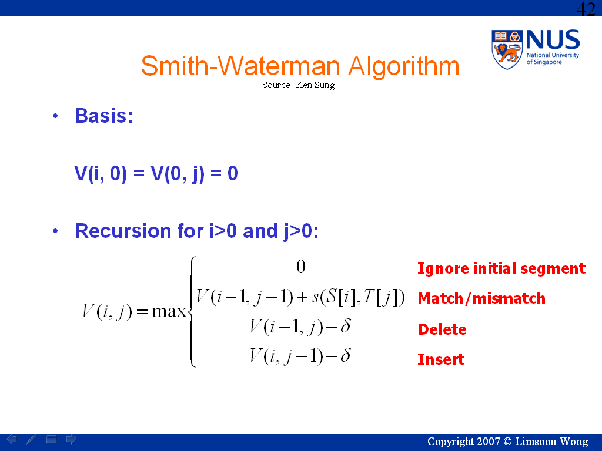

- [4 marks] Please modify/use it to find the best approximate repeat when overlapping repeats are not allowed.
- [4 marks] Please modify/use it to find the best approximate repeat when overlapping repeats are allowed.
- [2 marks] What are the time complexities of your solutions to (a) and (b)?

--------------------end of assignment #3--------------------

