CS2220 Introduction to Computational Biology
Assignment #3
To be submitted by 4/11/10
This assignment contributes 10% to the final course grade

The objective of this assignment is to test your understanding of basic sequence alignment algorithm.

Two substrings S₁ and S₂ of a string S are said to be the best approximate repeat in S if the global alignment score between them are the highest among all the substrings of S. Recall the Smith-Waterman algorithm given in lecture 5: the optimal local alignment of two sequences (S,T) is given as H(S,T) = max_{i < |S|, j < |T|} V(i,j), and V(i,j) is defined as below.

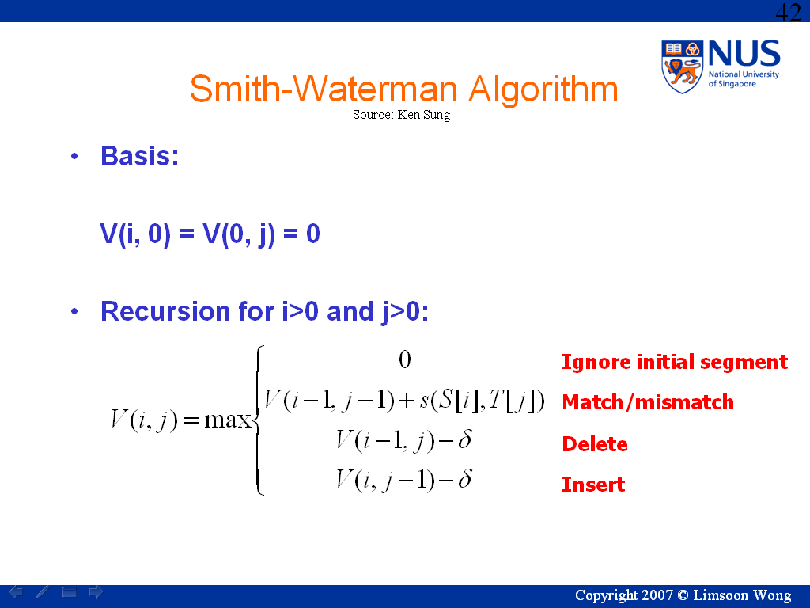

- [4 marks] Please modify/use it to find the best approximate repeat when overlapping repeats are not allowed.

- [4 marks] Please modify/use it to find the best approximate repeat when overlapping repeats are allowed.

- [2 marks] What are the time complexities of your solutions to (a) and (b)?

--------------------end of assignment #3--------------------

