CS2220 Introduction to Computational Biology
Assignment #3
Please submit to Prof Wong Limsoon by 5/11/2015
This assignment contributes 10% to the final course grade

The objective of this assignment is to test your understanding of basic sequence alignment algorithm.

Consider the Smith-Waterman sequence alignment algorithm given below.

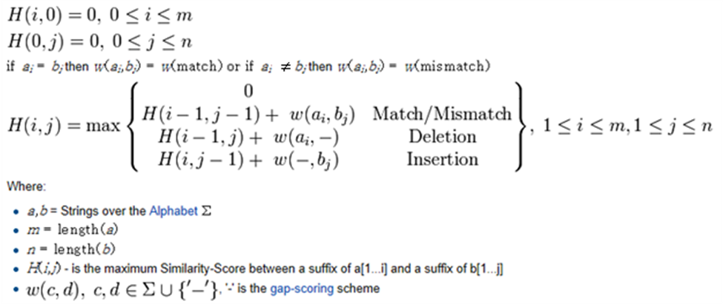

- Please modify it to make it much harder in getting indels in the alignment that are less than 5 residues apart. [4 marks]

- Please briefly justify the correctness of your answer. [4 marks]

- What is the time complexities of your solution to (a)? ]2 marks]

--------------------end of assignment #3--------------------

