
Tanglin Secondary School
40th Anniversary Celebration (1964 - 2004)
Programme for the Evening
28th August 2004

Venue: Tanglin Secondary School

6.00 pm Arrival of Guests (Alumni, please see * below)
6.15 pm Arrival of Guest of Honour
Mr Cedric Foo, Minister of State (Defence)

Alumni marching to begin *
Planting of Family and House Trees
7.00 pm Arrival of Alumni Marching Contingents
7.20 pm Welcome Speech by Principal
Speech by SAC Chairman
Speech by Alumni President
Speech by Guest of Honour
7.50 pm Video Presentation
8.00 pm Dinner
9.00 pm “Joseph & the Amazing Technicolour Dreamcoat”
10.15 pm School Tour / Coffee and chat
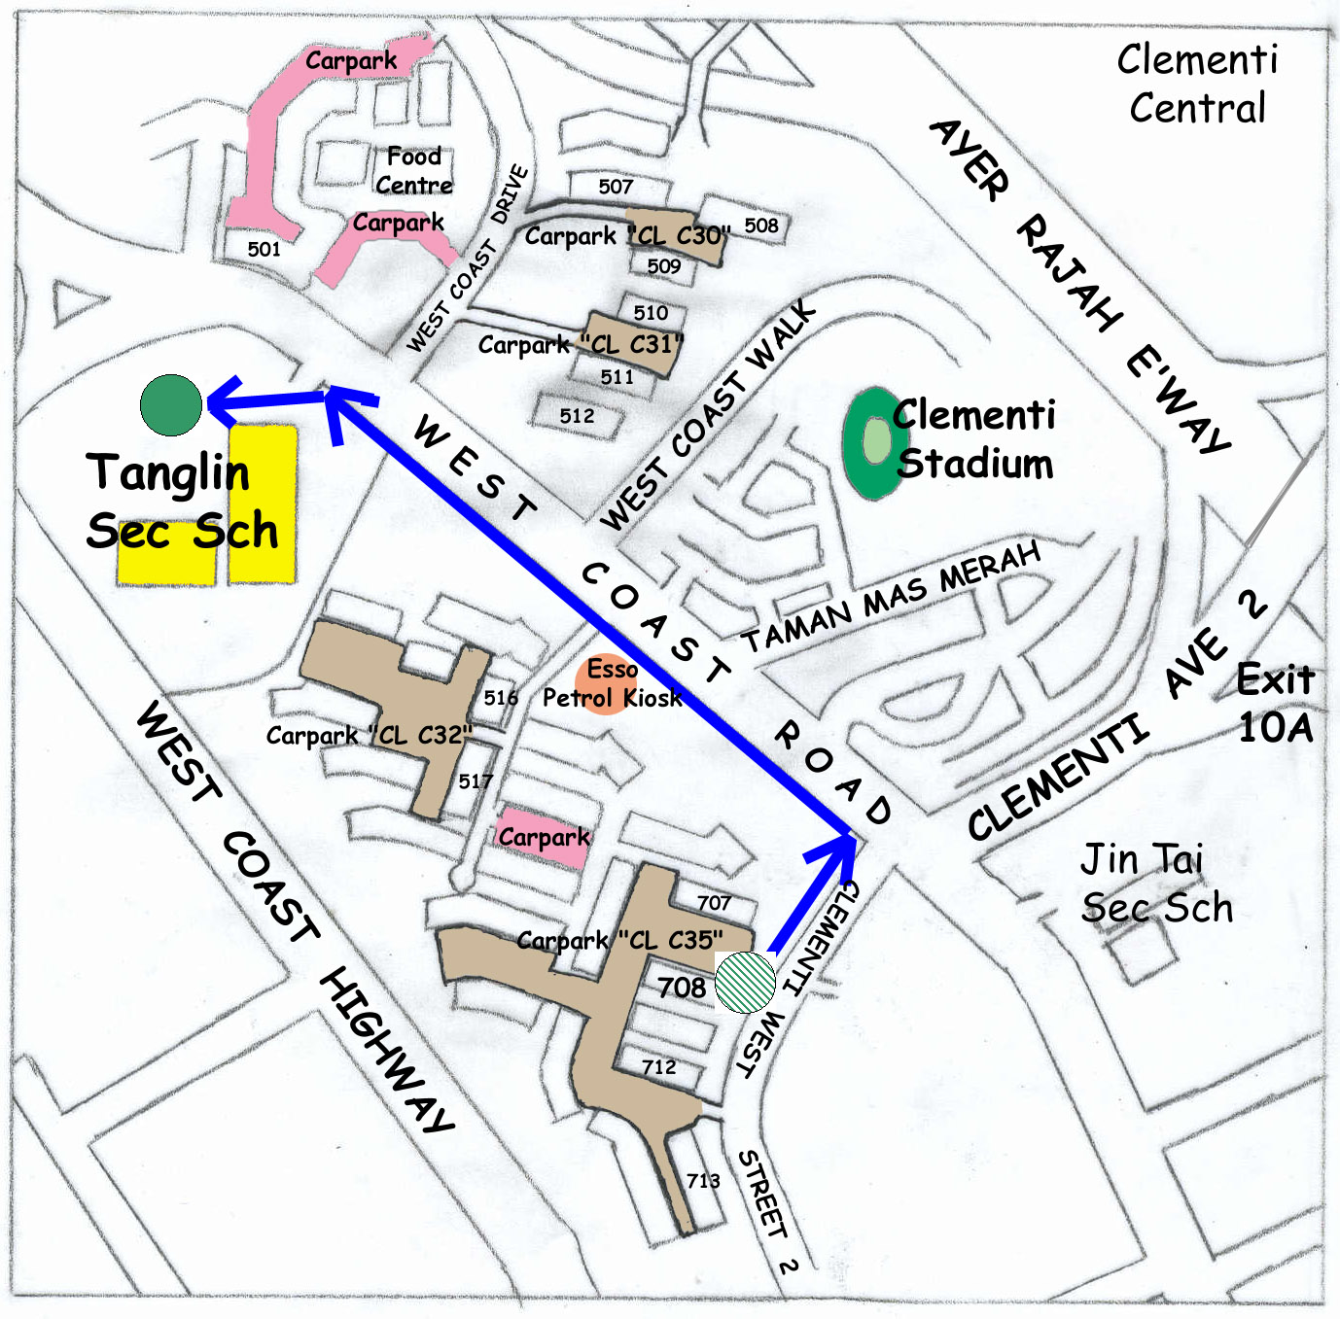
10.30 pm Au Revoir!

* Special Note to Alumni
As part of the celebration, we have arranged a parade of the alumni consisting of 41 cohorts of alumni / current students marching to the school from Clementi West Street 2. All alumni are strongly encouraged to participate in the march.
Please assemble at the void deck of Blk 708, Clementi West Street 2 by 6.00 pm. You may park at the surrounding HDB car parks. Please remember to display parking coupons.

Key

: Marching contingents assembly and start point

: End point

: Marching route

: HDB Car Parks

