Gene Expression Profiling Improves Accuracy of Diagnosis of Childhood Acute Lymphoblastic Leukaemia and Optimizes Risk-Benefit Ratio of Therapy Especially in Developing Countries

Jinyan Li¹, Huiqing Liu¹, Limsoon Wong¹, Allen Yeoh²

¹Institute for Infocomm Research
²National University of Singapore

Childhood acute lymphoblastic leukaemia (ALL) is the most common form of childhood cancer. Though it looks identical under the microscope, childhood ALL is a highly heterogeneous disease, with as many as 6 different subtypes that have widely differing treatment outcome. To avoid under-treatment (which causes relapse and eventual death) or over-treatment (which causes severe long-term side-effects), accurate diagnostic subgroup must be assigned upfront so that the correct intensity of therapy can be delivered to ensure that the child is accorded the highest chance for cure.

Contemporary approaches to the diagnosis of childhood ALL require an extensive range of procedures including morphology, immunophenotyping, cytogenetics, and molecular diagnostics.

Our single platform of microarray expression analysis can accurately identify each of the known clinically important subgroups of childhood ALL. This is confirmed using computer-assisted supervised learning algorithms, where we achieved an exceedingly accurate overall diagnostic accuracy of 96% in a blinded test set illustrating the robustness of our diagnostic platform.

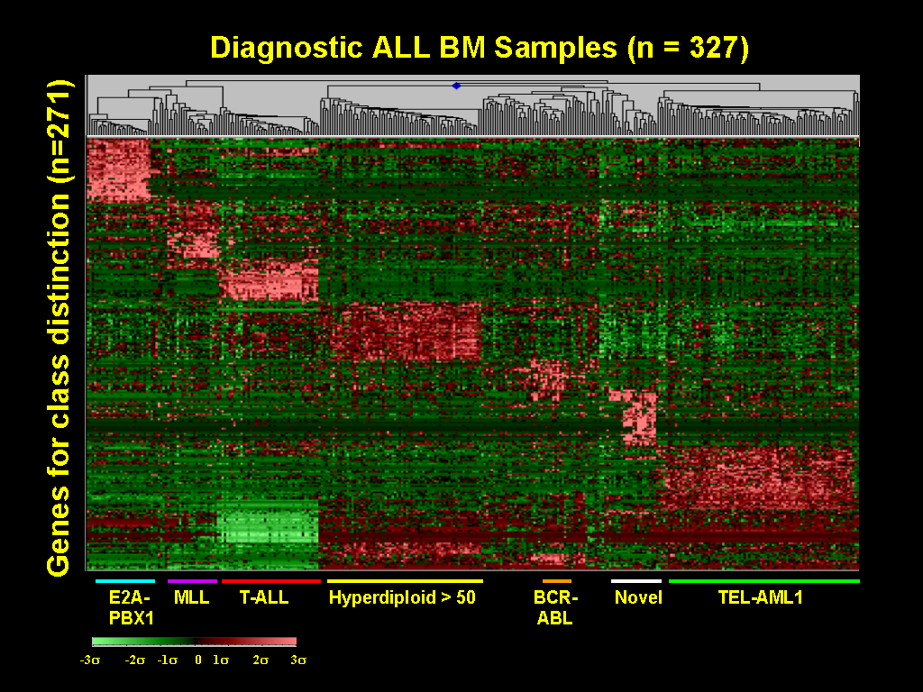

Relapse and the development of therapy-induced acute myeloid leukaemia (AML) remain the main treatment failures in childhood ALL. To determine if expression profiling at diagnosis might further help us identify those patients who are likely to relapse up to 4 years later, we compared the expression profiles of four groups of leukaemic samples with different outcomes. We successfully identified distinct gene expression profiles for each of these groups.

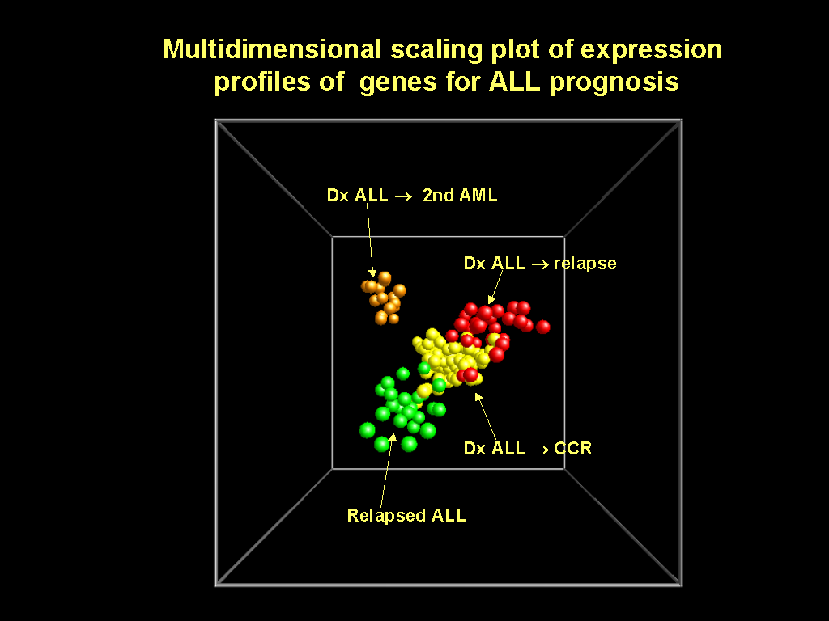

Every year, >2000 new cases of childhood ALL are diagnosed in ASEAN countries. This is a disease with cure rate of >75% in Singapore. But in ASEAN countries, except Malaysia and Singapore, childhood ALL patients have a dismal 5-20% cure rates. This is mainly due to these countries’ inability to deliver the correct intensity of therapy, resulting in
- excessive toxic deaths;
- too much side effects, especially long-term ones like decrease in IQ; and
- under-treatment for high-risk cases.

Treatment for childhood ALL over 2 years for intermediate-risk costs US$60k, good-risk costs US$36k, and high-risk costs US$72k. Treatment for relapse cases costs US$150k. There is also an un-quantified cost of dealing with side-effects.

As medical facilities in the less developed ASEAN countries generally lack the ability to diagnose the subtypes of their childhood ALL patients, the treatment for intermediate risk case is conventionally applied for everyone. If our single-test platform becomes broadly available, they could then adopt a more accurate treatment strategy, resulting in a highly significant savings of US$51.6 million a year yet with better cure rates and much reduced side-effects because the correct intensity of therapy is applied upfront.

 | Conventional treatment | Risk-stratified using our single-test platform
Treatment | - intermediate intensity to every patient | - low intensity to 50%  - intermediate intensity to 40%  - high intensity to 10%
Risk of failure | - overly intensive for 50% of patients, leading to increased side effects  - insufficiently intensive for 10% of patients, resulting in relapse
Cost | - US$120 million (US$60k * 2000) for the intermediate risk treatment  - US$30 million (US$150k * 2000 * 10%) for the relapse treatment  Totalling US$150 million a year plus the un-quantified costs for dealing with side effects, for the less developed ASEAN countries | - US$36 million (US$36k * 2000 * 50%) for prognostically good cases  - US$48 million (US$60k * 2000 * 40%) for intermediate cases  - US$14.4 million (US$72k * 2000 * 10%) for prognostically poor cases  Totalling US$98.4 million a year plus significantly reduced side effects cases
Impact |  | - savings of US$51.6 million  - better cure rates  - much reduced side-effects

