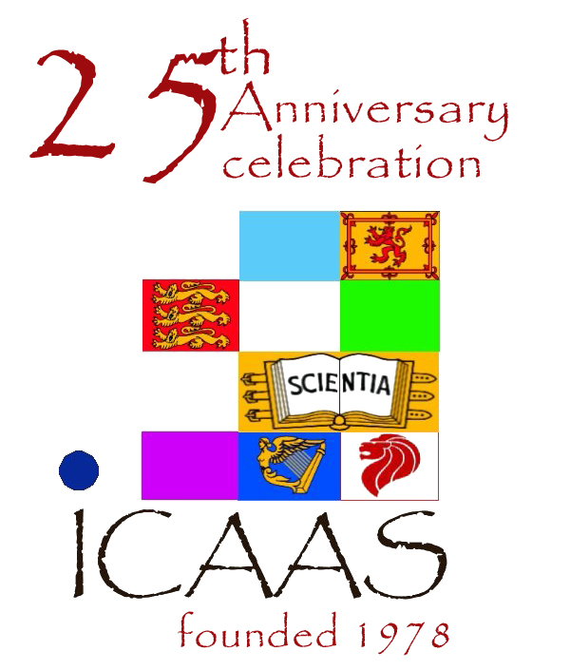
Report of the President & Hon. Sec. for August 2003 to September 2004
IMPERIAL COLLEGE ALUMNI ASSOCIATION OF SINGAPORE

patron: RAdm (NS) Teo Chee Hean, Minister for Defense
advisor: Mr. J. Y. Pillay, Chairman, Singapore Exchange Pte Ltd

The activities organized/participated by ICAAS this year are summarised below.
- Social activities
- ICAAS 25th Anniversary Gala Dinner & 26th AGM, 19 Aug 2003
ICAAS celebrated our 25th anniversary at the Regent Hotel. The event was graced by Radm Teo Chee Hean. Dr. Lee Hing Yan (ICAAS VP) was the main organizer of the event.
- ICAAS Networking Dinner w/ Prof. David Ewins (Pro Rector), 26 Aug 2003
Prof. Ewins was in town to discuss the A*STAR-Imperial partnership programme. ICAAS EXCO organized a networking dinner to welcome Prof. Ewins at the Ritz Carlton.
- ICAAS Visit to Singapore Turf Club, 27 Sept 2003
Several members of ICAAS had a great time visiting the Turf Club. The visit was arranged by Mr. Chen Hung (ICAAS EXCO), who also gave us the quick intro on how to read the "betting program" and watch the horses, as well as tips on how to "sha" (win)---e.g. "never walk in a straight line" (because winnings from bets were called "hengcai", meaning side-money) and "bring a small knife" (because better to "sha", meaning making-a-killing), and so on.
- ICAAS Networking Dinner w/ Dr. Tidu Maini (Pro Rector) and Dominique Kleyn (Head of Life Sciences, IC Innovations), 31 October 03
Dr. Maini and Ms. Kleyn was in Singapore to discuss a A*STAR-Columbia-Imperial tri-parte co-operation. ICAAS EXCO organized a networking dinner to welcome them.
- ICAAS Networking Supper w/ Prof. David Begg (Principal, Tanaka Business School), 20 Nov 2003
Prof. Begg was in town to meet past and present students of the Imperial College Singapore MBA Programme. ICAAS EXCO hosted a networking supper for Prof. Begg.
- ICAAS EXCO Visit to ICAAM EXCO in KL, 10 Jan 2004.
ICAAS EXCO visited ICAAM EXCO in KL and discussed possible jointly organized events. Some preliminary suggestions were a large convocation event (2007 would coincide with Imperial’s centenary), a tour to an unusual country (Siberia), and a seminar event (“Trust in Singapore, Business in Malaysia”).
- ICAAS Bowling, 29 Feb 2004.
As there was no inter-varsity bowling tournament this FY, Mr. Allen Chong (ICAAS Hon. Sec.) organized instead a bowling and networking event at the Cathay Bowl for our members.
- ICAAS Networking Dinner w/ Sue Stone (Asst Registrar) and David Robb (Admission Tutor, Dept of Mech Eng), 9 Mar 2004.
Sue Stone and David Robb were in Singapore for student recruiment activities. ICAAS EXCO organized a networking dinner at the Linzhi Vegetarian Restaurant to welcome them.
- “Exciting Vibrations”, Lecture by Prof. David Ewins (Pro Rector), 7 Apr 2004
ICAAS was proud to present a public lecture by Prof. David Ewins o n a topic of great interest to mechanical and civil engineers: vibrations. The talk was held at NUSS Guild House, and was attended by over 40 alumni and professional engineers. The talk was organized by Mr. Mark Wong (ICAAS EXCO) and Mr. Allen Chong (ICAAS Hon. Sec.).
- ICAAS Networking Dinner w/ Anne Benjamin (Imperial College Singapore MBA Programme), 9 April 2004 at Huating Restaurant, Orchard Hotel.
- ICAAS tour to Mongolia, 5-16 July 2004
3 members of ICAAS (Ms. Ip Siok Hui, Mr. Oh Lock Soon, Prof. Wong Limsoon) went on a tour to Mongolia. The tour was inspired/planned by ICAAS member Toh Poh Joo who had lived in Mongolia for 3 months. The tour was a fantastic experience---full marks for the country, though the tour guides/company was insufficiently experienced---we were their 1st customers.
- ICAAS BBQ to welcome new members, 30 July 2004
We had new members joining ICAAS almost every month during this FY. Mr. Allen Chong (ICAAS Hon. Sec.) organized a wonderful BBQ at the Rendenzvous Hotel to welcome them. Prof. Wong Limsoon (ICAAS President) also took the opportunity to show the attendees photos taken during the Mongolian tour by himself and fellow ICAAS members Mr. Oh Lock Soon and Ms. Ip Siok Hui.
- ICAAS Networking Dinner w/ Lord Ron Oxburgh (Chairman of Shell & former Rector), 7 Aug 2004.
Lord Oxburgh was in Singapore to review progress of various A*STAR tech scan panels. ICAAS EXCO organized a networking dinner at the Huating Restaurant to welcome him.

- Co-organized activities
- ICAAS-NLB IT @ Orchard lecture by Dr. Yau Wei Yun, 2 Sept 2003
This talk was on the topic of biometrics and was given by Dr. Yau Wei Yun (Chairman, Biometrics Technology Committee, ITSC). It was the second last of the ICAAS-NLB IT @ Orchard series of public lectures on IT. Dr. Lee Hing Yan (ICAAS VP) was the main organizer of this series.
- ICAAS-NLB IT @ Orchard lecture by Dr. Derek Kiong, 7 Oct 2003
The talk was on “secure e-commerce with an anti-virus”. Dr. Derek Kiong (Program Director, Institute of Systems Science). It was the last of the ICAAS-NLB IT @ Orchard series of public lectures on IT. Dr. Lee Hing Yan (ICAAS VP) was the main organizer of this series.

- Other activities
- ICAAS Most Outstanding JC Science Student Award, Dec’03
This annual award is given by ICAAS to a current JC science student in Singapore who has distinguished in his academic achievement in science, in his ability to explain scientific results, and in his attitude towards science and to difficult problems and issues. Mr Tan Haihan of Hwa Chong Junior College was chosen as the 5th winner of the ICAAS Most Outstanding Junior College Science Student Award by a panel of eminent scientists and educators chaired by ICAAS President and Deputy Executive Director for Research at the
A*STAR Institute for Infocomm Research, Prof. Limsoon Wong. The winner of this award also earned the right to represent Singapore at the Stockholm International Youth Science Seminar and at the Nobel Prize Ceremony. This award was sponsored by World Scientific.

- ICAAS raising of donations for ICSS’ Flag-gel-lah event, Jan 2004
The Singaporean students at Imperial College had an audacious goal of setting a Guiness World record by constructing the largest flag made of jello on 21 Feb 2004. ICAAS helped raised generous donations.

- Imperial College Singapore MBA graduation ceremony, 6 Jun 2004
ICAAS EXCO represented ICAAS at the Imperial College Singapore MBA graduation ceremony at the Fullerton Hotel on 6 Jun 2004. ICAAS President was the GOH. ICAAS also presented the ICAAS Best MBA Book Prize to the best all-round final year student in the Imperial College Singapore MBA Programme. The 1st winner of this award was Mr. Kan Wei Jin.

- ICAAS Most Outstanding Student Award, 21 Aug 2004.
This award is given by ICAAS to a current student at Imperial from Singapore who has made significant achievements and/or contributions to the Singaporean student community at Imperial. Mr. Ivan Phua was selected from among 3 candidates nominated by ICSS by a panel of 7 ICAAS members chaired by Mr. Tan Kee Yong on 19 Aug 2004. The ICAAS Most Outstanding Student Award was presented to Ivan on 21 Aug 2004 by Prof. Wong Limsoon (ICAAS President) at the ICSS Sojourn in Sentosa on 21 Aug 2004. The ceremony was witnessed by 80+ current students and Mr. Han Neng Hsiu (ICAAS Treasurer). Mr. Ling Ming Koon (ICAAS Youth Wing) was the main coordinator from ICAAS.

Amendments to ICAAS Constitutions:
- We are pleased to report that the amendments proposed at the 26th AGM have been approved by ROS, except for the proposed change to our financial year (clause 11.1) to coincide with our AGM. ROS required a fixed financial year. As we usually hold our AGM in late August or early September, ROS instructed that we amend clause 11.1 to fix our financial year as 1st Aug to 31st July and that we should hold AGM no later than 30th Sep.

There were a number of ICAAS members that we would like to thank on behalf of ICAAS:
- Mr. Ng Beng Tiong, Mr. Allen Chong, Mr. Bill Liu, Ms. Ip Siok Hui, Mr. Huang Shang Bai, A/Prof. Kwoh Chee Keong, & Prof. Wong Limsoon for generous donations to the ICSS flag-gel-lah event, Jan 2004
- Ms. Chin Wai Phin for hosting the ICAAS networking dinner with Prof. David Ewins on 26 Aug 2003
- Ms. Ip Siok Hui for hosting the ICAAS Mongolia Tour Introduction lunch on 28 February 2004
- Prof. K. K. Phua for hosting the ICAAS networking dinner with Lord Ron Oxburgh on 7 Aug 2004
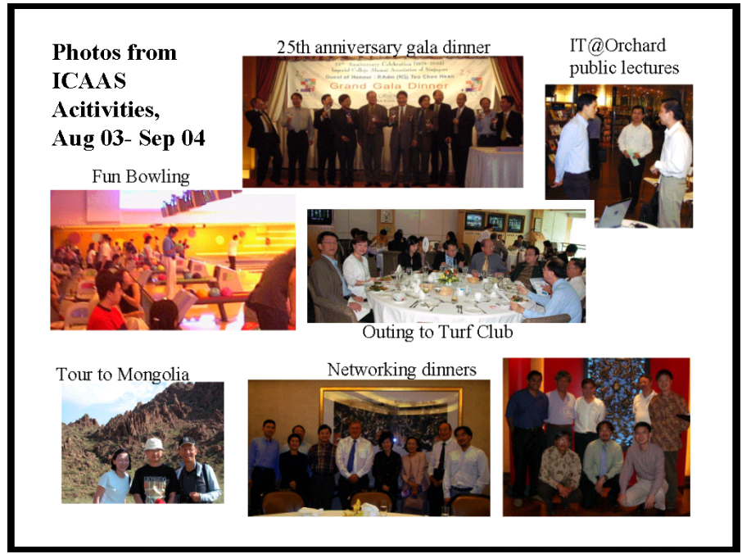
Limsoon Wong
President, ICAAS
Allen Chong
Hon. Sec., ICAAS

